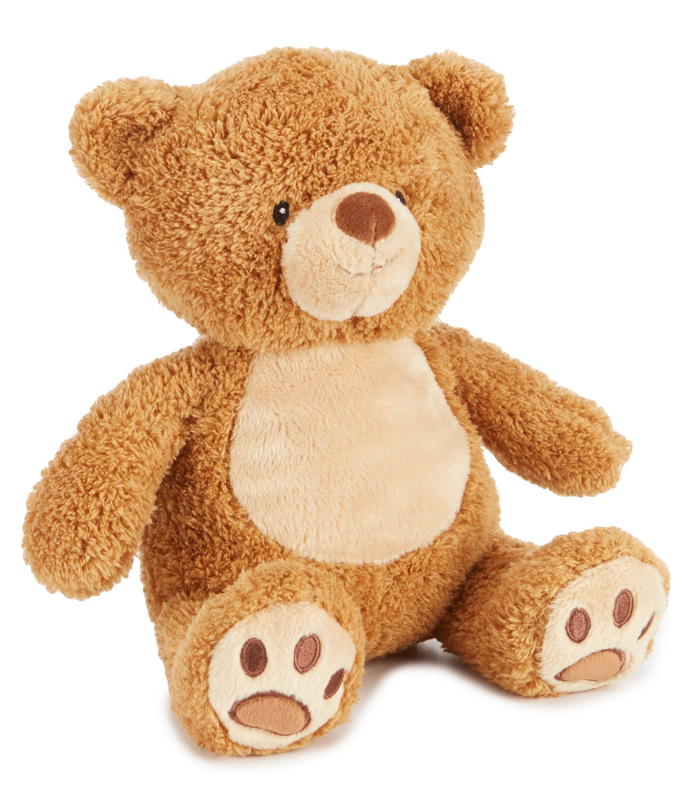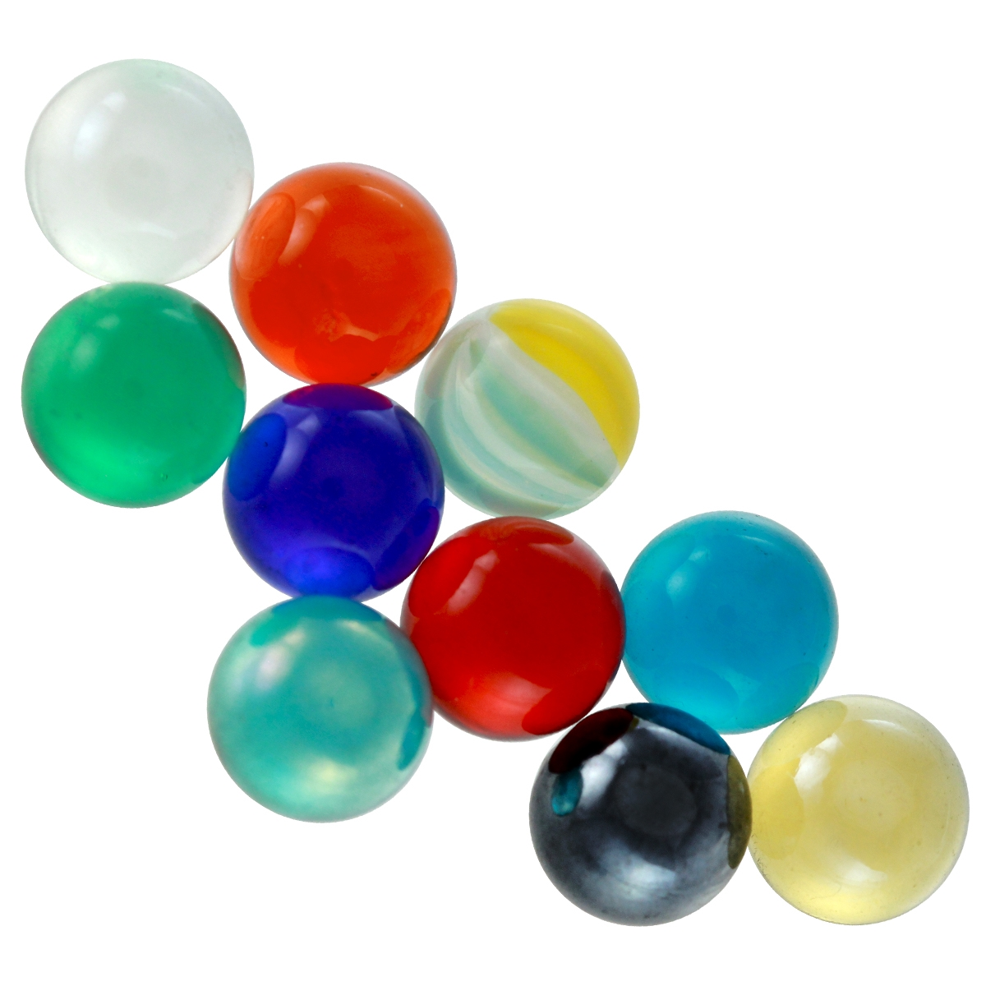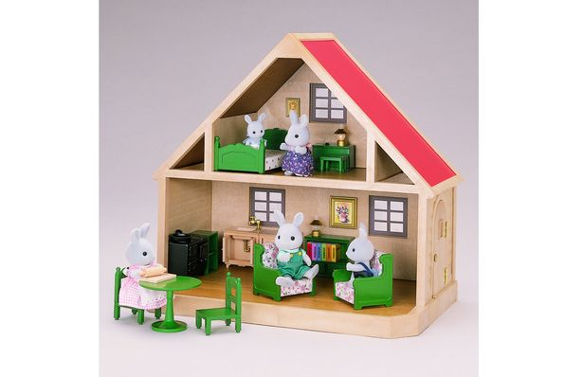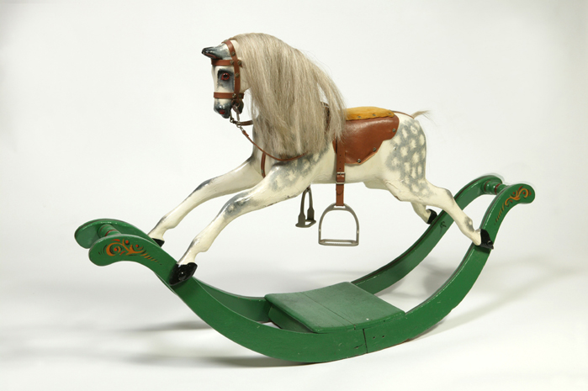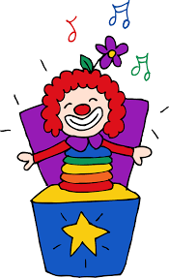

As Authors we will:

Read and write the traditional tale ‘Pinocchio’. We will also read a range of non-fiction and write our own non-chronological report about how to make a toy.

How are toys different to a long time ago?

As Citizens we will:

Investigate dealing with difficult situations and emotions.

As Readers we will:

Read the traditional tale of ‘Pinocchio’.

As Designers we will:

Explore different ways of joining fabrics before creating our own hand puppets based upon characters from a well-known fairy tale.

Dear Parents of Emerald children:

Here is our topic map for this half term.

If you have any questions, then please do not hesitate to ask!

Miss Hope

As Musicians we will:

Experiment with timbre and dynamics to write our own melody for an adventure story.

As Programmers we will:

Learn about digital imagery as we create a miniature adventure story and capture it using photography skills.

As Scientists we will:

Continue to learn about animals and their habitats. This term we will focus on micro-habitats and investigate the micro-habitats that we have around school. We will also learn about food chains.

As Believers we will:

Explore Muslim celebrations and visit the mosque in Lincoln. A letter will be sent out soon.

As Historians we will answer the following questions:

LC1 Can I talk about toys today?

LC2 Can I find out about toys in the past?

LC3 Can I compare similar toys from different times?

LC4 Can I compare Victorian toys with modern toys?

LC5 Can I recognise how toys have changed over time?

LC6 Can I use words relating to the passing of time?