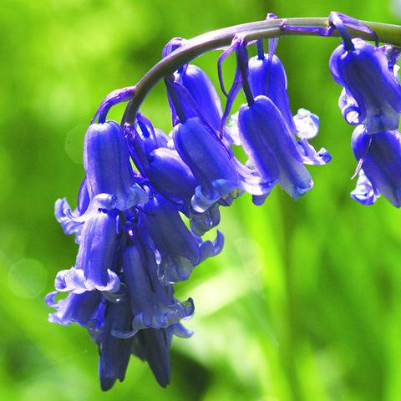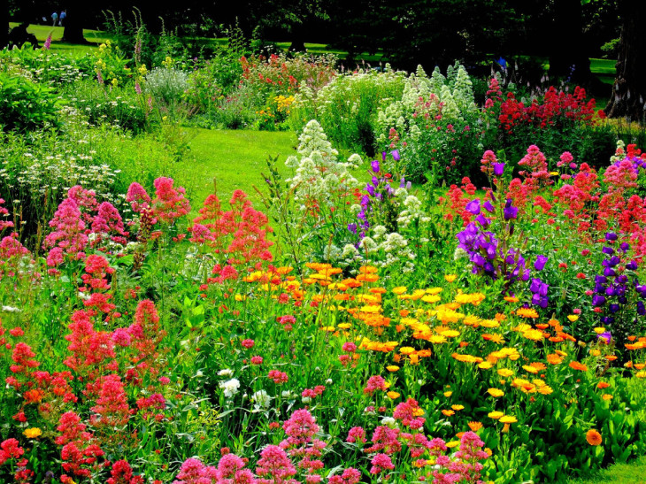

As Readers we will:

Read ‘Jim and the Beanstalk’ and compare it to ‘Jack and the Beanstalk’.

As Athletes we will:

Practise our sending and receiving skills using equipment in rounders.

As Artists we will:

Sketch and watercolour a variety of wild flowers. We will also paint ‘Sunflowers’ by Van Gogh.

How does your garden grow?

As Geographers we will:

Think about the question, ‘How does the weather change?’. We will observe changes in weather, research hot and cold countries and locate the countries on a map.

As Authors we will:

Write a description of an image from the book ‘The Little Gardener’ and write an explanation text of the life cycle of a frog. We will also be looking at the traditional tale ‘Jack and the Beanstalk’.

As Programmers we will:

Practise our word processing skills.

As Musicians we will:

Explore clapping along to the syllables of words and phrases before creating rhythmic patterns to tell a familiar fairy tale.

Dear Parents of Emerald children:

Here is our curriculum map for this term. We also have a range of extra-curricular experiences planned such as a trip to Belton for a ‘woodland walk’ and gardening with the residents at Welbourn Manor. Please let us know if you can join us to help!

Miss Hope

As Believers we will:

Explore the different places of worship across a range of religions and identify their key features.

As Scientists we will answer the following questions:

LC1 Can I plant some seeds?

LC2 Can I identify and name common wild plants?

LC3 Can I identify and name common garden plants?

LC4 Can I sort plants?

LC5 Can I sort deciduous and evergreen leaves?

LC6 Can I identify and describe the parts of plants and trees?

LC7 Can I explain what plants needs to grow?

LC8 Can I observe and describe changes?