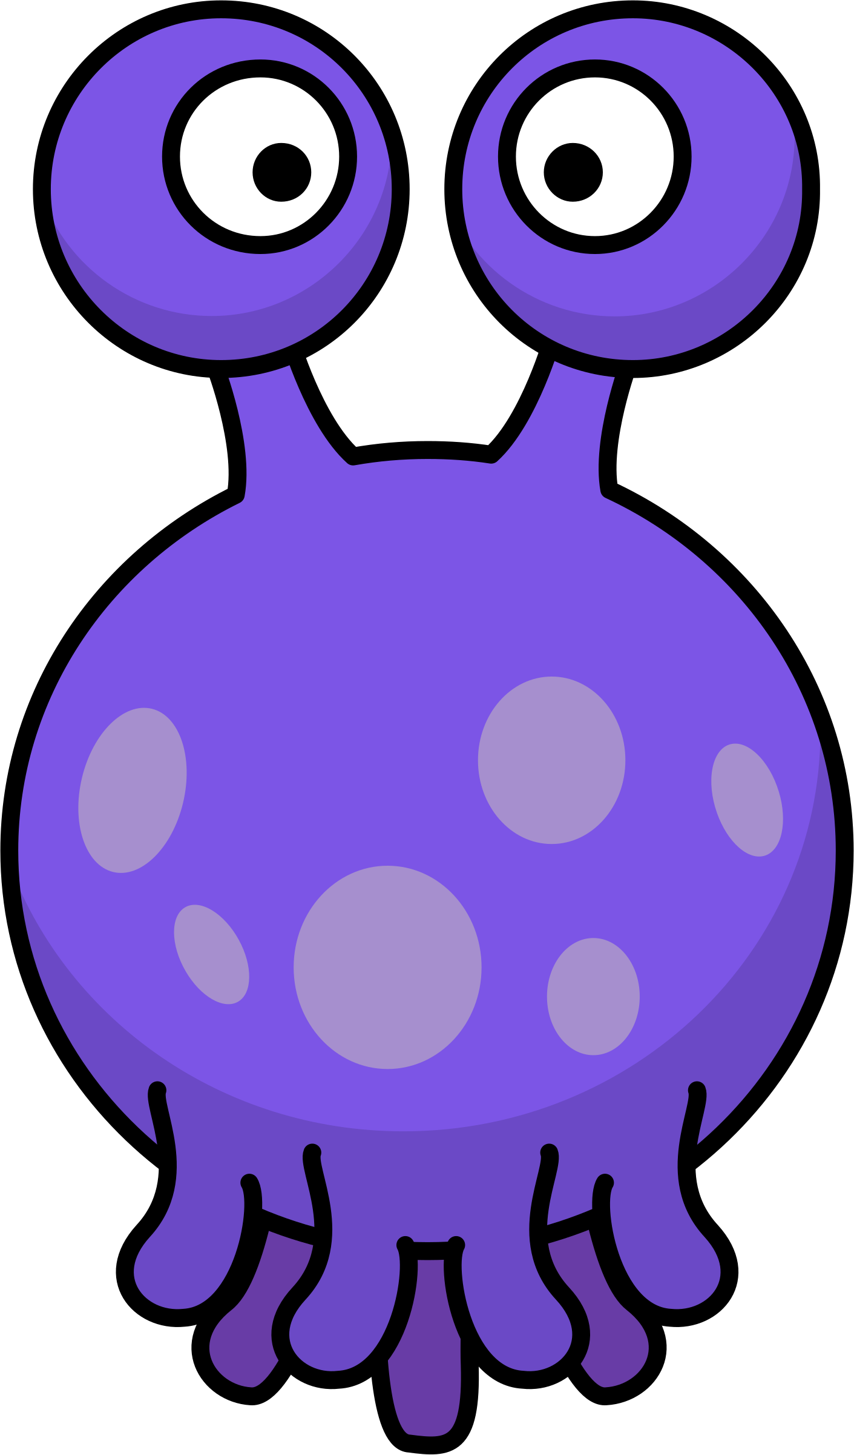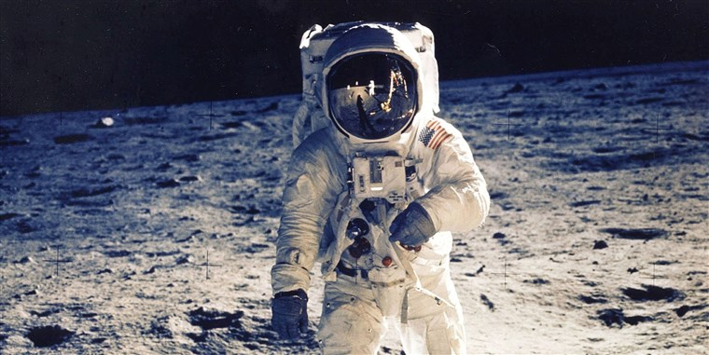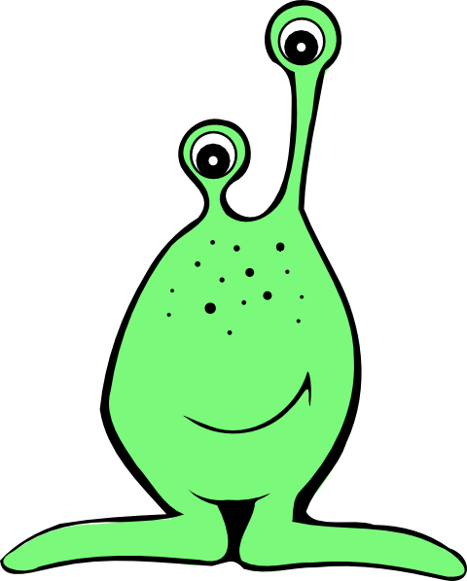

Would you like to be an explorer?

As Historians we will answer the following questions:

LC1 Can I find out about Neil Armstrong?

LC2 Can I explain what happened at the moon landing?

LC3 Can I order events chronologically?

LC4 Can I research the planets?

LC5 Can I find out about Christopher Columbus?

LC6 Can I explore the impact of Columbus’s voyages?

LC7 Can I compare the achievements of two explorers?

As Athletes we will:

Apply the skills that we have learnt this year to 5 vs 5 invasion games.

As Readers we will:

Read ‘Aliens Love Underpants’ and non-fiction books about space.

Dear Parents of Emerald children:

Here is our curriculum map for this term. We also have a range of extra-curricular experiences planned such as a trip to The Space Centre and ongoing visits to Welbourn Manor to sing with the residents. Please let us know if you would like to help.

Miss Hope

As Musicians we will:

Visualise a journey to the moon and create music to go with a rocket journey the moon. We will also learn and sing songs at Welbourn Manor.

As Scientists we will:

Continue our learning on plants and trees. We will be identifying and describing the parts of plants and trees and learning what they need to grow.

As Authors we will:

Write our own fantasy stories. We will also write space poetry and write a letter of application to become an astronaut.

As Programmers we will:

Design, build and test our own rockets using software. We will also develop skills in debugging as we learn about sequencing instructions.

As Believers we will:

Explore the different places of worship across a range of religions and identify their key features.