Welbourn C of E Primary School
‘Believe, Excite, Succeed, Together’
RE Long Term Plan Amethyst Class Year A 2023-2024
 | Autumn |  | Spring |  | Summer
R.E | Intent  We learn R.E to help us hold balanced and well informed conversations about religion and belief  Implementation  We learn R.E through the Balanced RE approach and explore these principles…  - Theology – believing  - Philosophy – thinking  - Human/ social science – living  The 4 key areas of enquiry of the agreed syllabus are:  - God (concepts of belief)  - Being human (faith, belief and actions)  - Community, worship and celebration (expressing religion and beliefs)  - Life journey – rites of passage (marking important events in life)  How does this plan work?  In this plan the above areas of enquiry are approached through four key concepts, (3 concepts covered in KS1) to help ensure coherence, i.e. threads that run through the curriculum. These are:  - Belief and values: enquiry area 1: What do people believe about God?  - Belonging, community and identity: enquiry area 2 - How faith and belief affects the way people live their lives.  - Expression, experience and the sacred place: enquiry areas 3 and 4 - Expressing beliefs; being human, life journey.  - Knowledge and truth:  These concepts will be displayed in each classroom for teachers and children to refer to and make links through.
Year | Year 5/6 |  | Year 5/6 |  | Year 5/6
Term | Autumn |  | Spring |  | Summer
Key concept | 2. Belonging, community and identity | 3. Expression, experience and the sacred place.  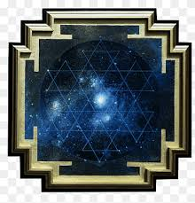 | 1. Beliefs and values  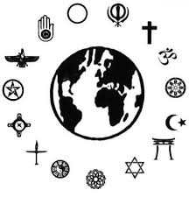 | 1. Beliefs and values | 2. Belonging, community and identity | 4. Knowledge and truth  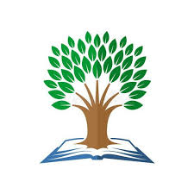
Key questions for enquiry | How is Muslim worship expressed collectively?  How does Muslim worship and celebration build a sense of community?  Text: Lailah’s Lunchbox – A Ramadan Story 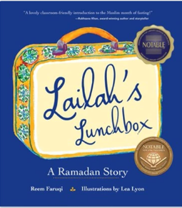 | How do Hindus show they belong?  How does Hindu worship and celebration build a sense of community? (include symbolism with festival of light – Diwali and Christmas)  Text: Belonging Street – Poems by Mandy Coe  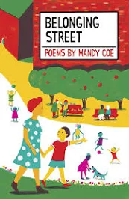 | Why do some texts matter more than others?  (Sacred texts all 3 religions). | How do Christians act because of their beliefs about Jesus and the resurrection?  (SALVATION) | What is a pilgrimage?  What does pilgrimage involve?  Eg: Christian pilgrimage to Walsingham, Lourdes, Iona, Jerusalem, Muslim pilgrimage to Makkah, Jewish pilgrimage to Jerusalem, Hindu pilgrimage to the Ganges.  Environmental impact of pilgrimage.  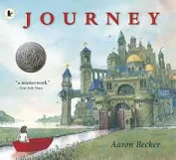 | Does a religion have to have a god?  (Links to Buddhism)
Topic name | ISLAM - How do people express their religion and beliefs? | HINDUISM – How do people mark important events in life? | What can we learn from sacred texts? | What difference does the resurrection make for Christians? (Salvation) | Additional Unit  Pilgrimage | Additional Unit Big Questions  Does a religion have to have a god?
Key knowledge | To know the importance of family life, roles and responsibilities.  To know the influence of some contemporary Muslims.  To know why the Five Pillars are important and how they bind the global Muslim community together.  To know what the Hadith teaches about how Muslims treat each other.  To know how Muslims put corporate and personal responsibility into action. | To know about important Hindu Festivals, e.g. Diwali, Holi - stories, practices, food, worship, diversity,  shared experiences.  To know about the Hindu belief that life is a journey from one body to another and each life itself a journey from birth to death (Reincarnation).  To know about the first of the ‘Samskaras’ (life-stage rituals).  To know about Raksha Bandan (Rakhi ceremony).  To know about Pilgrimage (focus in term 5) sacred places, e.g.  River Ganges, Varanasi, Ayodhya  and associated stories | To know that  many religions have sacred texts.  To know that  people of the same faith may value different religious texts or versions.  To know that  most concepts are  universal and are  shared across all  religions. | To know the timeline of the ‘big story’  To know why Christians believe in the resurrection.  To know about Christian practices during Good Friday, Easter Sunday etc  To know how the belief of the resurrection of Jesus makes a difference to people’s lives today.  To know about the passage of Luke 24 and how it describes the concept of sacrifice, resurrection, salvation, Incarnation, and hope. | To know that journeys are  part of everyday  life and will reflect on their life journey so far.  To know that some places  are of particular  significance in the religious life of some people.  To understand that humans are often inspired by places.  To learn that an inspiring place may have  natural, historic or religious  significance.  To know that Christians,  Jews, Hindus,  Sikhs, Buddhists  and Muslims may make religious  journeys as part of their faith and practice.  What are the similarities and differences between pilgrimages in different religions? |  | To think about whether a religion needs a god.  To find out more about being a non-religious person.  To know what the terms theist, atheist andagnostic mean.  To consider questions such as: does God help people to be good? How can you be good without God?  To examine similarities and differences between different views of God.
Key skills | To make links between Muslim beliefs about God and a range of ways in which Muslims worship.  To give examples of ibadah (worship) in Islam and describe what they involve.  To raise questions and suggest answers about the value of submission and self-control to Muslims, and whether there are benefits for people who are not Muslims.  To make links between the Muslim idea of living in harmony with the Creator and the need for all people to live in harmony with each other in the world today, giving good reasons for their ideas. | To explore different Hindu festivals and the meaning behind them.  To make links between the story of Rama and Sita at Divali and the idea of overcoming evil in life today.  To describe what happens in sacred thread ceremonies and say what these rituals mean to some Hindu people.  To make comparisons and links between beliefs about love and commitment and how Hindu people live and celebrate.  To discuss and explain the importance of reincarnation for Hindus.  To give good reasons why they think ceremonies of commitment are or are not valuable today. | To describe features of some religious texts and why they are regarded as important to  people of faith.  To make connections between different religious texts, describing some concepts that  are similar.  To explore why religious texts can be an important part of worship and  day to day life for people of faith.  To discuss and present their own ideas on challenging questions relating to the  concepts of honesty, unity, truthfulness, justice and love.  To explore and present their own ideas on what relevance some religious quotations  might have for people today. | To make suggestions about the meaning of various accounts.  To compare ideas and interpret texts.  To explain connections between concepts (sacrifice, salvation, incarnation, hope)  To offer and justify my own opinions | To describe ways people on a religious pilgrimage might explain their journey and its impact on their  lives.  To present their own views on challenging questions about what makes a pilgrimage ‘the  journey of a lifetime’ for some people  To explain with reasons why a person today might choose to spend their savings on going on a  pilgrimage, or sponsor someone else to do a pilgrimage, and consider it very worthwhile.  To make connections between a journey to a pilgrimage site and the values and commitments of  pilgrims and the pupils’ own values and commitments.  To explore the similarities and differences between pilgrimages in different religions. |  | To define the terms theist, atheist andagnostic and give examples of statements that reflect these beliefs.  To give reasons why a Christian believes in God and one why an atheist does not.  To have debates on different views on why people believe in God or not, including their own ideas.  To enquire into what some atheists,agnostics and theists say about God ,expressing their own ideas and arguments,using evidence and examples.  To think of reasons why some people don’t believe in God.  Ask thoughtful questions about religious and non-religious ways of life.  To make links  between religious and non-religious ideas.  To examine similarities and differences between different views of God.
Key vocabulary | Ramadan  ibadah (worship), iman(faith),  messenger, adhan (call to prayer),  five pillars,  salat (prayer), sawm (fasting), zakat (charity), Ramadan, hajj (pilgrimage). | Samskaras (passage of life)  Birth - namkarna (naming  ceremony), jatakarma  (welcoming the baby into the  family)  Ear piercing (karnavedha) and  first haircut (mundan)  Upananyana or sacred thread  Ceremony dharma,  karma,  moksha | Buddhist: Tripitaka, Dhamapada  Bahai’: Tablets, Baha’u’llah  Jewish: Torah, Tanakh, Talmud  Muslim: Qur’an, Hadiths  Christian: Bible, Testament  Religious and Human Experiences: shrine,  God, worship, artefact, holy, spiritual,  sacred, devotion. | Incarnation  Resurrection  Christian  Belief  Salvation  sacrifice  Hope  Jesus  Theological  Worship  Gospels  Heaven  Restoration | Pilgrimage  Pilgrims  Religious and Human Experiences: Change,  Life changing, Journey of life  Pupils will have opportunities to use words  related to specific religions:  including Buddhism: Bodh Gaya, Buddha, Enlightenment |  | theist,  atheist andagnostic  Buddhism  Buddha  Buddhist

Our plan follows and uses the following key documents and websites:
- The Lincolnshire Agreed Syllabus (2018 – 23)
- Understanding Christianity (text, impact, connections)
- https://www.lincolndiocesaneducation.com/page/?title=Lincolnshire+Locally+Agreed+Syllabus&pid=30

