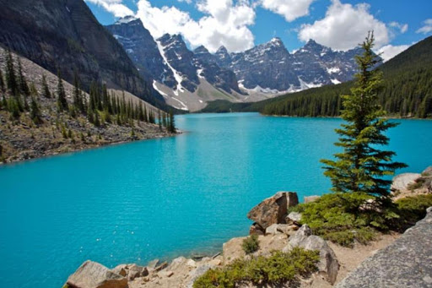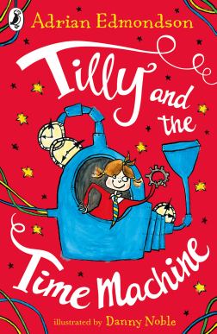

As authors we will: be focusing on playscripts linked to our play ‘Pirates and mermaids’. We will then be writing diary entries linked to our text Tilly and the time machine, and finally looking at imagery in poetry.

We will also be implementing a new scheme called Active English to make learning spag fun!

Wow Days and Trips:

As part of our geography topic we will be visiting Snipe Dales to learn all about rivers. We will also have chicks arriving in school as part of our Science topic linked to farming!

Dear Parents and Year 3 and 4 children:

Welcome back! I hope you had a lovely half term break. This half term we will be exploring the geography topic ‘Rivers and mountains’.

Our challenge questions are:

LC1: To know the main mountains and rivers in the UK.

LC2: To know the longest rivers and highest mountains in the world.

LC3: To know and label the features and route of a river.

LC4: To know and label the water cycle

LC5: To know how rivers and mountains are used around the world.

LC6: To know how mountains are formed.

LC7: To locate the equator, tropics of cancer and Capricorn and the Greenwich Meridian.

LC8: To know why rivers flood.

In IT we will: be continuing to learn all about databases. The children will then put into practise the skills that they have learnt, to sort and filter data to plan a holiday.

As musicians we will: be learning to tell stories through music, then create our own original compositions to match an animation.

As believers we will: be exploring the question ‘What do Christians learn from the creation story?’

As designers we will: be designing and creating different scenery to use in our play!

Where does the river take you?

As readers we will: be reading ‘Tilly and the time machine’. We will also

be looking

at a

variety of

playscripts.

As mathematicians we will:

be focusing on creating graphs using measurement, fractions, multiplication and division, and telling the time.

We will continue to have times tables tests every Wednesday, and practice using times tables

rockstars. Please practise at home too!