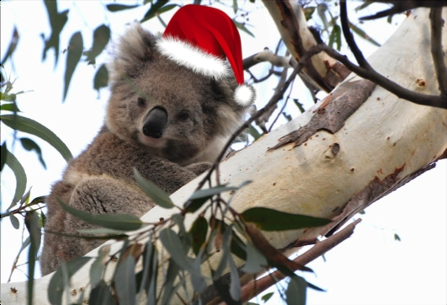

Our **Geography** topic this term will be all about Australia. The children will develop their Geography knowledge and build on their learning last term about continents and oceans. They will compare the UK to Australia and learn about Australia’s culture, features and animals. They will use maps and symbols to improve their mapping skills and even learn about Christmas in Australia!

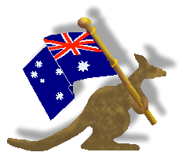

**Emerald**

**How is Australia different to where we live?**

We will continue to follow our new Read Write Inc programme for **reading** and **writing.**

In **Music** we will be singing Christmas songs ready for our nativity performance.

In **RE** this term we will be answering the question ‘Why is Christmas so important to Christians?’. We have an exciting term ahead with nativity preparations but alongside this we will be learning about the celebration of Christmas around the world – including in Australia! We will look at the different ways in which it is celebrated.

In **Computing** we will use both our word processing skills and our **Science** knowledge from last term to type an animal fact file.

This half term in **Maths** we will be learning to recognise coins and notes. Some of us will learn to combine amounts and give change. We will also learn more about multiplication and division, fractions and shape. The times tables that we will practise are 2, 5 and 10.

In **PE** we will be working with Mr. Green on a Monday to improve our throwing and catching skills. We will have gymnastics on a Tuesday.

In **Art** we will be developing our art skills whilst learning about a range of different Aboriginal painting techniques and styles including dot painting.