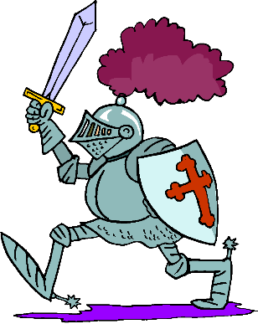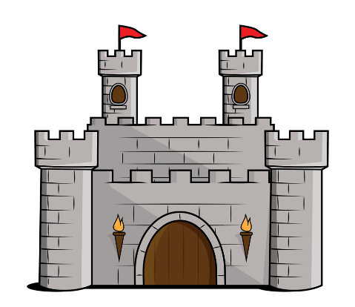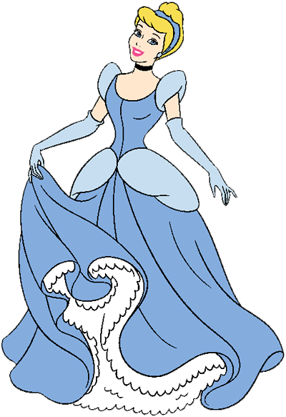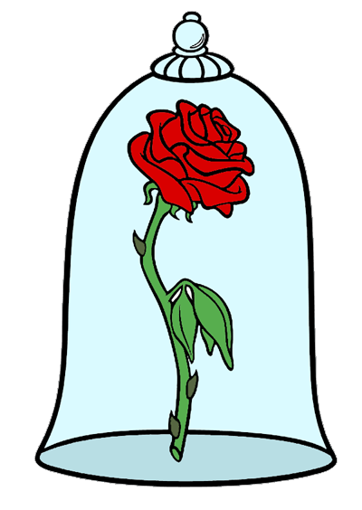

In **Art** the children will be developing their colour mixing and painting skills whilst incorporating their maths shape skills. They will build up skills to paint Paul Klee’s ‘Castle and Sun’.

To develop our **Geography** skills, we will be locating castles in the UK on a map and labelling the surrounding seas.

For **Maths** this term Emerald will be developing their number knowledge whilst also practising their subtraction, multiplication and division.

In **PE,** the children will be doing dance and multi skills.

For **Music**, Emerald will learn about timbre and syllables before creating their own rhythmic pattern to tell a familiar fairy tale.

We will be visiting **Tattershall Castle** on **31st March** and taking part in medieval dancing, a castle tour and handling real artefacts.

For **RE** this term Emerald will be learning about why Easter is important to Christians. We will also be visiting church for our Easter service.

In **Computing** this term the children will be programming a Beebot to roam around a castle floor plan.

In **History** this term we will be learning all about castles. We will place castles on a timeline and compare what is the same and different about them. We will label a castle and identify the key features and what they were built for. We will also compare daily life for the rich and poor and learn who William the Conqueror was.

Emerald

Is a castle a safe place to live?