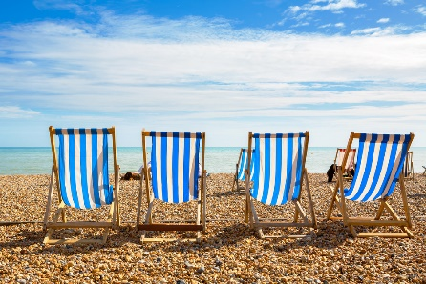
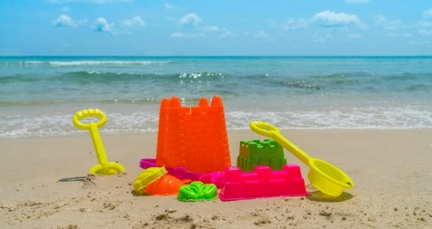
Welbourn Primary School home learning
‘Believe, Excite, Succeed, Together’

Summer Term 2 Week 1 Why do we like to be beside the seaside?
During the course of the week, we would like you to complete the following learning. We understand that this is a very difficult time for us all and that some children will struggle to engage with learning at times. This learning is for your child to complete at your own time.
Visit www.padlet.com/beckyhope for resources to support your child’s learning organised by subject along with additional resources for extra learning.
Morning session tasks: (Choose one or two per day)
9.00 – 9.30 P.E:
Joe wicks: https://www.youtube.com/playlist?list=PLyCLoPd4VxBvQafyve889qVcPxYEjdSTl
or GoNoodle https://www.youtube.com/user/GoNoodleGames
or Strictly Come Dancing’s Oti Mabuse https://www.youtube.com/channel/UC58aowNEXHHnflR_5YTtP4g
9.30am – 10.00am Maths:  Daily maths lessons can be found at:  https://whiterosemaths.com/homelearning/  - Click on your child’s year group  - Watch the video clip  - Complete the activity sheet  Sheets are now only available to us as a school through our membership. They will be uploaded to our Maths padlet each week.  In addition, visit https://www.topmarks.co.uk/maths-games/hit-the-button daily for 5 - 10 minutes of mental maths practise. Choose between: Times tables: 2, 5, 10 and 3 for extra challenge. Number bonds to 10 and 20. Doubles and halves within 20. Division facts for 2, 5 and 10 times table. |  | 10.30am – 11.00am Phonics and reading:  Follow the link to access daily phonics lessons for Set 3 Read Write Inc.  https://www.youtube.com/channel/UCo7fbLgY2oA_cFCIg9GdxtQ  Please note that although the sounds are restarting, there will be new words to read. Visit https://www.ruthmiskin.com/en/find-out-more/parents/ for more information and links to stories and poems read aloud.  There should be a minimum of 5-10 minutes of daily reading in addition to phonics. Visit https://www.oxfordowl.co.uk/for-home/find-a-book/library-page/ for free Read Write Inc eBooks. |  | 11.30am – 12.00pm Writing:  Watch https://www.literacyshed.com/bubbles.html to support these tasks.  Task 1 – Make a word bank using your knowledge of nouns, verbs, adjectives and adverbs from last term about the seaside or things that you can see in the video. There are examples for you.  Task 2 – Complete the seaside rhyming words activity sheet. (Visit https://www.poetry4kids.com/rhymes/ if you’re stuck!)  Task 3 – Using your vocabulary, write either an acrostic seaside poem or a senses seaside poem. Templates are on the padlet.
Spellings to learn this week. Choose between 5 and 10 to learn:

Year 1: The digraphs ‘ph’ and ‘wh’
1. dolphin 2. alphabet 3. phonics 4. elephant 5. when 6. where 7. which 8. wheel 9. while 10. white

Year 2: Homophones and near homophones
1. there 2. their 3. they’re 4. here 5. hear 6. see 7. sea 8. to 9. too 10. two

Visit our English padlet for PowerPoint presentations, handwriting sheets and word searches to support learning.
Afternoon sessions: Choose an activity from the list below
History  Read the PowerPoint, look at the photographs on it and refresh your memory of the features of the seaside. Using your senses knowledge from last term, complete the activity sheet writing down what you can see, hear, smell, touch and taste at the seaside. There are other sheets to try too if you want to! You might also like to draw and label a picture of the seaside using the key word sheet to help. | Geography  Read the PowerPoint and recount the different seaside resorts that you have visited. Complete the activity sheet researching a seaside of your choice. You might prefer to present your research a different way (video, poster or ICT). | Art  Drawing on either https://www.youtube.com/user/ArtforKidsHub or http://www.robbiddulph.com/draw-with-rob  DT  *Optional as resources needed* Design a mini fairground wheel. Look at the examples on the PowerPoint then use the sheet to design your own. We will be making it over the coming weeks. Please see resources sheet for what will be needed. | Music  Visit https://www.bbc.co.uk/teach/bring-the-noise/eyfs-ks1-music-play-it-bring-the-noise/z4sq92p . Children can explore the different elements that make up a song, play or clap along with the music and make then listen back to their own version of songs. Have fun! | Science  Visit https://www.bbc.co.uk/bitesize/topics/zpxnyrd/articles/z3wpsbk and then read the PowerPoint about trees and plants. Go on a walk to see what trees and plants you can see. Choose a flower (ask an adult first!) to dissect into parts. Stick the parts to a poster and label them. Alternatively, complete the tree or flower worksheet. | IT  Play maths and English games on https://www.ictgames.com/ with recommended games for each year group.  PSHE & Well-being  Visit http://www.welbournprimary.co.uk/WellBeing.asp and look at the range of activities including lego, colouring and cooking. Choose one to complete.
Outside learning challenge:
Visit Carres Outreach youtube channel https://www.youtube.com/channel/UC81FScB7_xOGLQqA1vr1x-A and complete one of the tasks set daily by the coaches (including Mr.Green )!
or
Make a nature photo frame using the activity sheet on the padlet. Collect resources then display them!

