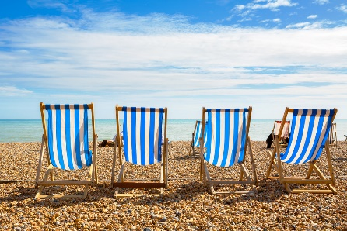
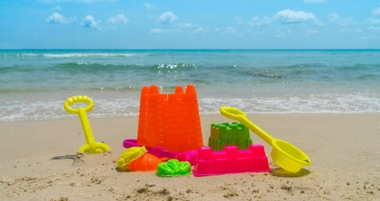
Welbourn Primary School home learning
‘Believe, Excite, Succeed, Together’

Summer Term 2 Week 5 Why do we like to be beside the seaside?
During the course of the week, we would like you to complete the following learning. We understand that this is a very difficult time for us all and that some children will struggle to engage with learning at times. This learning is for your child to complete at your own time.
Visit www.padlet.com/beckyhope for resources to support your child’s learning organised by subject along with additional resources for extra learning.
Morning session tasks: (Choose one or two per day)
9.00 – 9.30 P.E:
Joe wicks: https://www.youtube.com/playlist?list=PLyCLoPd4VxBvQafyve889qVcPxYEjdSTl
or GoNoodle https://www.youtube.com/user/GoNoodleGames
or Cosmic Kids Yoga https://www.youtube.com/user/CosmicKidsYoga
9.30am – 10.00am Maths:  Daily maths lessons can be found at:  https://whiterosemaths.com/homelearning/  - Click on your child’s year group  - Watch the video clip  - Complete the activity sheet  Sheets are now only available to us as a school through our membership. They will be uploaded to our Maths padlet each week and emailed to you.  In addition, visit https://www.topmarks.co.uk/maths-games/hit-the-button daily for 5 - 10 minutes of mental maths practise. Choose between: Times tables: 2, 5, 10 and 3 for extra challenge. Number bonds to 10 and 20. Doubles and halves within 20. Division facts for 2, 5 and 10 times table. |  | 10.30am – 11.00am Phonics and reading:  Follow the link to access daily phonics lessons for Set 3 Read Write Inc.  https://www.youtube.com/channel/UCo7fbLgY2oA_cFCIg9GdxtQ  1. Speed sounds  2. Spelling  3. Hold a sentence  4. Read longer words  There should be a minimum of 5-10 minutes of daily reading in addition to phonics. Visit https://www.oxfordowl.co.uk/for-home/find-a-book/library-page/ for free Read Write Inc eBooks. If you feel that your child has progressed with reading, they can move to the next colour. Contact me via email or teams to find out what this is. |  | 11.30am – 12.00pm Writing:  Task 1 – Write sentences to describe the seaside images on the sheets. Try to include: Capital letters, full stops, conjunctions (and, so, but, because…) and adjectives (describing words!) Use your neatest handwriting!  Task 2 – Write sentences to describe what you can see, smell and hear when you’re at the beach. Use the image at the top of the sheet to help you.  Task 3 – Complete the sun, sea and beach safety reading comprehension. Use a crayon or pen to circle key words in the text to help you to find the answer. Write your answers in full sentences if you can.
Spellings to learn this week. Choose between 5 and 10 to learn:

Year 1: Contractions
1. I’m 2. I’ll 3. we’ll 4. she’ll 5. you’ll 6. they’ll 7. we’re 8. you’re 9. he’s 10. they’re
Year 2: Months of the year (continued from last week) and time
1. November 2. December 3. after 4. past 5. hour 6. half 7. minute 8. quarter 9. month 10. second
Afternoon sessions: Choose an activity from the list below
History  Look at the photographs of the seaside on the PowerPoint slides. Think about similarities and differences. Then, choose one or more of the following.  1. Cut out the seaside images and organise them into three columns. 100 years ago, 50 years ago and today. Write down observations that help you to decide where they go and why!  2. Research what people wore at the seaside and design your own swimming costumes for each period of time using the templates on the sheet.  3. Cut and stick your new costumes designs on larger paper and design a shop poster advertising them for sale. | Geography  Read though the Islands PowerPoint then choose one or more of the following.  1. Fill in the map sheets, writing down the names of the Islands and using the PowerPoint for help if you don’t have an atlas.  2. Research one hot and one cold island. What can you find out about them? Can you make a poster comparing the two islands? Draw pictures, too! | Art  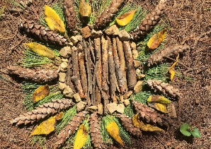  Before this lesson go on a woodland walk and collect a range of natural materials using the checklist as a guide. Try to collect leaves / twigs / stones / flowers / pine cones. Read the PowerPoint about Andy Goldsworthy and look at the pictures of land art. Use your natural resources to create your own land art. See an example below and more examples on the PowerPoint | Music  Visit https://www.bbc.co.uk/teach/bring-the-noise/eyfs-ks1-music-play-it-bring-the-noise/z4sq92p .  Children can explore the different elements that make up a song, play or clap along with the music and make then listen back to their own version of songs. Have fun! | Science  Read the PowerPoint to learn which plants we eat. Watch https://www.bbc.co.uk/bitesize/clips/zc62tfr to see seeds planted by children and a farmer explaining what happens. Then, choose one or more of the following.  1. Complete the farm activity sheet, drawing your own crops on the farm.  2. Design a poster about what plants we eat. You could compare British crops to crops in another country.  3. Design a food menu including plants that we can grow and eat. | IT  Play maths and English games on https://www.ictgames.com/ with recommended games for each year group.  PSHE & Well-being  Visit http://www.welbournprimary.co.uk/WellBeing.asp and look at the range of activities including lego, colouring and cooking. Choose one to complete.
Outside learning challenge:
Visit Carres Outreach youtube channel https://www.youtube.com/channel/UC81FScB7_xOGLQqA1vr1x-A and complete one of the tasks set daily by the coaches (including Mr.Green )!
or Build a bird’s nest! Use the sheet from the learning pack or on the padlet.

Emerald Microsoft Teams Timetable 29th June – 3rd July

Messaging on Emerald team page with daily challenges | Daily / ongoing to respond to as and when
Year 1 video chat  Children to share a piece of learning with everyone. | Thursday 2nd July 2pm
Year 2 video chat  Children to share a piece of learning with everyone | Thursday 2nd July 3pm
Family quiz  A fun, light hearted and child friendly quiz. Make sure you have a pen and paper! | Friday 3rd July at 2pm

