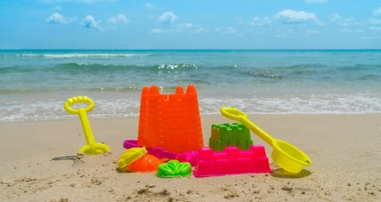
Welbourn Primary School home learning
‘Believe, Excite, Succeed, Together’

Summer Term 2 Week 6 Why do we like to be beside the seaside?
During the course of the week, we would like you to complete the following learning. We understand that this is a very difficult time for us all and that some children will struggle to engage with learning at times. This learning is for your child to complete at your own time.
Visit www.padlet.com/beckyhope for resources to support your child’s learning organised by subject along with additional resources for extra learning.
Morning session tasks: (Choose one or two per day)
9.00 – 9.30 P.E:
Joe wicks: https://www.youtube.com/playlist?list=PLyCLoPd4VxBvQafyve889qVcPxYEjdSTl
or GoNoodle https://www.youtube.com/user/GoNoodleGames
or Cosmic Kids Yoga https://www.youtube.com/user/CosmicKidsYoga
9.30am – 10.00am Maths:  Daily maths lessons can be found at:  https://whiterosemaths.com/homelearning/  - Click on your child’s year group  - Watch the video clip  - Complete the activity sheet  Sheets are now only available to us as a school through our membership. They will be uploaded to our Maths padlet each week and emailed to you.  In addition, visit https://www.topmarks.co.uk/maths-games/hit-the-button daily for 5 - 10 minutes of mental maths practise. Choose between: Times tables: 2, 5, 10 and 3 for extra challenge. Number bonds to 10 and 20. Doubles and halves within 20. Division facts for 2, 5 and 10 times table. |  | 10.30am – 11.00am Phonics and reading:  Follow the link to access daily phonics lessons for Set 3 Read Write Inc.  https://www.youtube.com/channel/UCo7fbLgY2oA_cFCIg9GdxtQ  1. Speed sounds  2. Spelling  3. Hold a sentence  4. Read longer words  There should be a minimum of 5-10 minutes of daily reading in addition to phonics. Visit https://www.oxfordowl.co.uk/for-home/find-a-book/library-page/ for free Read Write Inc eBooks. If you feel that your child has progressed with reading, they can move to the next colour. Contact me via email or teams to find out what this is. |  | 11.30am – 12.00pm Writing:  For these tasks, watch the traditional story ‘Jack and the Beanstalk’ on https://www.youtube.com/watch?v=W5rxfLRgXRE or alternatively read the PowerPoint.  Task 1 – Describe a character from the story using the sheet with the word bank provided. Include capital letters, full stops and adjectives (describing words) .  Task 2 – Cut and stick the pictures and writing from the story, sequencing them into the correct order. This will help with task 4!  Task 3 – Write sentences about each of the images from the story.  Task 4 – Rewrite the story of ‘Jack and the Beanstalk’, using tasks 1 – 3 to help you. Remember finger spaces, capital letters and full stops! Adjectives and adverbs for a challenge.
Spellings to learn this week. Choose between 5 and 10 to learn:
Year 1: Common Exception Words
1. of 2. said 3. was 4. has 5. come 6. one 7. once 8. ask 9. your 10. is
Year 2: Question words and SPAG terms
1. who 2. why 3. what 4. how 5. which 6. where 7. when 8. adjective 9. adverb 10. verb
Afternoon sessions: Choose an activity from the list below
History  Read through the PowerPoint and think about similarities to seaside holidays in the past and now. Then choose one or more of the following:  1. Cut the statement cards from the sheets and organise them into past and now. Some may fall in the middle and apply to both!  2. Read the description of seaside holidays in the past on the table then write what they are like now.  3. Use the question cards to practise discussing what seaside holidays are and were like. | Geography  We have finished our seaside Geography learning so will spend the next few weeks looking at climate / weather to link to this. Read through the PowerPoint learning about climates around the world. Then choose one or more of the following tasks:  1. Colour the map to show the climate zones of the world. Use the answers sheet to help you.  2. Cut out the animals and stick them in their correct climate zone.  3. Research the climate in a country / continent of your choice and present this on a poster or using ICT. | Art  Read through the ‘Big Build’ PowerPoint and using natural resources, similar to last week, plan and build a natural sculpture. Use the help sheet and look at photographs of others to help you.  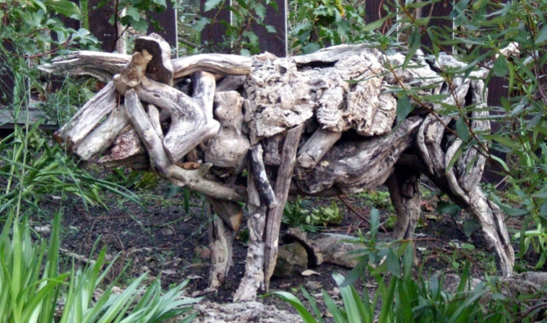  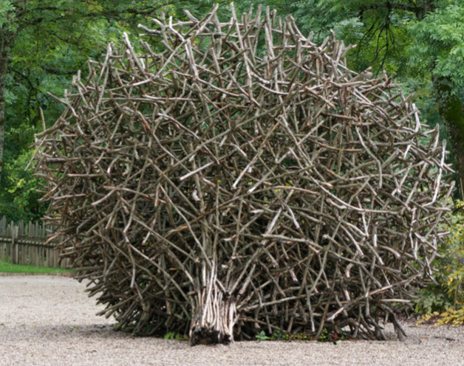 | Music  Visit https://www.bbc.co.uk/teach/bring-the-noise/eyfs-ks1-music-play-it-bring-the-noise/z4sq92p .  Children can explore the different elements that make up a song, play or clap along with the music and make then listen back to their own version of songs. Have fun! | Science  We are continuing to explore plants that we can eat this week. Last week, you designed your own farm of crops. This week, read through another PowerPoint explaining what plants we can eat. Complete the cut and stick activity matching the plants to their category. Then, can you design a food menu for a restaurant using plants in each course (starter, main and desert)?  Challenge: can you create a plant only menu? (vegetarian or vegan!) | IT  Play maths and English games on https://www.ictgames.com/ with recommended games for each year group.  PSHE & Well-being  Visit http://www.welbournprimary.co.uk/WellBeing.asp and look at the range of activities including lego, colouring and cooking. Choose one to complete.
Outside learning challenge:
Visit Carres Outreach youtube channel https://www.youtube.com/channel/UC81FScB7_xOGLQqA1vr1x-A and complete one of the tasks set daily by the coaches (including Mr.Green )!
or Have a try at creating a rainbow wind chime using the activity sheet to help.

Emerald Microsoft Teams Timetable 6th July – 10th July
Messaging on Emerald team page with daily challenges | Daily / ongoing to respond to as and when
Year 1 video chat  Children to share a piece of learning with everyone. | Thursday 9th July 2pm
Year 2 video chat  Children to share a piece of learning with everyone | Thursday 9th July 3pm
Family quiz  A fun, light hearted and child friendly quiz. Make sure you have a pen and paper! | Friday 10th July at 2pm

