Long Term Curriculum Overview Year 1/2 2019 - 2020
Our Vision: At Welbourn we aim to promote and develop Christian attitudes throughout the school, enabling children to make informed decisions and become aware and be tolerant of other cultures and religions. Our school mission statement, “trying our best to be our best,” provides a framework whereby we put children at the centre of all that we do and value aspirations, resilience and independent learning. It has at its heart our Christian focus and our desire to see children grow and develop their God given potential as part of a loving school community: Believe, Excite, Succeed, Together
Year group
 | Autumn 1 | Autumn 2 | Spring 1 | Spring 2 | Summer 1 | Summer 2
Key Question  ( Topic name) | What is causing the commotion in the ocean? | How is Australia different to where we live? | What is making the jungle rumble? | Is a castle a safe place? | Who was Florence Nightingale? | Why do we like to be beside the seaside?
Driver | Geography / Science | Geography | Science | History | History | Geography
Key events, experiences, trips | Under the Sea crafts wow day.  The Deep visit 10th October  Visits to Welbourn Manor | Roots to Food experience day – foods from around the world  Visits to Welbourn Manor | Woodside Wildlife Park visit  Visits to Welbourn Manor | Tattershall castle visit  Visits to Welbourn Manor | Visitor – Nurse  Designing and making a healthy fruit smoothie  Visits to Welbourn Manor | Visit to the beach – Skegness  Visits to Welbourn Manor
Parental engagement opportunities | Share and shine morning | Nativity | Share and shine morning | Royal banquet WOW day and medieval dancing | Share and shine morning | Share and shine morning
English units and rich texts | Commotion in the Ocean. Rainbow fish. Tiddler. |  | Giraffes can’t dance.
Maths links and opportunities | Venn diagrams and tables – sorting animals  Ordering temperature  Data – favourite ocean animal | Recipes – making food around the world (measures) | Design a jungle using shapes  Data – favourite animals  Ordering animals  Sorting animals | Shapes – Lincoln castle  Chronological order of key dates | Recipe for a fruit smoothie (measures)  Data – favourite smoothies. | Drawing a beach and constructing a map and key – shapes
Science topic | Animals  - describe and compare the structure of a variety of common animals (fish, amphibians, reptiles, birds and mammals, including pets)  - notice that animals, including humans, have offspring which grow into adults |  | Animals and Plants  - observe and describe how seeds and bulbs grow into mature plants,  - find out and describe how plants need water, light and a suitable temperature to grow and stay healthy.  - Identify and name a variety of common animals including fish, amphibians, reptiles, birds and mammals |  | Animals including humans  s  - find out about and describe the basic needs of animals, including humans, for survival (water, food and air)  - describe the importance for humans of exercise, eating the right amounts of different types of food, and hygiene.  identify, name, draw and label the basic parts of the human body and say which part of the body is associated with each sense
SC1 skills opportunities | - noticing patterns, |  | grouping and classifying things |  | - observing changes over a period of time,  - carrying out simple comparative tests,  and finding things out using secondary sources
Geography | Oceans  -name and locate the world’s seven continents and five oceans  -name, locate and identify characteristics of the four countries and capital cities of the United Kingdom and its surrounding seas  -location of cold areas of the world  -use world maps, atlases and globes to identify the United Kingdom and its countries, as well as the countries, continents and oceans studied at this key stage |  |  | Name and locate the 4 countries in the UK, their capital cities and surrounding seas.  To know and locate a castle in each country.  To know about the local castle to Welbourn.  To devise a map, creating a key. |  | Beaches  -location of hot areas of the world  -use basic geographical vocabulary to refer to:  -key physical features, including: beach, cliff, coast, forest, hill, mountain, sea, ocean, river, soil, valley, vegetation, season and weather  -use aerial photographs and plan perspectives to recognise landmarks and basic human and physical features; devise a simple map; and use and construct basic symbols in a key
History |  |  |  | Lincoln study. Castles, Kings and Queens.  significant historical events, people and places in their own locality. | Florence Nightingale  -the lives of significant individuals in the past – Florence Nightingale
Art | Landscapes using different media (Under the sea – on Kapow) | Skills (Kapow) | Sculptures and collages – living things (kapow) | Painting in the style of Paul Klee – ‘Castle and sun’. (Link to maths with shape)  To develop a wide range of art and design techniques in using colour, pattern, texture, line, shape, form and space | .
DT |  | Roots to Food experience day – preparing meals from around the world.  - select from and use a wide range of ingredients, according to their characteristics | Forest schools. Designing and making musical instruments.  -select from and use a range of tools and equipment to perform practical tasks [for example, cutting, shaping, joining and finishing] |  | Fruit and vegetables (Kapow) smoothie making. | Fairground wheel (Kapow)
Music | By The Sea (Kapow) | Nativity – singing and performing | Forest schools. Playing musical instruments made out of natural resources. | Fairy Tales - Kapow | Pulse and Rhythm (All about me) Kapow | On This Island (Kapow)
PE | Jumping  Athletics | Throwing  Athletics | Running  Gymnastics | Sending and receiving using body  Dance | Sending and receiving using equipment  Gymnastics | Attacking and defending  Dance
Computing | Word processing and staying safe online – Kapow |  | Introduction to data – animals. Kapow. | Programming a beebot to roam around a map. Kapow.
RE | Being Human – Islam  What does the Qur’an say about how Muslims should treat others and live their lives?  How can Muslim faith and beliefs be seen in the actions of inspirational Muslims? | Why does Christmas matter to Christians? | Life Journey – Islam  What do Muslims do to celebrate birth?  What does it mean and why does it matter to belong? | Why does Easter matter to Christians? | Thankfulness | Thankfulness
Church school values | Justice | Peace and Forgiveness | Love and Compassion | Generosity and Thankfulness | Service and Stewardship | Equality
British values | Democracy  -class rules  -School Council elections | Mutual respect | Individual liberty | The rule of law | Tolerance | The best of being British
Global learning links/ international days | 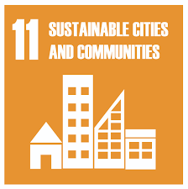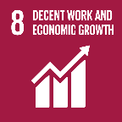 | 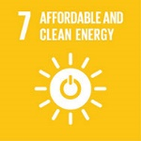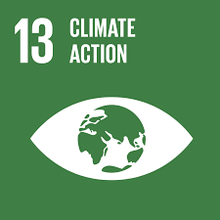 | 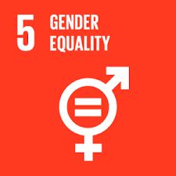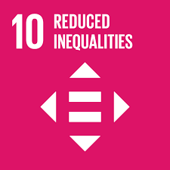 | 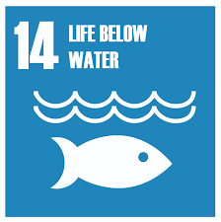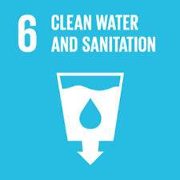 | 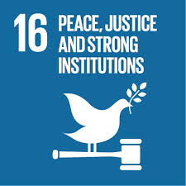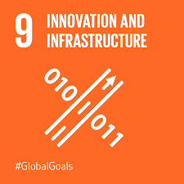
SMSC opportunities

PSHE/ P4C | Families and people who care for me | Caring friendships | Respectful relationships | Mental wellbeing | Being safe | Online relationships
Themed weeks | Well being week / transition / new starts | Anti Bullying Week  World Hello Day  Routes to Food workshop | Chinese new year |  | KS1 & KS2 SATs weeks  Sports day | Move up morning - transition

