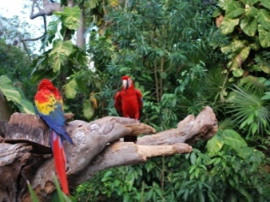 Welbourn Primary School home learning 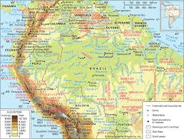
‘Believe, Excite, Succeed, Together’
Summer Term 2 Week 4 The Amazing Amazon!
During the course of the week, we would like you to complete the following learning. We understand that this is a very difficult time for us all and that some children will struggle to engage with learning at times. This learning is for your child to complete at your own pace, if you wish to do more, you can access learning on our school website, on your class page via the padlets.
Moonstone Class Week 4 Summer Term 3
9.00 – 9.30 P.E daily P.E lessons:
Joe wicks: https://www.youtube.com/playlist?list=PLyCLoPd4VxBvQafyve889qVcPxYEjdSTl
or dance moves with JumpStart Johnny https://www.youtube.com/channel/UC8PDFwCV0HHcl08-1SzdiBw
or Strictly Come Dancing’s Oti Mabuse https://www.youtube.com/channel/UC58aowNEXHHnflR_5YTtP4g
or Cosmic Kids Yoga https://www.cosmickids.com

Maths:  Daily maths lessons can be found at: https://whiterosemaths.com/homelearning/year-5/ Week 9  https://whiterosemaths.com/homelearning/year-6/ Week 9 Worksheets attached  Please use your maths text books and then if you require any further work use the whiterose maths sheets.  Keep up with TT Rockstars – see if you are able to improve your Rockstar status!  Challenge: Have a go at some of the maths challenges from Third Space Learning or using Iseemaths.  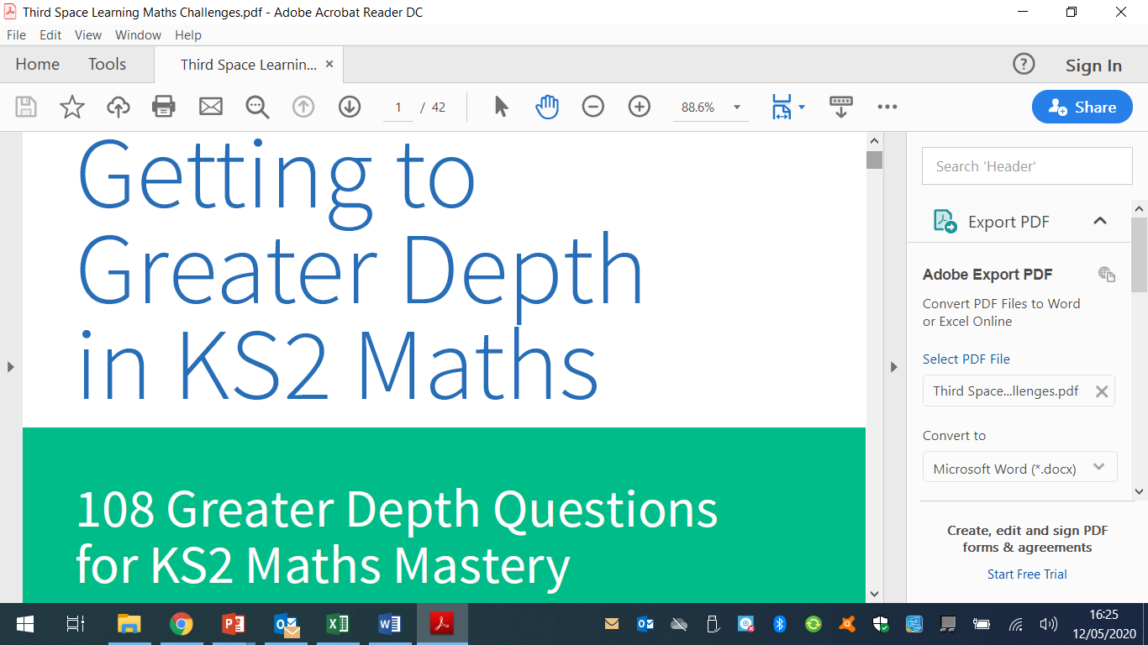 | Reading:  Task 1 – Read Chapter 4 The River – The Explorer (ebook on padlet)  Task 2 – Look up any vocabulary you are unsure of and find out the meaning.  Task 3 – Complete the reading comprehension on padlet |  |  | Writing:  Task 1 – This term we are going to be looking at persuasive writing. I would like you to complete this lesson on Oak National Academy using this link https://classroom.thenational.academy/lessons/persuasive-letter-reading-comprehension-inference/activities/1  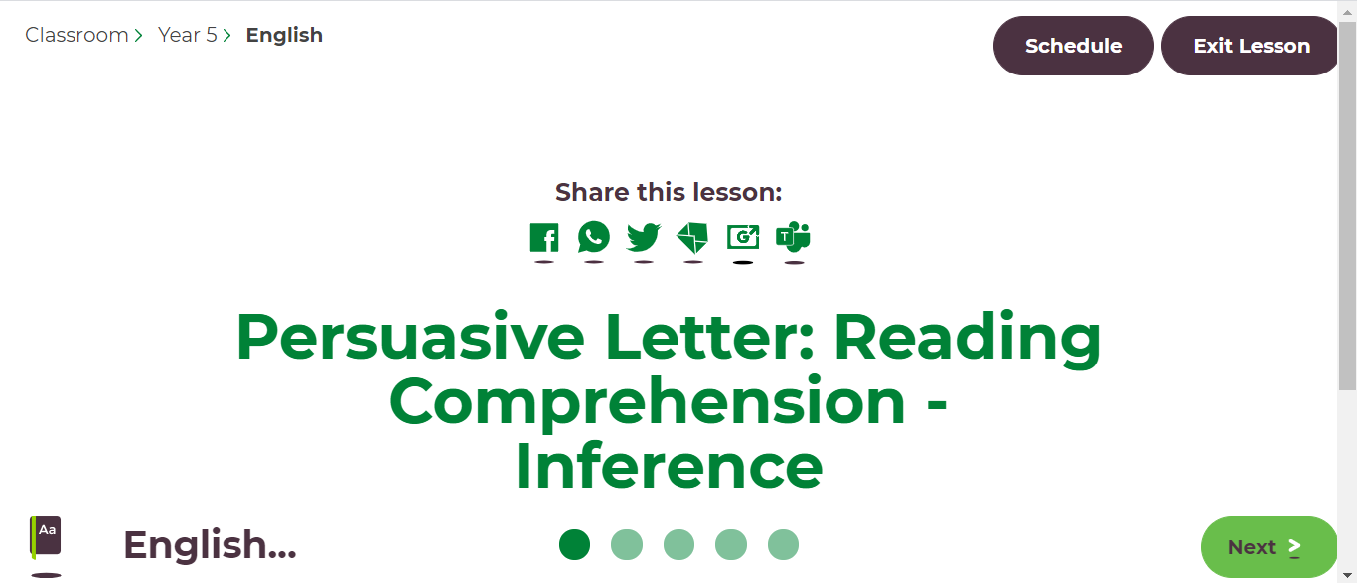  I would like you to watch the lesson and complete the activities as you go along. Although this is a reading comprehension, it is important for you to make the links when doing persuasive writing.  Task 2 – Now I would like you to complete the lesson on word meaning. https://classroom.thenational.academy/lessons/persuasive-letter-reading-comprehension-word-meaning  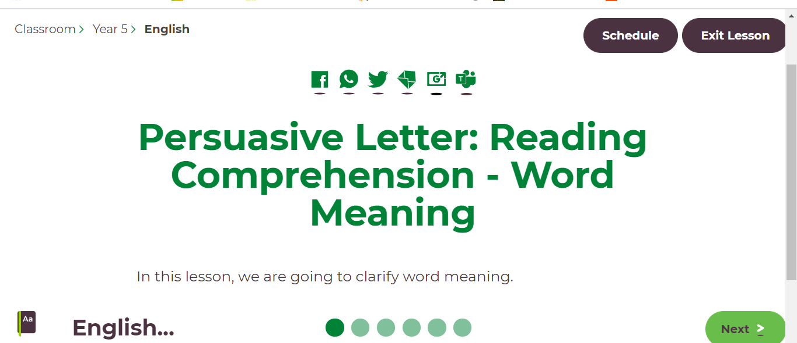  It is important that you complete these tasks as we will be doing a whole class activity via teams in a couple of weeks.
Spellings to learn this week, synonyms and antonyms: deafening, piercing, blaring, ear-piercing, raucous, silent, tranquil, inaudible, unobtrusive, peaceful
Topic – Amazon Rainforest  Geography  Task 1 – Learn all about the devastating effects of deforestation of the Amazon Rainforest. You can watch the following video link and then look through the power point on our class padlet. https://www.youtube.com/watch?v=Ic-J6hcSKa8  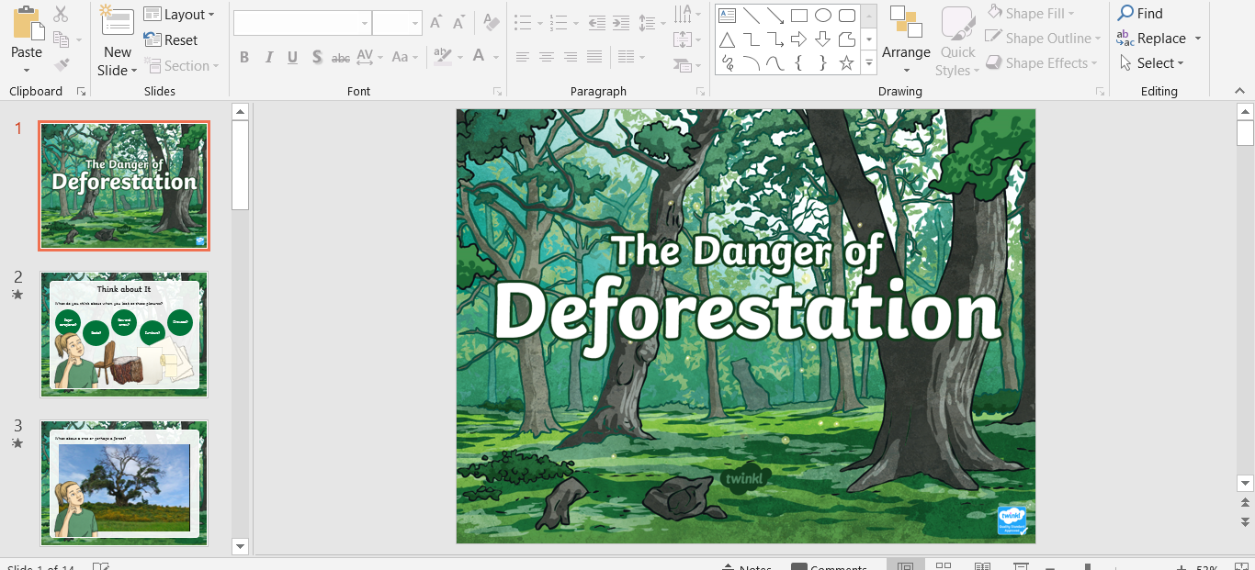  Task 2 - Once you have done this I would like you to research the effects of deforestation and the effect it is having on the rest of the world.  Task 3 – complete the activity sheets available on our class padlet.  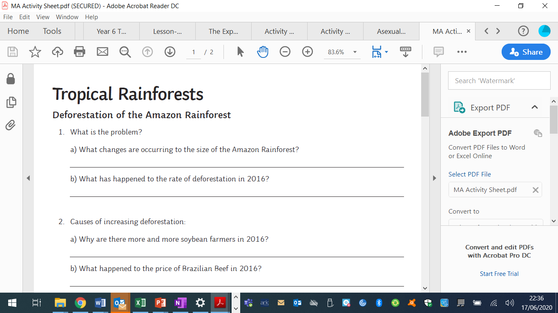 |  | Art / D.T  Task -Have a look at this link https://www.youtube.com/watch?v=0hG-mgQPess  Task 2 – I would like you to create your very own rainforest landscape collage. You can use different leaves, different textured materials, tissue paper. Anything you can find. Be as creative as your mind allows. | Music  https://www.bbc.co.uk/bitesize/topics/zcbkcj6/articles/z3x6msg  Learn all about the structure of music in this lesson on BBC Bitesize on the link above  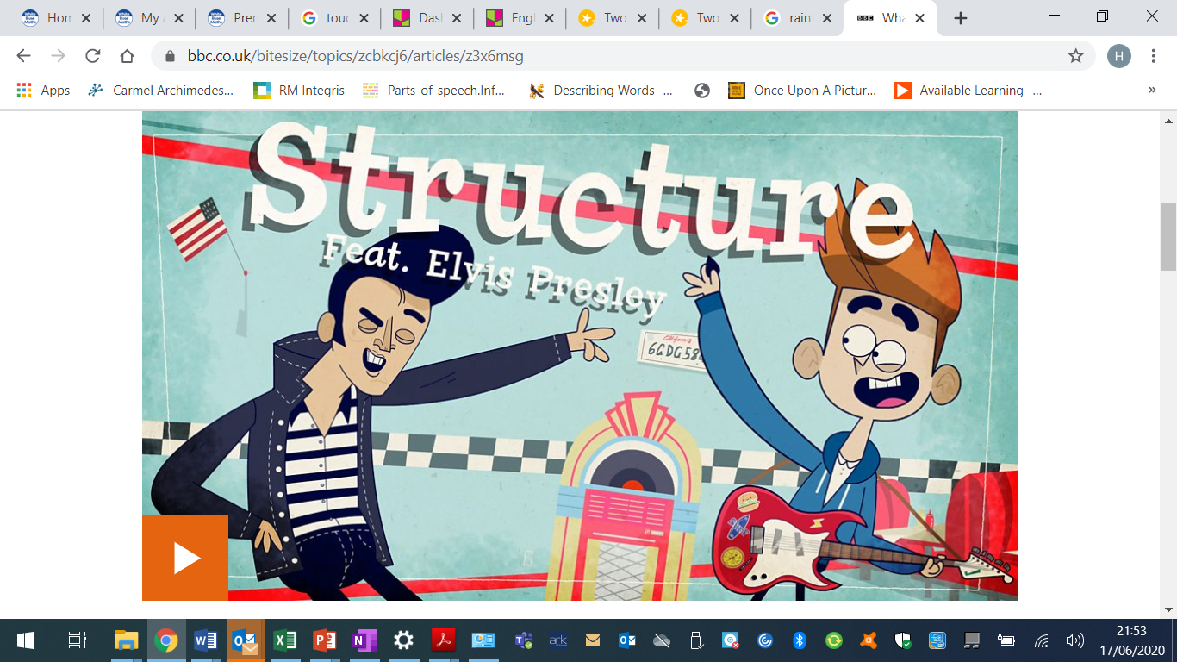  https://www.incredibox.com  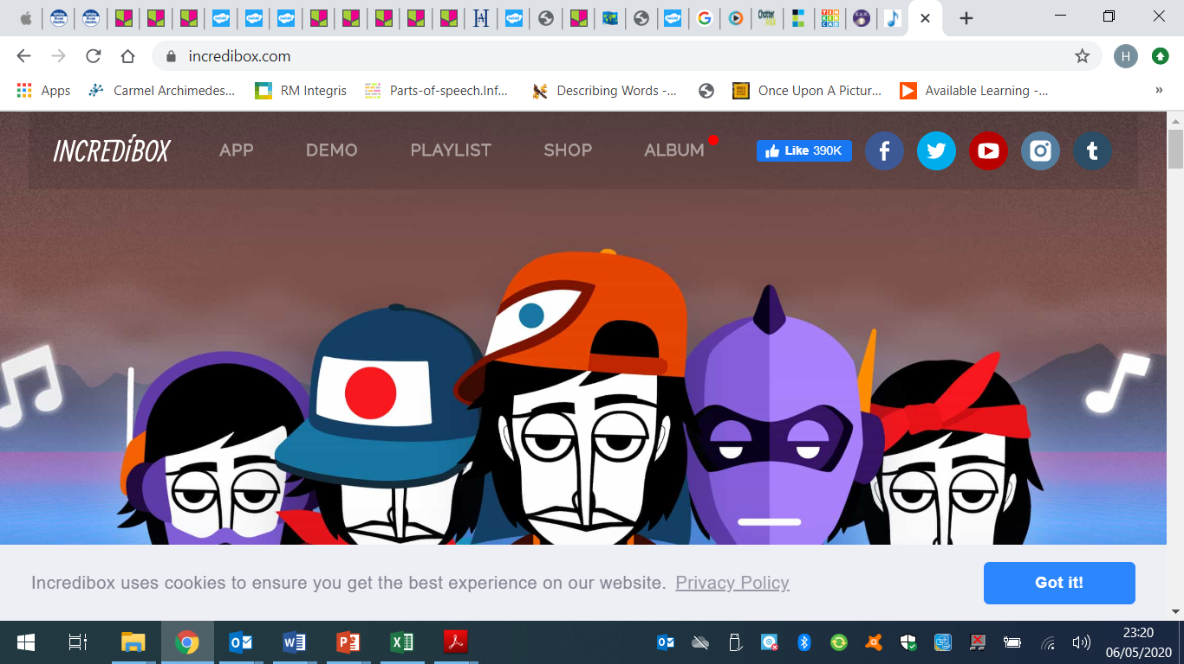 |  | Science – Animals including humans – Human Timeline  Task 1 - Look through the following power point.  Task 2 – Complete the 3 worksheets attached or on our class padlet.  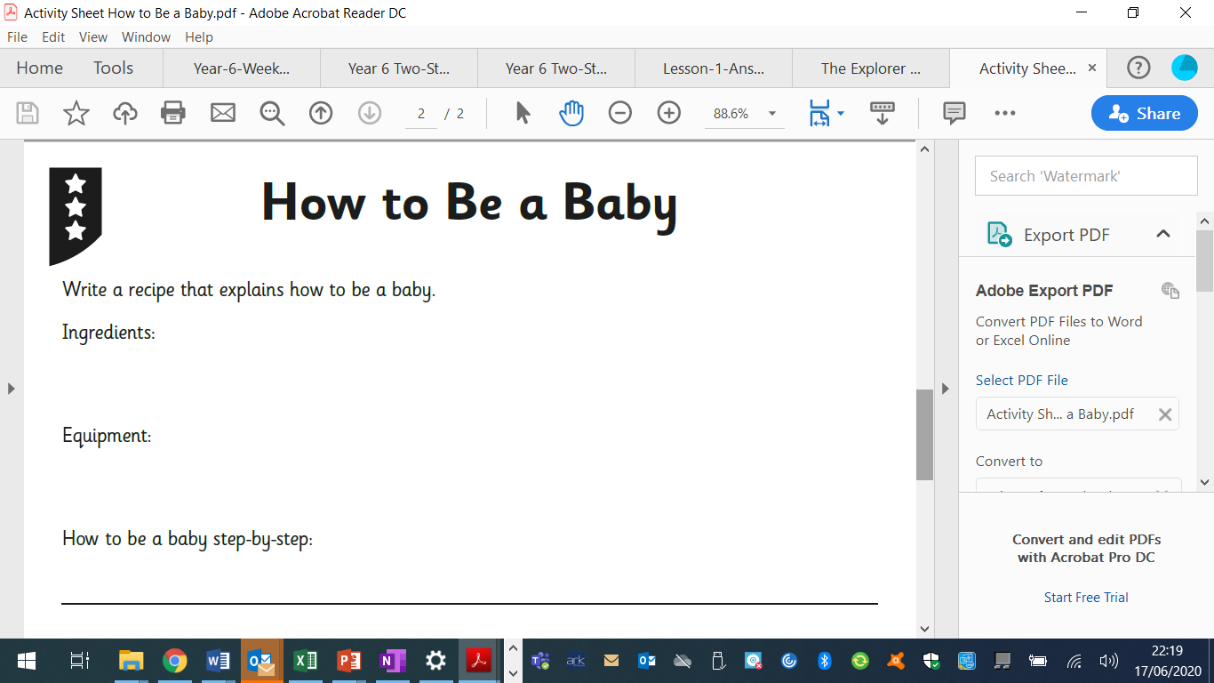  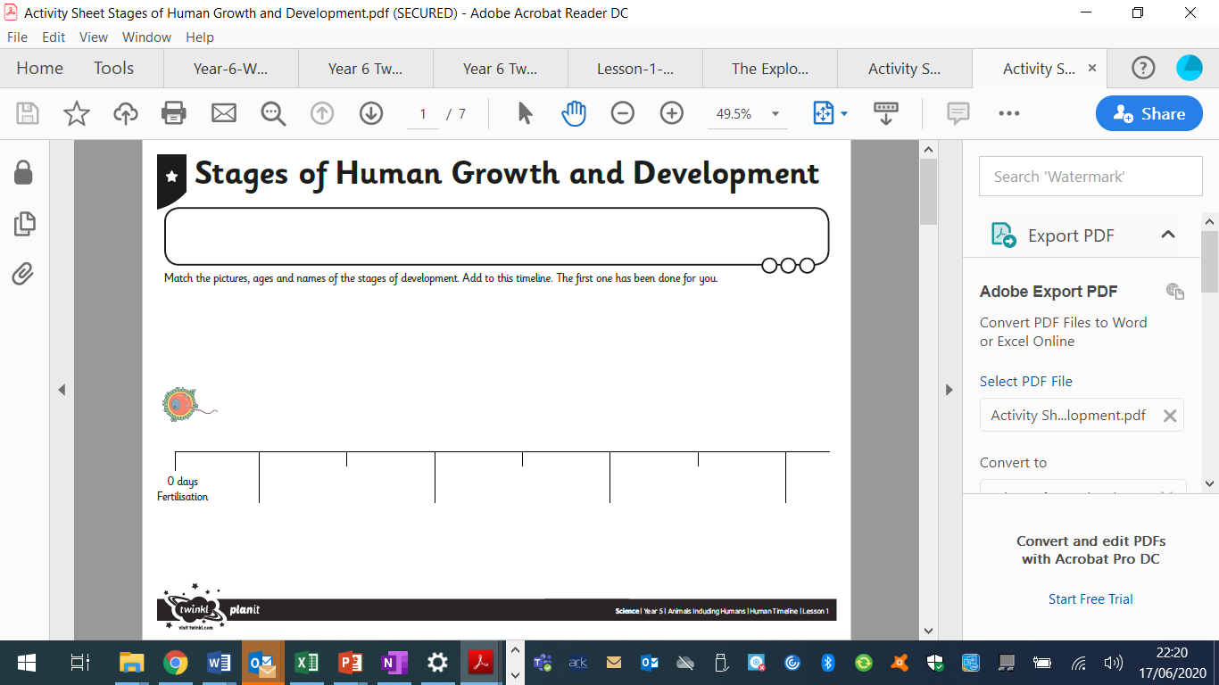  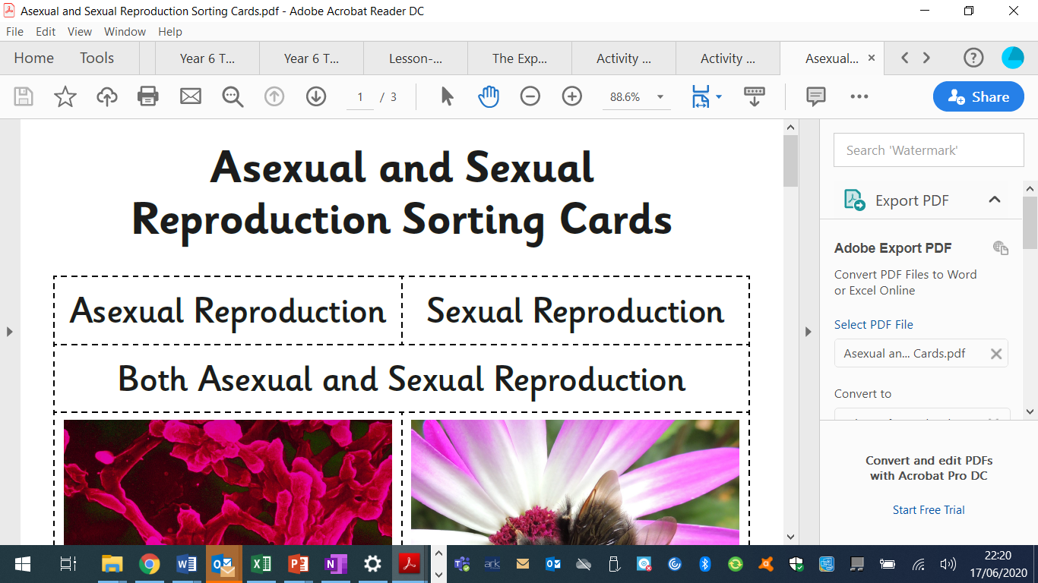 | I.T.  Have a go at some more coding activities this week. You can find the link here. Use the lesson and workbook to complete the activities.  https://learn-programming-with-icompute.now.sh/lessons/1.1Making%20Moves/making-moves
PSHE –  I would like you Talk (or write) about a time when you had to do something difficult and you got through it. Explore how you felt beforehand and how you overcame the challenge. Think about which character strengths you used to help you. |  |  | French: You can access French learning here: https://www.duolingo.com, it is free to join,  you can take a small test first to see how much you know before moving on.  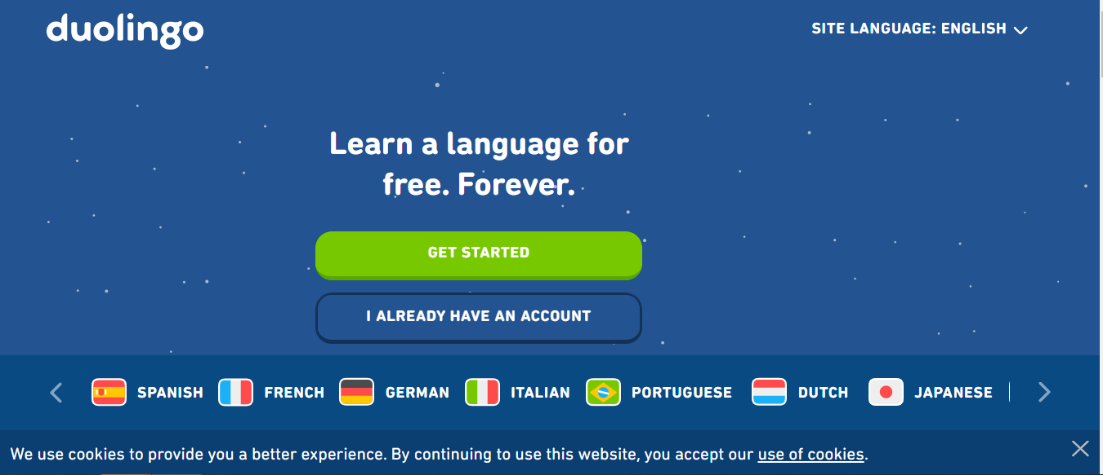  Have a go at this French lesson on BBC Bitesize https://www.bbc.co.uk/teach/school-radio/french-ks2-radio-labo-9-ecole/zv7k382  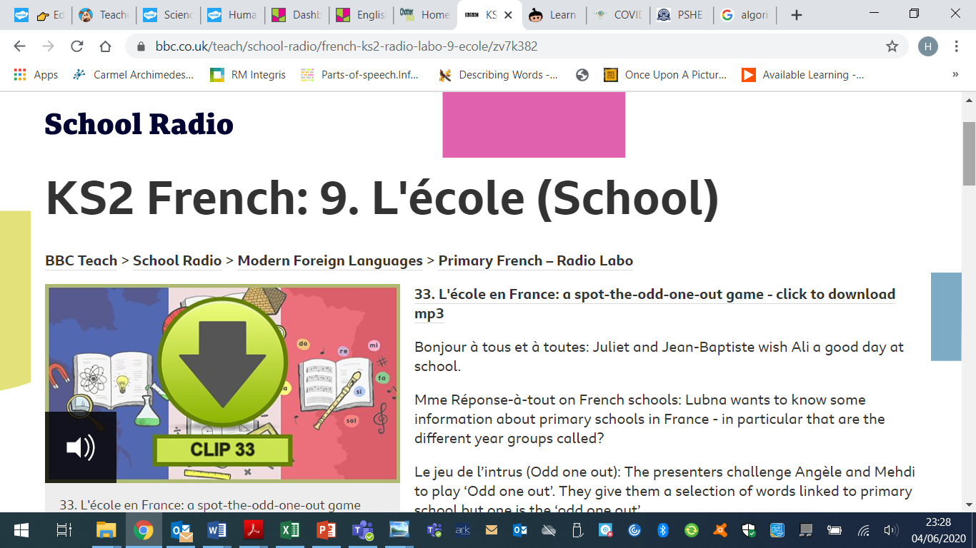  If you fancy something different, try some  French games here: https://www.frenchgamesnet  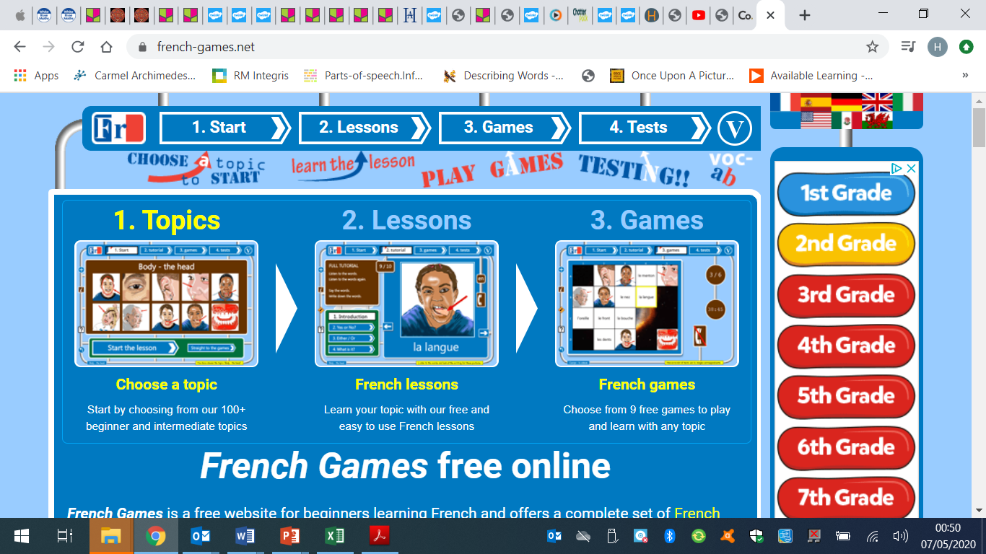

Week 3 - Moonstone Timetable for Microsoft Teams

09:00 Each morning a task will be set for pupils to complete. Each Monday I will post assignments due for that week which the children will be notified of when they sign in.

14:00 Available for messaging each day

On a Friday we will have a live video with the whole class – Please message any ideas for this week.

This week the assignments due in will be art work due in Wednesday
Science work due in Thursday

