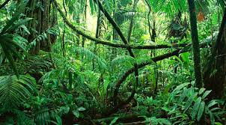 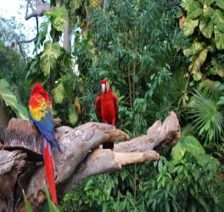 Welbourn Primary School home learning 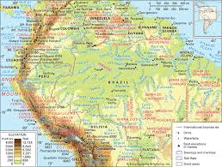 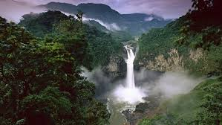
‘Believe, Excite, Succeed, Together’
Summer Term Week 5 The Amazing Amazon!
During the course of the week, we would like you to complete the following learning. We understand that this is a very difficult time for us all and that some children will struggle to engage with learning at times. This learning is for your child to complete at your own pace, if you wish to do more, you can access learning on our school website, on your class page via the padlets.
Moonstone Class Week 1 Summer Term 2
9.00 – 9.30 P.E daily P.E lessons:
Joe wicks: https://www.youtube.com/playlist?list=PLyCLoPd4VxBvQafyve889qVcPxYEjdSTl
or dance moves with JumpStart Johnny https://www.youtube.com/channel/UC8PDFwCV0HHcl08-1SzdiBw
or Strictly Come Dancing’s Oti Mabuse https://www.youtube.com/channel/UC58aowNEXHHnflR_5YTtP4g
or Cosmic Kids Yoga https://www.cosmickids.com

Maths:  Daily maths lessons can be found at: https://whiterosemaths.com/homelearning/year-5/ Week 5  https://whiterosemaths.com/homelearning/year-6/ Week 5 Worksheets attached  Keep up with TT Rockstars – see if you are able to improve your Rockstar status!  Challenge: Have a go at some of the maths challenges from Third Space Learning. It does say year 6, but Year 5’s will be able to access too. I have attached them for you.  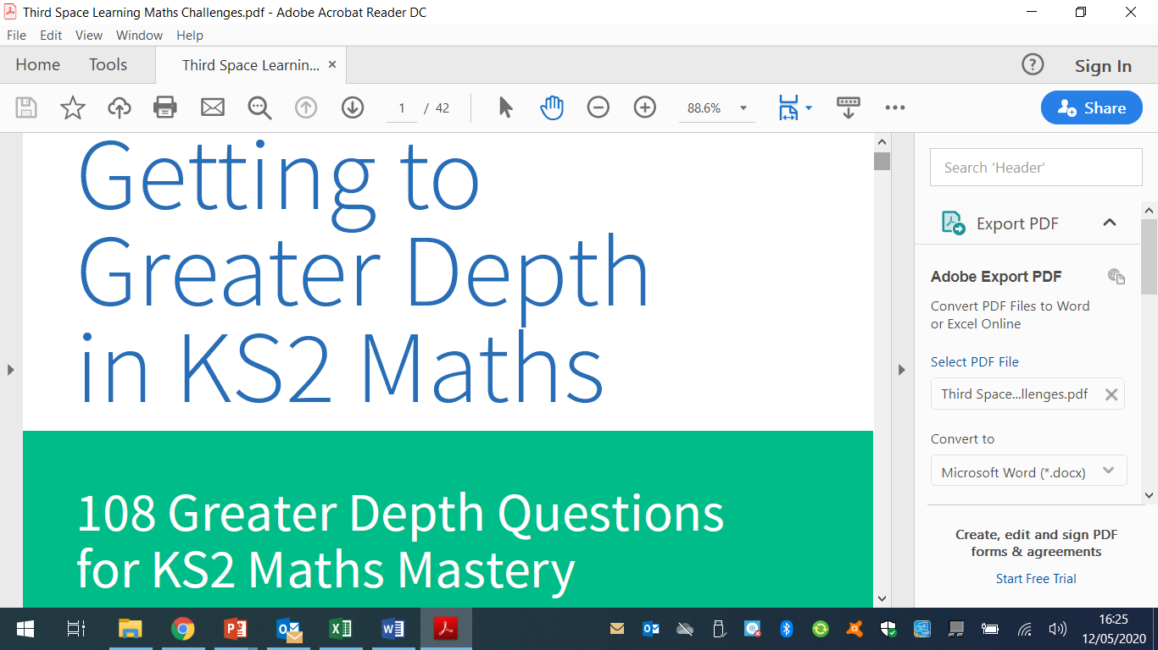 | Reading:  Task 1 – Read Chapter 1 – Flight of Explorer (ebook on padlet)  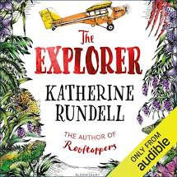  Task 2 – Look up any vocabulary you are unsure of and find out the meaning.  Task 3 – Complete the reading comprehension on padlet |  |  | Writing:  Task 1 – Watch Pandora https://vimeo.com/193963379  What information have you found out when you’ve watched this? Use the Information boxes to complete this task ( This is on our class padlet)  Task 2 – From the facts that you have written down about Pandora, choose 6-8 of these which you think are important to add into the introduction to the planet. E.g. It is located in Alpha Centauri, 4.4 light years from Earth, Pandora orbits Polyphemus, it has a toxic atmosphere. You need create a paragraph about the planet/moon Pandora. Use resource sheets 1a and 1b on our class padlet to help you.
Spellings to learn this week, words ending in -ible: possible, horrible, terrible, visible, incredible, sensible, forcible, legible, responsible, reversible
Topic – Amazon Rainforest  Geography  Task 1 – Read the rainforest fact sheet (on padlet). Locate the Amazon Rainforest using the world map provided http://www.mapsnworld.com/worldmap_kids.html  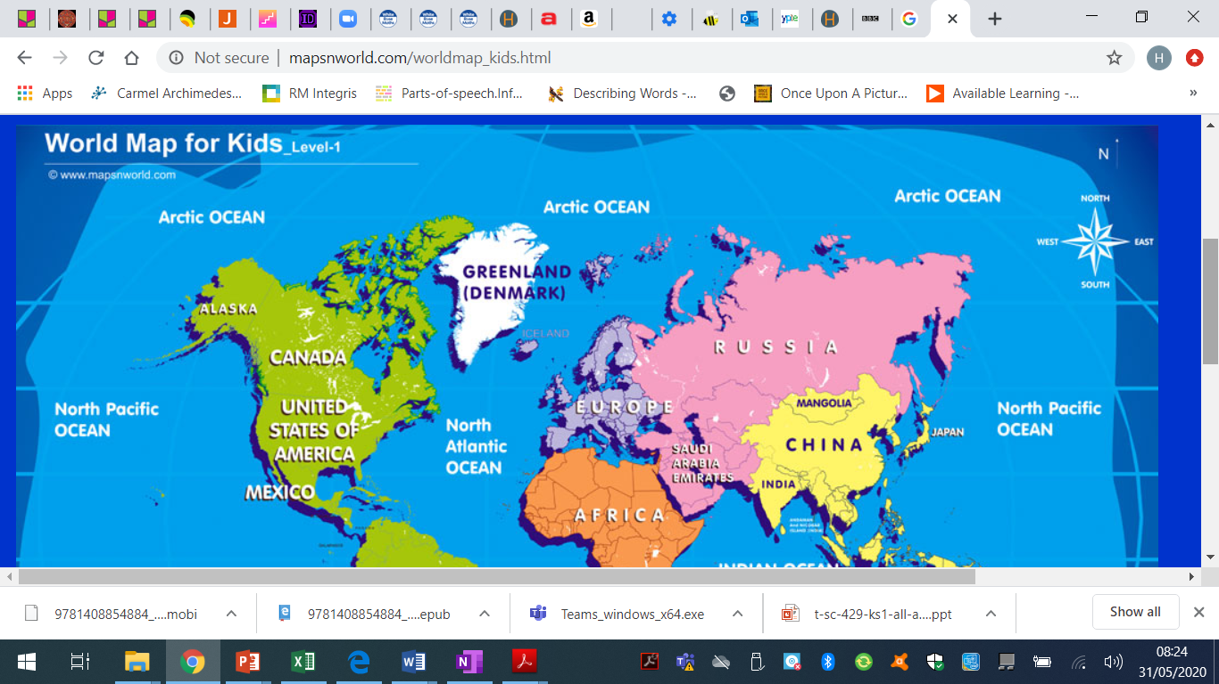  Task 2 – Use the following links to create a fact file all about the Amazon Rainforest.  https://www.bbc.co.uk/bitesize/articles/zvvmjhv  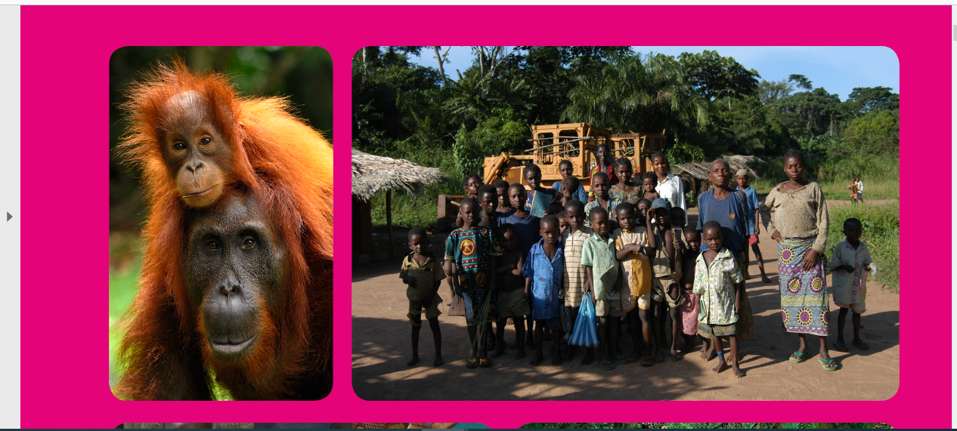  Task 3 – What is meant by the term climate? Compare the climate of the rainforest to the UK? Create a graph to show the differences. https://www.internetgeography.net/topics/what-is-the-climate-of-the-rainforest/ |  | Art / D.T  Have a go at creating a geometric chameleon.  Use the template provided (also on our class padlet) This link is useful for directions and zetangle designs https://thecraftyclassroom.com/chameleon-zentangle-art-project-for-kids/  You can also create any other animal that can be found in the rainforest. | Music  Look through the following power point. Can you create any rainforest sounds?  https://www.incredibox.com  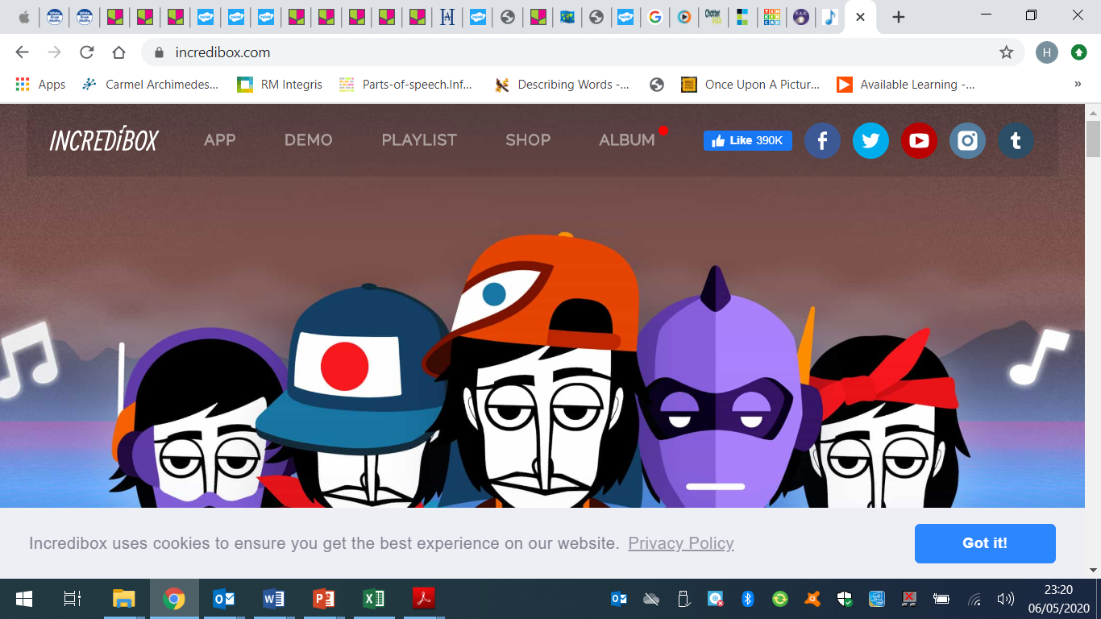 |  | Science – Animals including humans  Task 1 – Look through the following power point  Task 2 - Describe the ways in which nutrients and water are transported within animals, including humans.  Task 3 – Label the small intestine, the large intestine and the urinary system (these are all on our class padlet) | I.T.  How do search engines work?  Do you ever wonder how search engines like google actually work? As schools, homes and businesses all rely on the internet, how do we find what we are looking for? Have a look at this link which will explain how search engines work. https://www.bbc.co.uk/bitesize/topics/zs7s4wx/articles/ztbjq6f  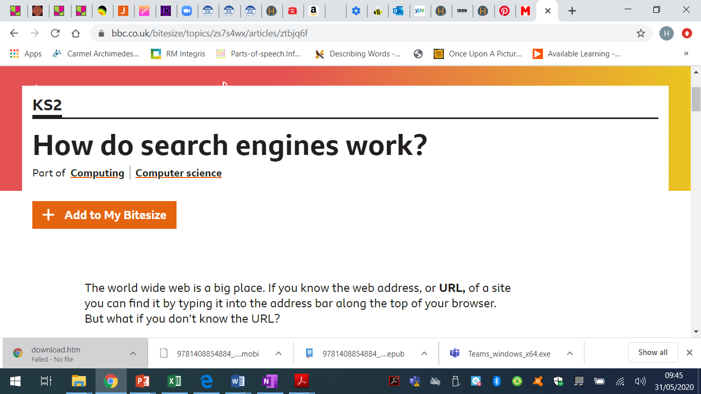  Task 2 – I will be putting a class quiz on Friday on Microsoft Teams about facts on the Amazon Rainforest. How many can you get right? Don’t forget to complete it. You will have until 3pm to get your answers in.
PSHE & Well-being  Do you have worries or anxiety about things that you feel are out of your control? Mrs Kinton has put together a great resource to help you overcome these worries, no matter how small you think they are.  Task: Complete the following to help you overcome your worries (This is on our class padlet) |  |  | French: You can access French learning here: https://www.duolingo.com, it is free to join,  you can take a small test first to see how much you know before moving on.  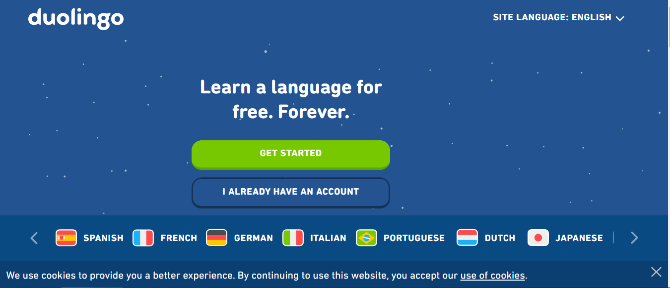  If you fancy something different, try some  French games here: https://www.frenchgamesnet  