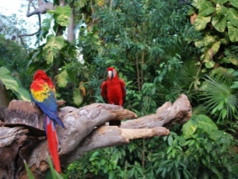 Welbourn Primary School home learning 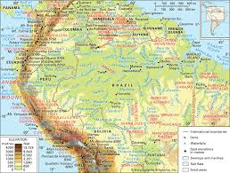
‘Believe, Excite, Succeed, Together’
Summer Term 2 Week 5 The Amazing Amazon!
During the course of the week, we would like you to complete the following learning. We understand that this is a very difficult time for us all and that some children will struggle to engage with learning at times. This learning is for your child to complete at your own pace, if you wish to do more, you can access learning on our school website, on your class page via the padlets.
Moonstone Class Week 5 Summer Term 3
9.00 – 9.30 P.E daily P.E lessons:
Joe wicks: https://www.youtube.com/playlist?list=PLyCLoPd4VxBvQafyve889qVcPxYEjdSTl
or dance moves with JumpStart Johnny https://www.youtube.com/channel/UC8PDFwCV0HHcl08-1SzdiBw
or Strictly Come Dancing’s Oti Mabuse https://www.youtube.com/channel/UC58aowNEXHHnflR_5YTtP4g
or Cosmic Kids Yoga https://www.cosmickids.com
Why not have a go at some home learning P.E Challenges 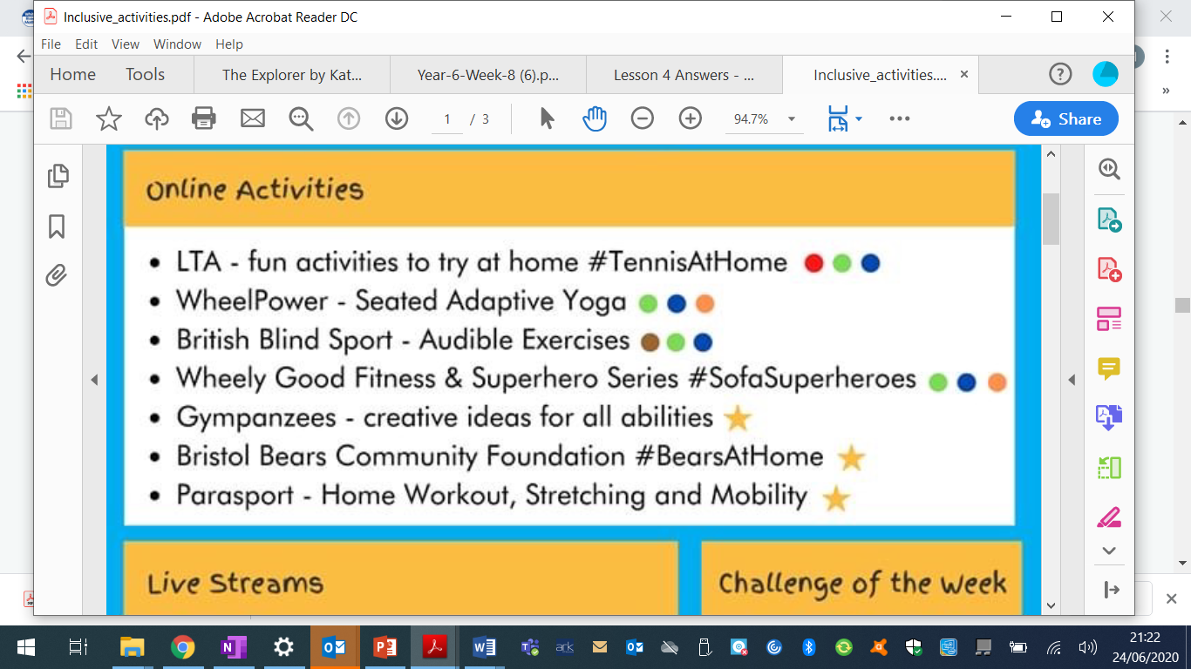 See our class padlet for details.
Maths:  Daily maths lessons can be found at: https://whiterosemaths.com/homelearning/year-5/ Week 10  https://whiterosemaths.com/homelearning/year-6/ Week 10 Worksheets attached  Please use your maths text books and then if you require any further work use the whiterose maths sheets.  Keep up with TT Rockstars – see if you are able to improve your Rockstar status!  Challenge: Have a go at some of the maths challenges from Third Space Learning or using Iseemaths.  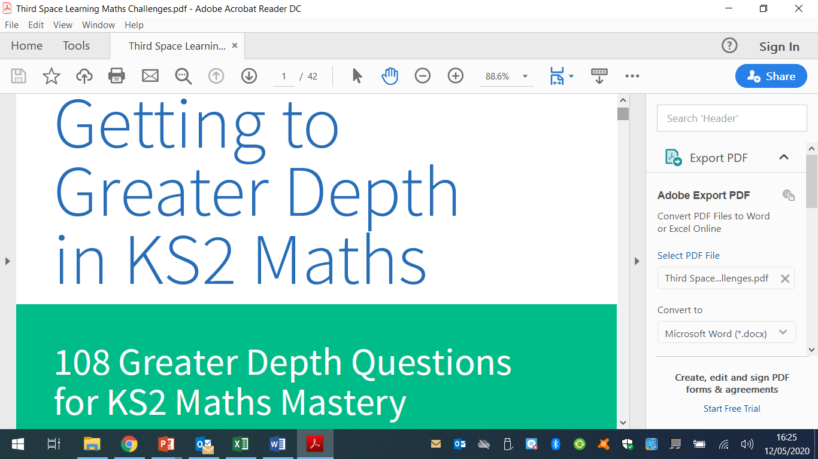  For those wanting extra maths challenges have a go at these https://www.firstmaths.com/mental-maths/fun-lockdown-maths-lessons/year-6-maths/free-year-6-maths-challenges-ks2-fun-teaching-resources/ | Reading:  Task 1 – Read Chapter 5 Food (almost)  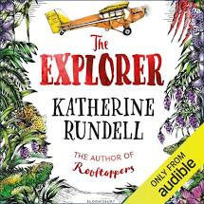  Task 2 – Look up any vocabulary you are unsure of and find out the meaning.  Task 3 – Complete the reading comprehension on padlet  Task 4 – Listen to Chapter 1 of The Great Kapok Tree  Task 5 – I would like you to write a couple of paragraphs about what is similar in this story compared to The Explorer and what is different. This is to include characters, setting and the story itself. |  |  | Writing:  Task 1 – Following on from last week, I would like you to look at the link below to identify the features of persuasive letter.  https://classroom.thenational.academy/lessons/persuasive-letter-identifying-the-features-of-a-text  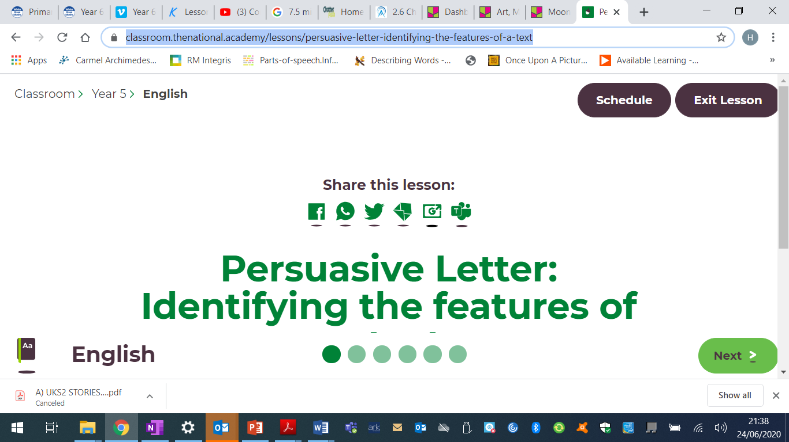  Task 2 – I would like you to write a letter to Parliament explaining why you think schools should fully open to all pupils or not (if you disagree). I would like you to use all the features you have learned so far.  Task 3 – Can you create an advert using persuasive writing to persuade people to either buy something of your choice, or to stop the destruction of the rainforest to protect the animals and wildlife and their habitats.
Spellings to learn this week, synonyms and antonyms: scorching, searing, sizzling, blistering, sweltering, chilling, frozen, artic, bitter, wintry
Topic – Amazon Rainforest  Geography  Task 1 – Look at the fact sheet about the invisible rivers of the rainforest.  Task 2 - I would like you to explain the following:-  - What is the water cycle?  - Why is rain important especially for the rainforest  - Is rain the same everywhere?  - What effect does light, air water and temperature have on plant growth?  - What role does condensation and evaporation have on the water cycle?  You can present this any way you wish, should it be a power point, video, or word document or even handwritten.  To find out more information on the water cycle take a look at this link:  https://www.metoffice.gov.uk/education/teachers/key-stage2 |  | Art / D.T  Task -This week I would like you to design a dart frog. Have a look at the design pdf (on our class padlet) and design your dart frog  Task 2 –Once you have designed your dart frog use the template and instructions to create your very own dart frog bean bag. (The pdf is on our class padlet | Music  Task – I would like you to do this lesson from musicteacher http://www.musictechteacher.com/music_lessons/garrett_music_tech_lesson_03_04_instrument_families.htm  It will learn all about the instrument families.  Once you have completed the lesson have a go at the quiz |  | Science – Animals including humans – Changes in old age  Read through the following power point  Task 2 – Complete the fact sheet reading comprehension on Facts about old age | I.T.  Task 1 – Get creative with digital making at home.  Task 1 – Using the link below have a go at some virtual sports https://www.raspberrypi.org/at-home/posts/do-virtual-sports-with-us/  Task 2 – Have a go at making a 3D image  https://www.raspberrypi.org/at-home/posts/lets-make-it-3d/
cPSHE –  This has been a really hard time for us all and we need to remind ourselves of all the positive things going in on in our lives as well as all the positive things around us. Sometimes when we are feeling down it is quite easy to let our negative thoughts take over.  Your task this week is to think of as many positive things in your life as you can using the worksheet on out class padlet.  Task 2 – why not try some mindfulness activity cards. They go through different breathing techniques and ways to relax should you have any worries. |  |  | French: You can access French learning here: https://www.duolingo.com, it is free to join,  you can take a small test first to see how much you know before moving on.  Have a go at this French lesson on BBC Bitesize https://www.bbc.co.uk/teach/school-radio/french-ks2-radio-labo-9-ecole/zv7k382  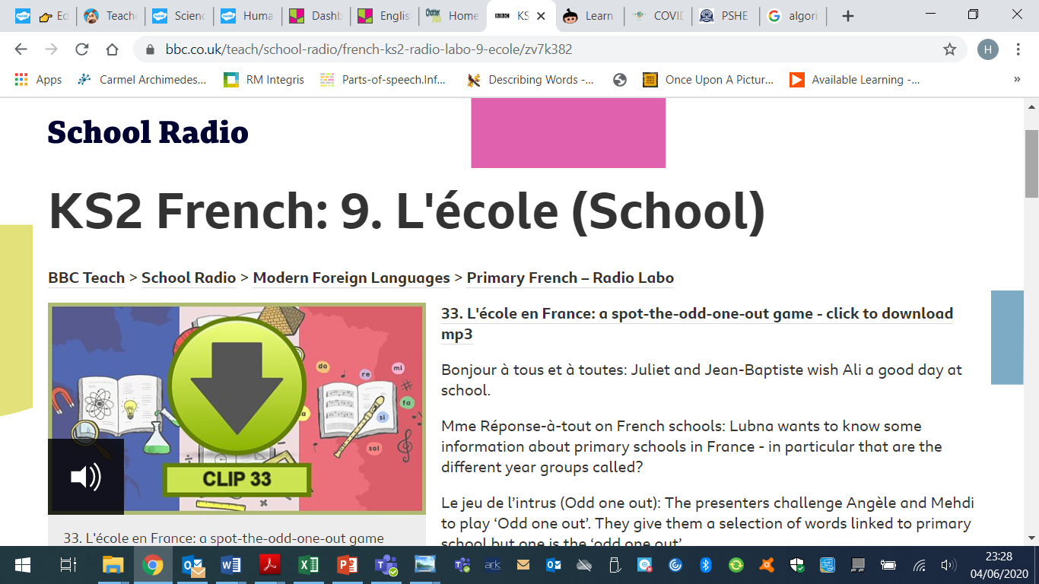  If you fancy something different, try some  French games here: https://www.frenchgamesnet  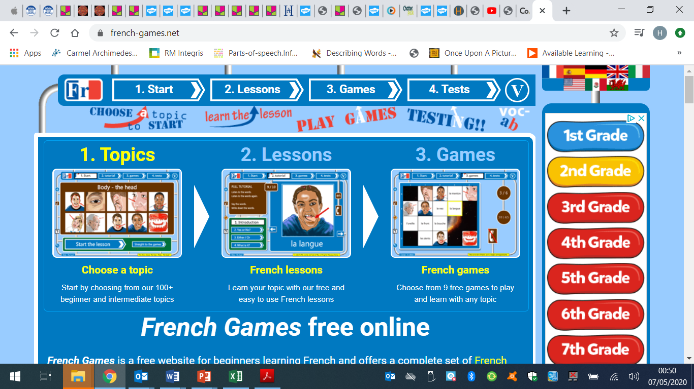

Week 3 - Moonstone Timetable for Microsoft Teams

09:00 Each Monday I will post assignments due for that week which the children will be notified of when they sign in.

14:00 Available for messaging each day

On a Friday we will have a live video with the whole class – Please message any ideas for this week.

This week the assignments due in are:
English on Wednesday
Reading on Thursday

Please feel free to message me if you would like any help or support with anything

