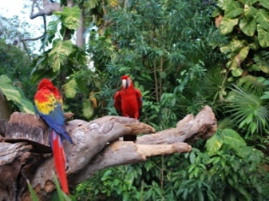 Welbourn Primary School home learning 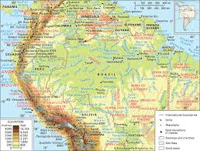
‘Believe, Excite, Succeed, Together’
Summer Term 2 Week 6 The Amazing Amazon!
During the course of the week, we would like you to complete the following learning. We understand that this is a very difficult time for us all and that some children will struggle to engage with learning at times. This learning is for your child to complete at your own pace, if you wish to do more, you can access learning on our school website, on your class page via the padlets.
Moonstone Class Week 6 Summer Term 2
9.00 – 9.30 P.E daily P.E lessons:
Joe wicks: https://www.youtube.com/playlist?list=PLyCLoPd4VxBvQafyve889qVcPxYEjdSTl
or dance moves with JumpStart Johnny https://www.youtube.com/channel/UC8PDFwCV0HHcl08-1SzdiBw
or Strictly Come Dancing’s Oti Mabuse https://www.youtube.com/channel/UC58aowNEXHHnflR_5YTtP4g
or Cosmic Kids Yoga https://www.cosmickids.com
Why not have a go at some home learning P.E Challenges 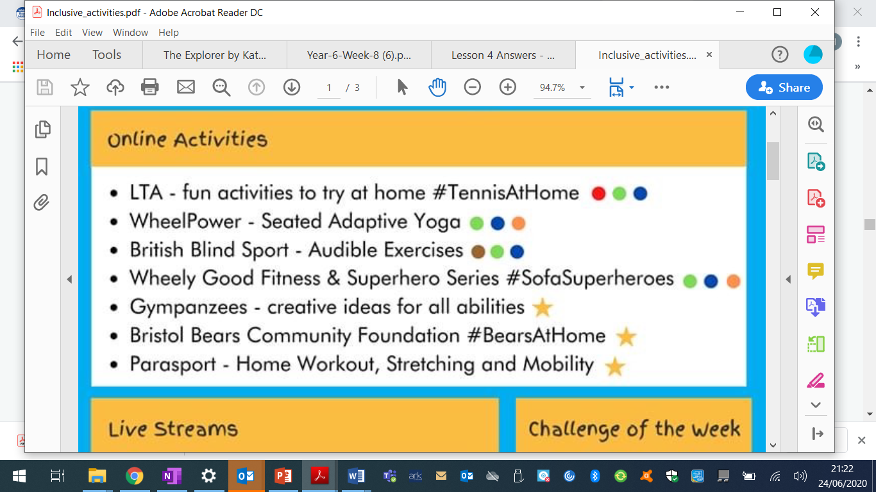 See our class padlet for details.
Maths:  Daily maths lessons can be found at: https://whiterosemaths.com/homelearning/year-5/ Week 10  https://whiterosemaths.com/homelearning/year-6/ Week 10 Worksheets attached  Please use your maths text books and then if you require any further work use the whiterose maths sheets.  Keep up with TT Rockstars – see if you are able to improve your Rockstar status!  Challenge: Have a go at some of the maths challenges from Third Space Learning or using Iseemaths.  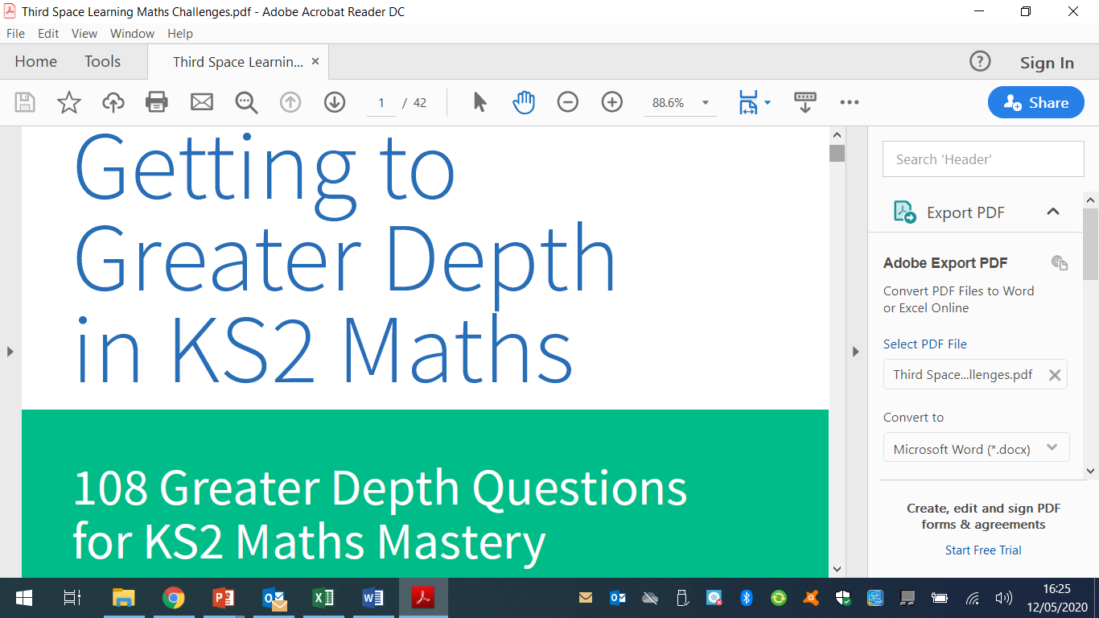  For those wanting extra maths challenges have a go at these https://www.firstmaths.com/mental-maths/fun-lockdown-maths-lessons/year-6-maths/free-year-6-maths-challenges-ks2-fun-teaching-resources/  There are some more maths puzzles and problems using the pdf file which you can find on our class padlet.  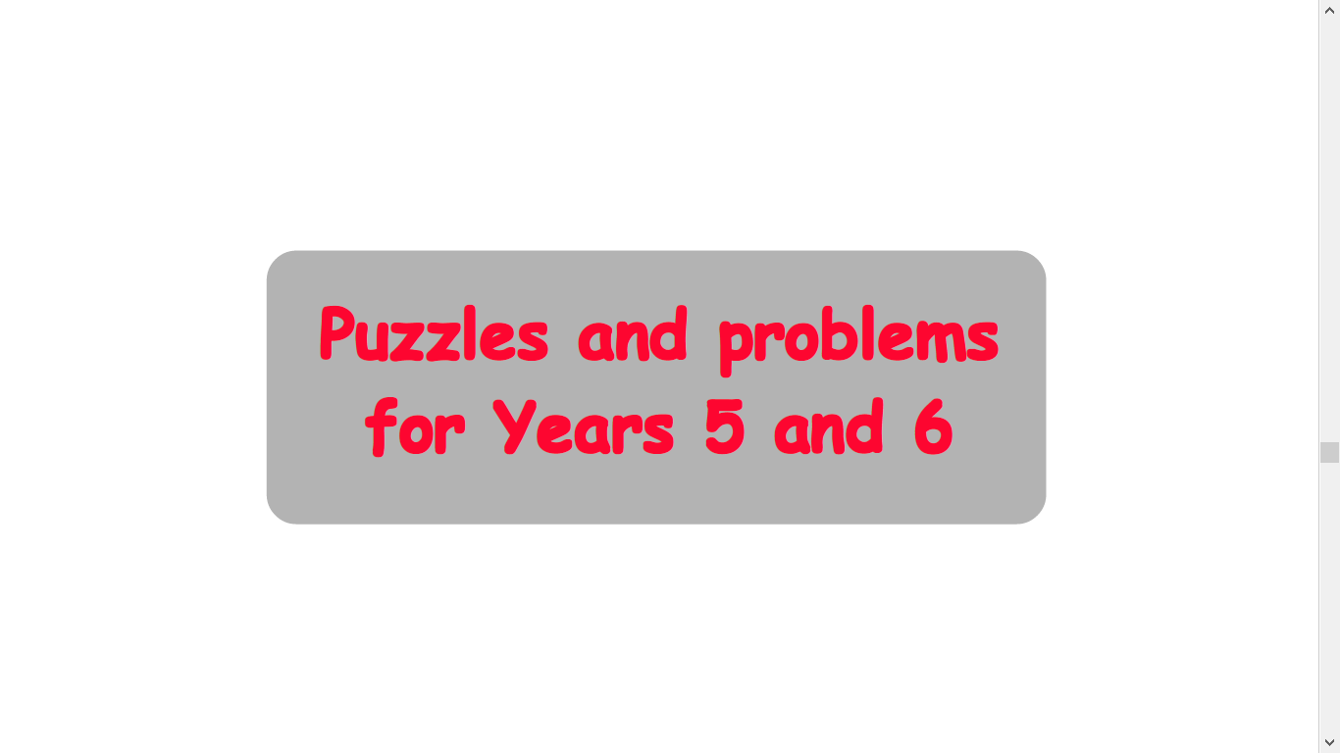 | Reading:  Task 1 – Read Chapter 6 Fire – The ebook can be found under files, class resources on Moonstone Mircrosoft Teams page.  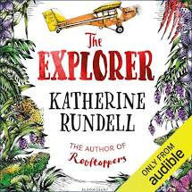  Task 2 – Look up any vocabulary you are unsure of and find out the meaning.  Task 3 – Complete the reading comprehension on our class padlet  Task 4 – I would like you to think about how you would cope if you were stranded in the Amazon. How would you react? What would you do to survive? How would you find food? Feel free to add pictures to your story. |  |  | Writing:  Task 1 – Following on from last week, I would like you to look at the link below to identify the features of persuasive letter.  https://classroom.thenational.academy/lessons/setting-description-spag-focus-parenthesis  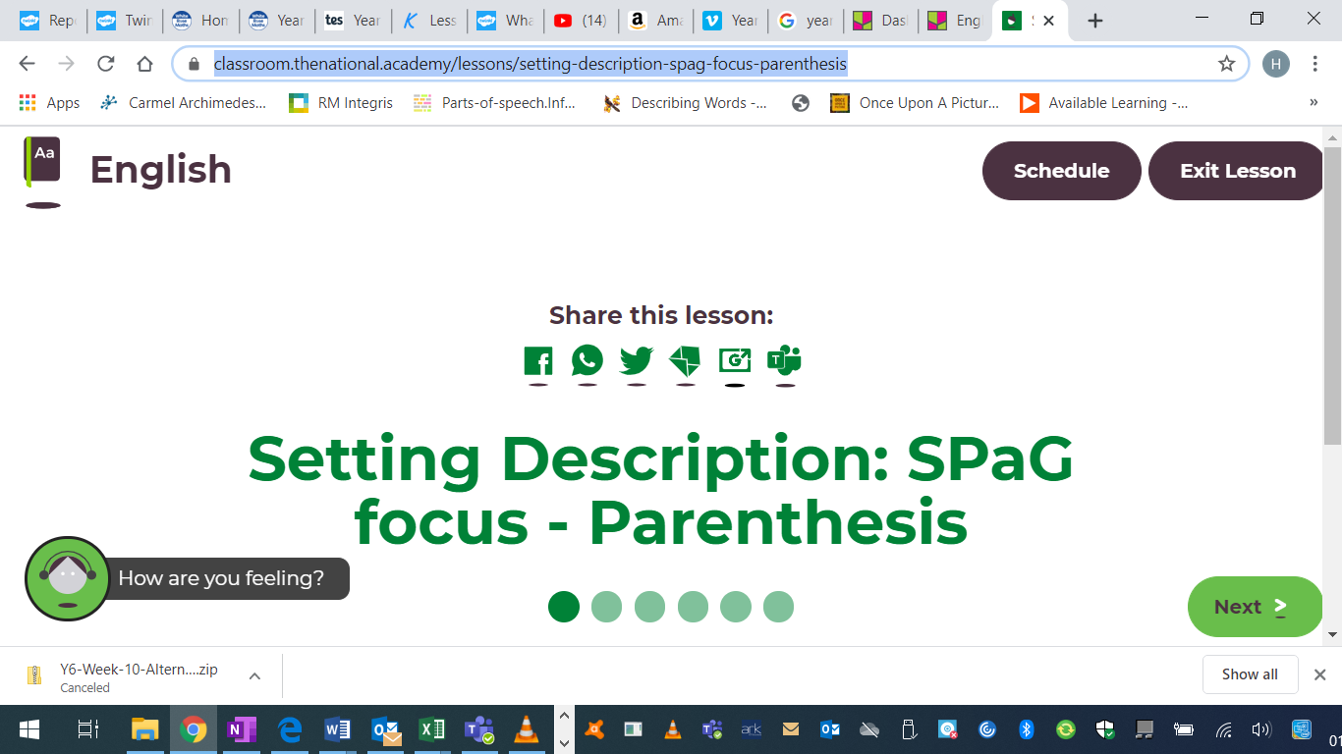  Task 2 – Complete the parenthesis worksheet which is on our class padlet  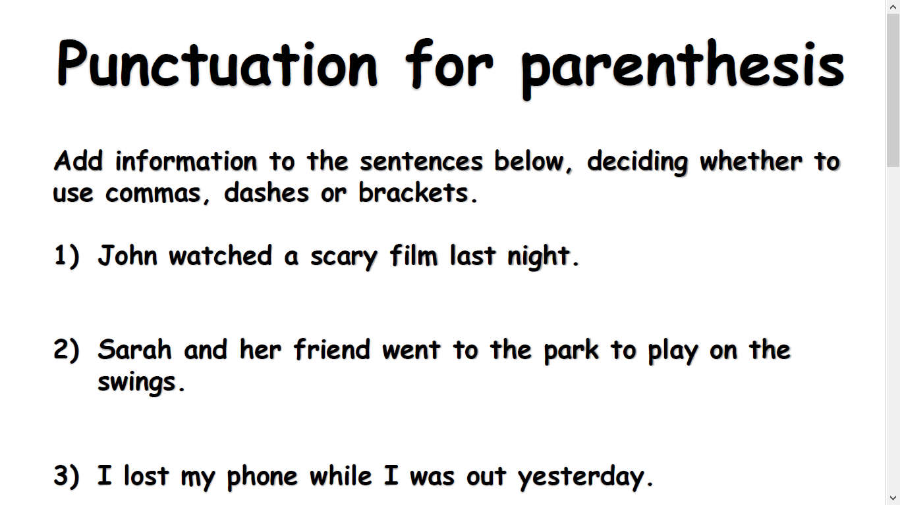  Task 3 – Write at least 5 persuasive sentences using parenthesis
Spellings to learn this week, synonyms and antonyms: ambled, tottered, strolled, staggered, sauntered, sprinted, raced, darted, dashed, galloped
Topic – Amazon Rainforest  Geography  Task 1 – Go through the photos and fact sheet about the Amazon rainforest  Task 2 - I would like you to then complete the following worksheet  Task 3 – I would like you to create a poster being as imaginative as you can to make people aware of the damage to the rainforest and what they can do to help save it. |  | Art / D.T  Task – This week I would like you to try something a little different. Have a go at some blow painting using a straw. What art are you able to create? You can paint anything your heart desires.  For some inspiration check out this link https://www.youtube.com/watch?v=Qi6symhJu0M  Task 2 – As we are approaching the end of the term, I would like you to create a memory box, or a memory tree of all the fun things you have done or achieved. This can be things you have done both inside or outside of school.  Your memory tree can look like this with photos or you can write down what you have done. | Music  Task – I would like you to do this lesson from musicteacher http://www.musictechteacher.com/music_lessons/garrett_music_tech_lesson_18_20_louis_armstrong.htm  Learn all about the music of Louis Armstrong. Use the link above for the lesson  Task 2 -https://www.bbc.co.uk/bitesize/articles/z44x6v4  Have a look at the link above and try out some singing to make you feel happy. |  | Science – Animals including humans – Animal gestation periods  Read through the following power point. This can be found on our class padlet  Task 2 – Complete the worksheet below which can be found on our class padlet.  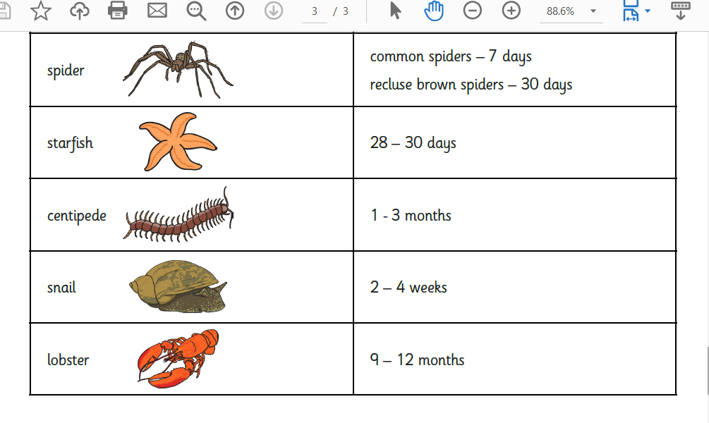  Task 3 - Complete the following worksheet on comparing gestation periods, this can be found on our class padlet.  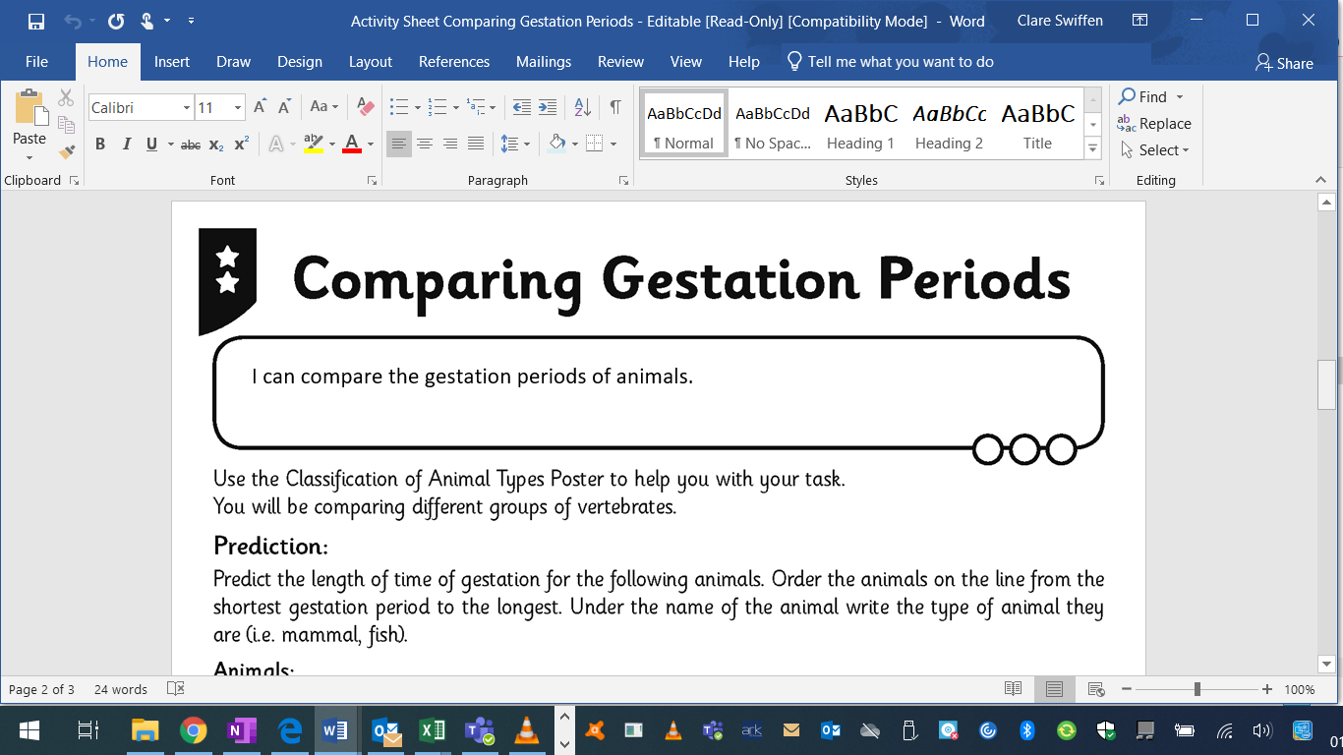  Task 4 – Complete the gestation booklet below this can be found on our class padlet | I.T.  Task 1 – Get creative with digital making at home.  Task 1 – Using the link below have a go at Hamster Party Cam https://projects.raspberrypi.org/en/projects/hamster-party-cam  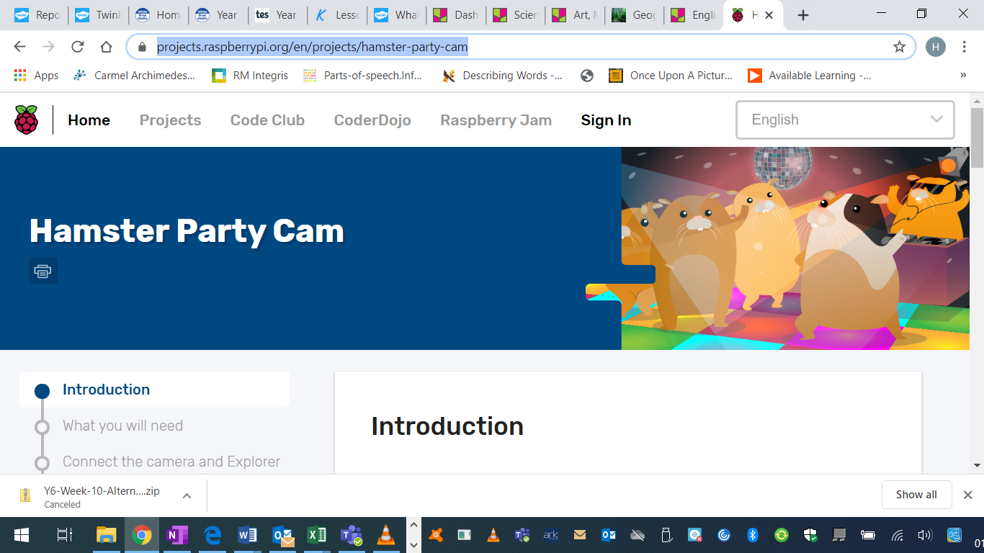  Task 2 – Have a go at creating secret messages.  https://projects.raspberrypi.org/en/projects/secret-messages  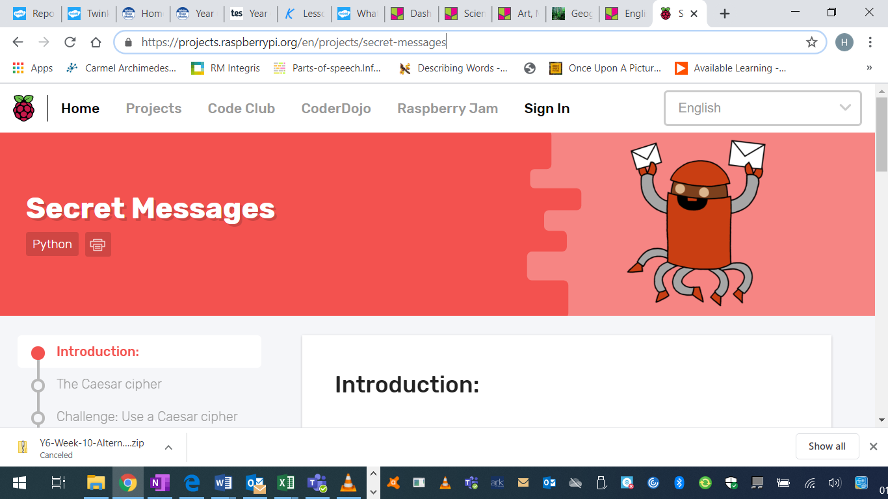
PSHE – This week I would like you to take some time out to relax and do some mindful games. This is to help with any worries, concerns, anxious feelings or to just relax a little. You have survived a piece of history and you all deserve to have some time to self-reflect.  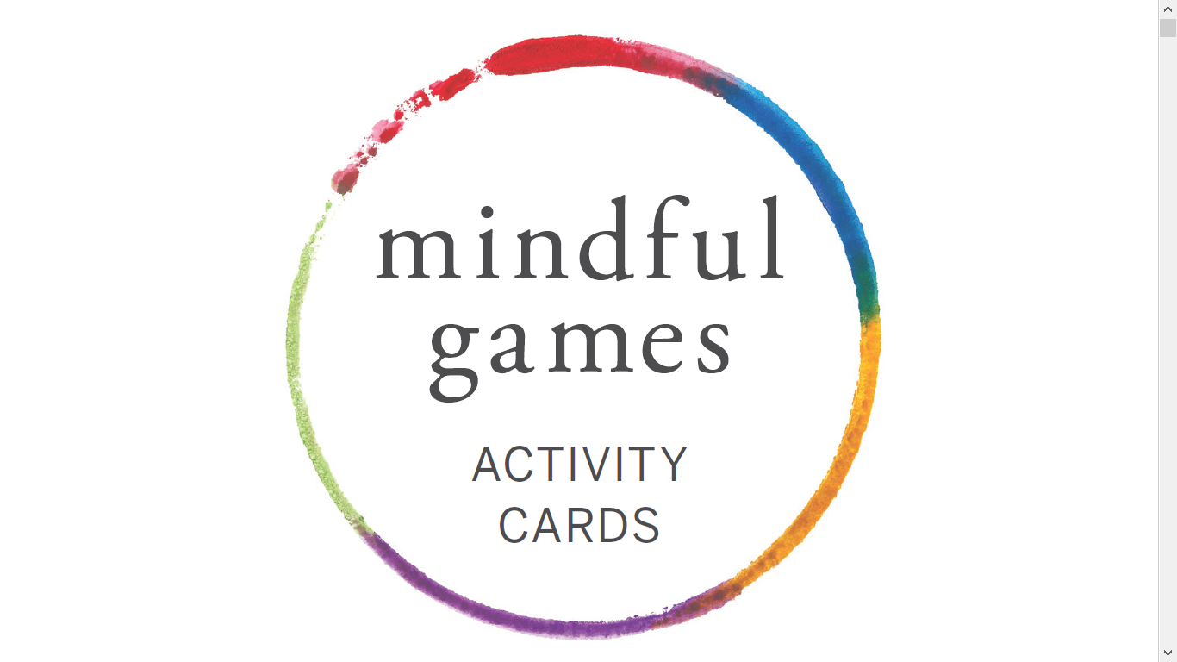 |  |  | French: You can access French learning here: https://www.duolingo.com, it is free to join,  you can take a small test first to see how much you know before moving on.  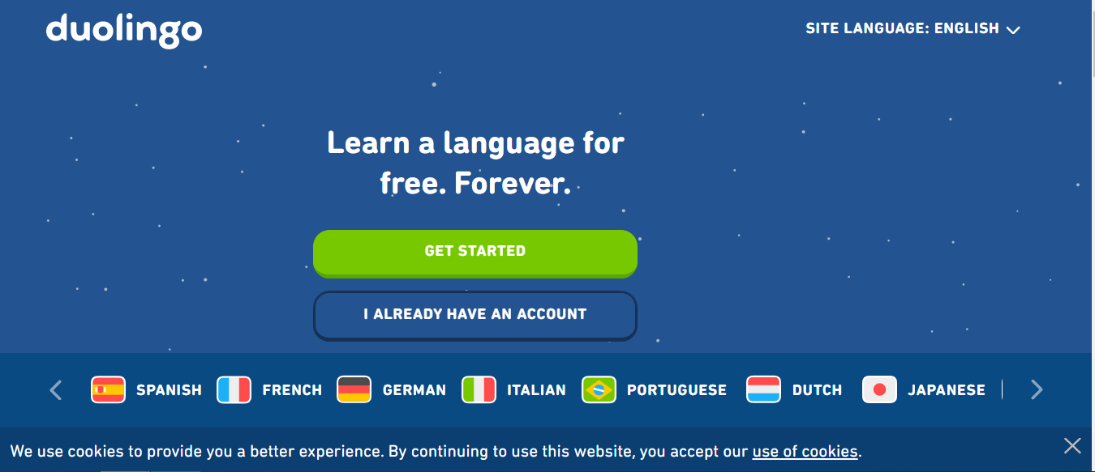  Have a go at this French lesson on BBC Bitesize https://www.bbc.co.uk/teach/school-radio/french-ks2-radio-labo-9-ecole/zv7k382  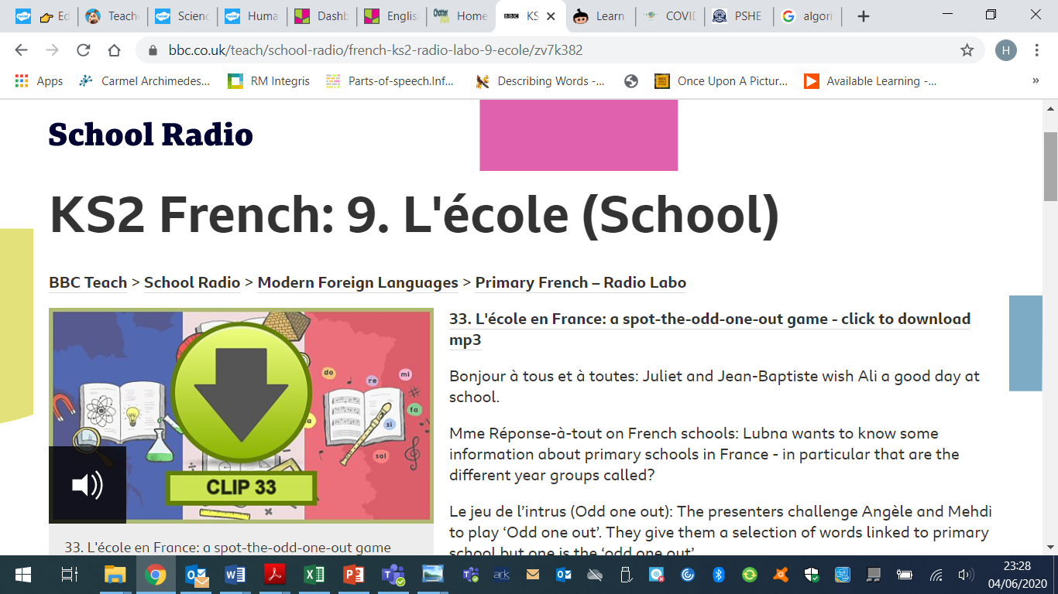  If you fancy something different, try some  French games here: https://www.frenchgamesnet  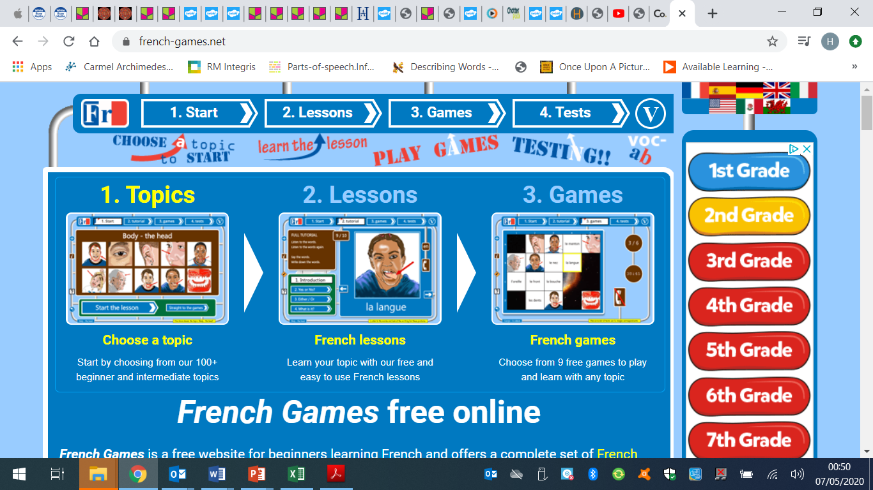

Week 3 - Moonstone Timetable for Microsoft Teams

09:00 Each Monday I will post assignments due for that week which the children will be notified of when they sign in.

14:00 Available for messaging each day

On a Friday we will have a live video with the whole class – Please message any ideas for this week.

This week the assignments due in are:
Art – Wednesday 3:30pm
Science – Friday 3:30pm
Please feel free to message me if you would like any help or support with anything

