Long Term Curriculum Overview Year 5/6 2019 - 2020
Our Vision: At Welbourn we aim to promote and develop Christian attitudes throughout the school, enabling children to make informed decisions and become aware and be tolerant of other cultures and religions. Our school mission statement, “trying our best to be our best,” provides a framework whereby we put children at the centre of all that we do and value aspirations, resilience and independent learning. It has at its heart our Christian focus and our desire to see children grow and develop their God given potential as part of a loving school community: Believe, Excite, Succeed, Together
Year group
 | Autumn 1 | Autumn 2 | Spring 1 | Spring 2 | Summer 1 |  | Summer 2
Key Question  ( Topic name) | History – World Wars with a focus of WW2 |  | Science – Forces | Geography/History – Scandinavia /Vikings | Mayans | Amazon Basin
Driver | History |  | Science | Geography | History | Geography
Key events, experiences, trips | Cranwell Aviation Museum  Bomber Command Centre | Holocaust Centre |  | Jorvik Viking Centre  York Chocolate Factory | Mayan Workshop with Past Productions
Parental engagement opportunities | What we have learned about WW2 so far | What we understand about the Holocaust |  | All about the Vikings | Maya Presentations | Creating poison dart frog bean bags
English units and rich texts | Goodnight Mister Tom  Fiction – Author Study / Genre study Biography Argument Texts | Diary of Anne Frank  Fiction – Author Study / Genre study Biography Argument Texts | Journalistic Writing Fiction: Scientific Poetry – Power of Imagery | Journalistic Writing Fiction: Scientific Poetry – Power of Imagery | Fiction - Myths and Legends Fiction - Stories with Flashbacks Poetry – Finding a Voice |  | Fiction - Myths and Legends Fiction - Stories with Flashbacks Poetry – Finding a Voice
Maths links and opportunities | Create a weekly menu for rationing for a family of 4 including all costs from the rationing book provided | Code breaking | Mass, Weight and Gravity – Newtons Law | Viking fraction lines | The Mayan Number System |  | The Amazon Basin in numbers
Science topic | Light | Electricity | Forces | Forces | Animals Including Humans |  | Animals Including Humans
WS skills opportunities | - observing changes over different periods of time,  - noticing patterns,  - grouping and classifying things,  - carrying out comparative and fair tests  and finding things out using a wide range of secondary sources | - observing changes over different periods of time,  - noticing patterns,  - grouping and classifying things,  - carrying out comparative and fair tests  and finding things out using a wide range of secondary sources | observing changes over different periods of time,  noticing patterns,  grouping and classifying things,  carrying out comparative and fair tests  finding things out using a wide range of secondary sources. | observing changes over different periods of time,  noticing patterns,  grouping and classifying things,  carrying out comparative and fair tests  finding things out using a wide range of secondary sources. | - observing changes over different periods of time,  - noticing patterns,  - grouping and classifying things,  - carrying out comparative and fair tests  and finding things out using a wide range of secondary sources |  | observing changes over different periods of time,  noticing patterns,  grouping and classifying things,  carrying out comparative and fair  tests and finding things out using a wide range of secondary sources.
Geography | Local Study – Welbourn vs London | Looking at the countries that were involved in WW2 | Forces of nature | Region in Europe Study Scandinavia | Maya civilisation mapping skills |  | North/South America – Amazon Basin
History | World wars |  | The work of Galileo Galilei and how it relates to forces | Vikings | Non- European – Mayans |  | History of the Amazon Basin/ how it has changed overtime
Art | Every picture tells a story – exploring artists and hidden meaning behind art | - Henry Moore art look up! | Centrifugal art | Sketching fierce warriors | Mayan Murals |  | Rainforest Art using sugar paper
DT | Rationing | Make do and mend – sewing  Sock teddies | Making our centrifugal device | Designing and making longships | Mayan masks |  | Poison Dart Frog Bean Bags
Music | WW2 Music and songs |  | Dance music for forces | Viking chant | Composing Mayan music |  | Recreating the sounds of the rainforest using different instruments
PE | Athletics  Hockey | Dodgeball  Football | Table Tennis  Badminton | Orienteering  Dance | Gymnastics  Gymnastics |  | Team Building  First Aid
Computing | Routine week : basic skills word  Bletchley Park 1: Secret codes | Bletchley Park 2  WW2 First Computers | Big Data 1 | Big Data 2 | Intro to Python |  | Micro:bit
RE | LAS Compulsory  Being Human - Islam | LAS Compulsory  Being Human - Hinduism | LAS Additional  DO you have to believe in God to be good? | Creation  Creation and science: conflicting or Complementary as conflicting or complementary digging deeper | LAS Compulsary  Life Journey – Hinduism/Islam  Hinduism: How do Hindus show they belong?  Islam: How do Muslims show they belong?  Rites of passage; include other religions. E.g. Bar/Bat Mitzvah in Judaism, confirmation in Christianity; have looked at how we know whether religious claims are true or not – this unit considers whether their truth or otherwise actually matters- what impact
Church school values | Justice | Equality | Love and Compassion | Service and Stewardship | Peace and Forgiveness |  | Generosity and Thankfulness
British values | Democracy | Mutual Respect | Individual Liberty | The Rule of Law | Tolerance |  | The best of being British
Global learning links/ international days | 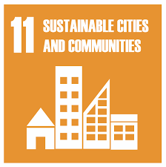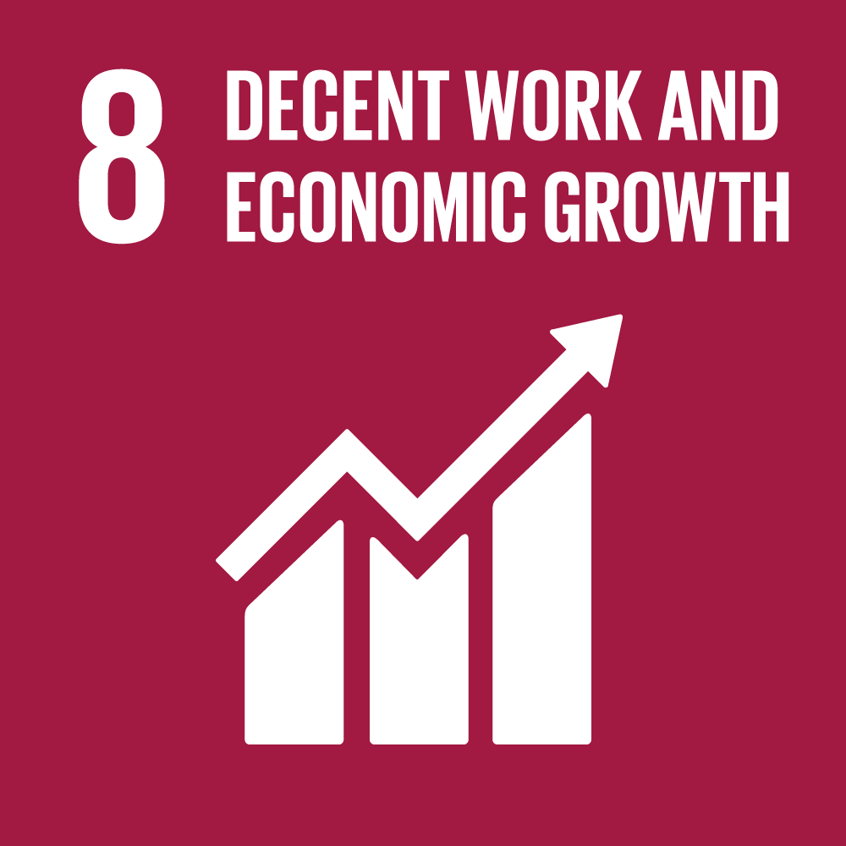 | 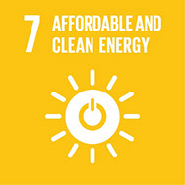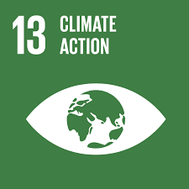 | 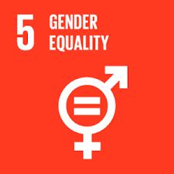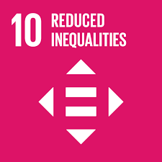 | 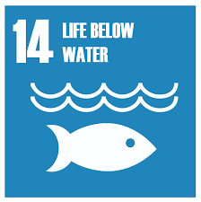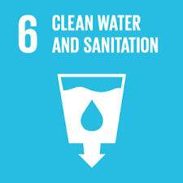 | 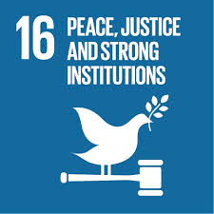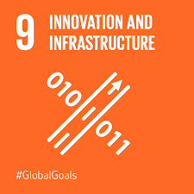
SMSC opportunities | Moral development Understanding the consequences of actions |  | Making appropriate choices about own life and justifying choices |  | Dealing with changes in life. Strategies for challenges and moral dilemmas.
PSHE/ P4C | Living in the wider world – rights and laws | Taking responsibility for our actions | Wellbeing – looking forward |  | Changes and emotions
MFL | French revision of key concepts |  | Life in my home |  | Meet the family , a week in the life
Themed weeks | Democracy Week | Anti-Bullying Week  World Hello Day | Arts Week  E-Safety Day | World Book Day  Chinese New Year | Routine Week |  | Aspirations Week

