Long Term Curriculum Overview Year 3/4 2019 - 2020
Our Vision: At Welbourn we aim to promote and develop Christian attitudes throughout the school, enabling children to make informed decisions and become aware and be tolerant of other cultures and religions. Our school mission statement, “trying our best to be our best,” provides a framework whereby we put children at the centre of all that we do and value aspirations, resilience and independent learning. It has at its heart our Christian focus and our desire to see children grow and develop their God given potential as part of a loving school community: Believe, Excite, Succeed, Together
Year group
 | Autumn 1 | Autumn 2 | Spring 1 | Spring 2 | Summer 1 | Summer 2
Key Question  (Topic name) | Romans  (Local study) |  | Plants/farming | Rivers and Mountains (The Alps) | Light | Anglo Saxons and Scots settlement in Britain
Driver | History and Geography |  | Science | Geography | Science | History
Key events, experiences, trips | Lincoln trip- Roman trail and castle  Magna science trip  Roots to food experience |  | Pizza express trip – DT  Rand farm visit  Chick hatching | River trip Snipe dales |  | Anglo saxon visitor
Parental engagement opportunities |  |  | Planting/gardening afternoon | Easter service |  | Sports day
English units and rich texts | The boy at the back of the class  Escape from Pompeii | The Iron man
Maths links and opportunities | Shape/tessellation mosaics  Timelines |  | Comparison and pattern spotting |  | Creating tables and graphs to record results | Focus on number/population figures
Science topic | States of matter | Animals including humans | Plants  As above (topic) |  | Light  As above (topic) | Electricity
SC1 skills opportunities | Skills covered:  Asking relevant questions and using different types of scientific questions to answer them.  Setting up simple practical enquiries, comparative and fair tests.  Making systematic and careful observations, and where appropriate, taking accurate measurements using standard units, using a range of equipment, including data loggers and thermometers.  Gathering, recording, classifying and presenting data in a variety of ways to help in answering questions.  Recording findings using simple scientific language, drawings, labelled diagrams, keys, bar charts, and tables.  Using results to draw simple conclusions, make predictions for new values, suggest improvements and raise further questions.  Identify differences, similarities or changes related to simple scientific ideas and processes. | Skills covered:  Asking relevant questions and using different types of scientific questions to answer them.  Setting up simple practical enquiries, comparative and fair tests.  Making systematic and careful observations  Gathering, recording, classifying and presenting data in a variety of ways to help in answering questions.  Recording findings using simple scientific language, drawings, labelled diagrams, keys, bar charts, and tables.  Reporting on findings from enquiries, including oral and written explanations, displays or presentations of results and conclusions. | Skills covered:  Setting up simple practical enquiries, comparative and fair tests.  Making systematic and careful observations, and where appropriate, taking accurate measurements using standard units, using a range of equipment, including data loggers and thermometers.  Gathering, recording, classifying and presenting data in a variety of ways to help in answering questions.  Recording findings using simple scientific language, drawings, labelled diagrams, keys, bar charts, and tables.  Reporting on findings from enquiries, including oral and written explanations, displays or presentations of results and conclusions.  Using results to draw simple conclusions, make predictions for new values, suggest improvements and raise further questions.  Identify differences, similarities or changes related to simple scientific ideas and processes.  Using straightforward scientific evidence to answer questions to support findings. |  | Skills covered:  Setting up simple practical enquiries, comparative and fair tests.  Making systematic and careful observations, and where appropriate, taking accurate measurements using standard units, using a range of equipment, including data loggers and thermometers.  Gathering, recording, classifying and presenting data in a variety of ways to help in answering questions.  Recording findings using simple scientific language, drawings, labelled diagrams, keys, bar charts, and tables.  Reporting on findings from enquiries, including oral and written explanations, displays or presentations of results and conclusions.  Using results to draw simple conclusions, make predictions for new values, suggest improvements and raise further questions.  Identify differences, similarities or changes related to simple scientific ideas and processes.  Using straightforward scientific evidence to answer questions to support findings. | Skills covered:  Asking relevant questions and using different types of scientific questions to answer them.  Setting up simple practical enquiries, comparative and fair tests.  Making systematic and careful observations, and where appropriate, taking accurate measurements using standard units, using a range of equipment, including data loggers and thermometers.  Gathering, recording, classifying and presenting data in a variety of ways to help in answering questions.  Recording findings using simple scientific language, drawings, labelled diagrams, keys, bar charts, and tables.  Using results to draw simple conclusions, make predictions for new values, suggest improvements and raise further questions.  Reporting on findings from enquiries, including oral and written explanations, displays or presentations of results and conclusions.  Using straightforward scientific evidence to answer questions to support findings.
Geography |  | As above (topic) |  | As above (topic)
History | As above (topic) |  |  |  |  | As above (topic)
Art | Skills  In this collection of lessons children learn and develop their skills in: design, drawing, craft, painting and art appreciation; making a variety of puppets using different materials, completing a drawing from observation, learning the difference between a tint and a shade and creating their own version of a cartoon drawn by a famous illustrator | Formal elements: texture and pattern  Exploring two of the formal elements of art: texture and pattern; pupils develop a range of mark-making techniques, make and use their own textured stamps for printing; draw a ‘flip’ pattern and recreate a famous and ancient geometric pattern |  |  | Formal elements: Shape and tone  Exploring two of the formal elements of art: shape and tone; children find shapes in everyday objects; use shapes as guidelines to draw accurately from observation; create form and shape using wire and practice shading neatly and from light to dark
DT |  |  | Cooking –savoury | Woodwork |  | Woodwork
Music | Romans  In this topic, pupils experiment and get creative with their music making. Drawing upon their understanding of repeating patterns in music, pupils are introduced to the concept of motifs and develop their skills further by adapting and transposing motifs before performing them to their peers | Rainforests  A topic of discovery; children will explore the rainforest through music and be introduced to new musical terms. Using a mixture of body percussion and tuned percussion instruments, children create their own rhythms of the rainforest, layer by layer | Jazz | Mountains  In this topic, pupils learn to tell stories through music. They begin this by first listening to music and considering the narrative it could represent by paying close attention to the dynamics, pitch and tempo and how they change throughout the piece. They then go on to create their own original compositions to match an animation, building up layers of texture | Blues  Children are introduced to this famous genre of music and its history, and learn to identify the key features and mood of blues music and its importance and purpose. They also get to grips with the 12 bar blues and the blues scale, and combine these to create an improvised piece with a familiar, repetitive backing | The Vikings  In this Viking themed topic, the children develop their singing technique; learning to keep in time, and work on musical notation and rhythm, culminating in a group performance of a song with action
PE | Hockey  Striking skills | Football  Athletics | Badminton  Dance | Volleyball  Orienteering | Softball  Swimming | Cricket  Swimming
Computing | Word processing  Building on the children’s ability to use word, including:  basic typing skills changing the appearance and position of text  Inserting and editing images, inserting tables | The Internet  In this topic, children learn what the Internet is and how it works. Acting out different processes, children gain a deeper understanding of how data is transferred and how this enables us to view and interact with different websites | Website design  In this topic children develop their research, word processing, and collaborative working skills whilst learning how web pages and web sites are created, exploring how to change layouts, embed images and videos and link between pages, children create their own cohesive looking websites |  | HTML  Children learn about the markup language behind a webpage; becoming familiar with HTML tags, changing HTML and CSS code to alter images and ‘remixing’ a website’s text and images to create a fake news story | Collaborative learning  In this topic, children learn about how to work collaboratively in a responsible and considerate way as well as looking at a range of collaborative tools including Google Docs, Slides, Forms and Sheets. They also develop their understanding of the benefits of working together and how the Internet provides opportunities to do this even when people are not physically in the same location
RE | LAS Additional  Sikhism  Why do we celebrate?  [What different events/times of life do we celebrate?  How do different people celebrate things differently?  How does celebration relate to remembrance?] | LAS Compulsory  Community – Hinduism  [How is Hindu belief expressed personally and collectively? How does Hindu worship and celebration build a sense of community?  Worship and celebration. Ways in which worship and celebration engage with/affect the natural world. Beliefs about creation and natural world] | LAS Compulsory  Community –Islam  [How is Muslim worship expressed collectively? How does Muslim worship and celebration build a sense of community?  Worship and celebration. Ways in which worship and celebration engage with/affect the natural world. Beliefs about creation and natural world] | Creation  UC 2a.1 (core)  What do Christians learn from the creation story? | LAS Additional  Pilgrimage (including Christianity)  [What is a pilgrimage? What does pilgrimage involve? E.g. Christian pilgrimage to Walsingham, Lourdes, Iona, Jerusalem, Muslim pilgrimage to Makkah, Jewish pilgrimage to Jerusalem, Hindu pilgrimage to the Ganges, etc. Environmental impact of pilgrimage]
Church school values | Justice | Peace and Forgiveness | Love and Compassion | Generosity and Thankfulness | Service and Stewardship | Equality
British values | Democracy  -class rules  -School Council elections | Mutual respect | Individual liberty | The rule of law | Tolerance | The best of being British
Global learning links/ international days | 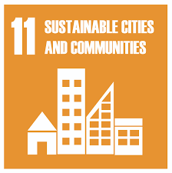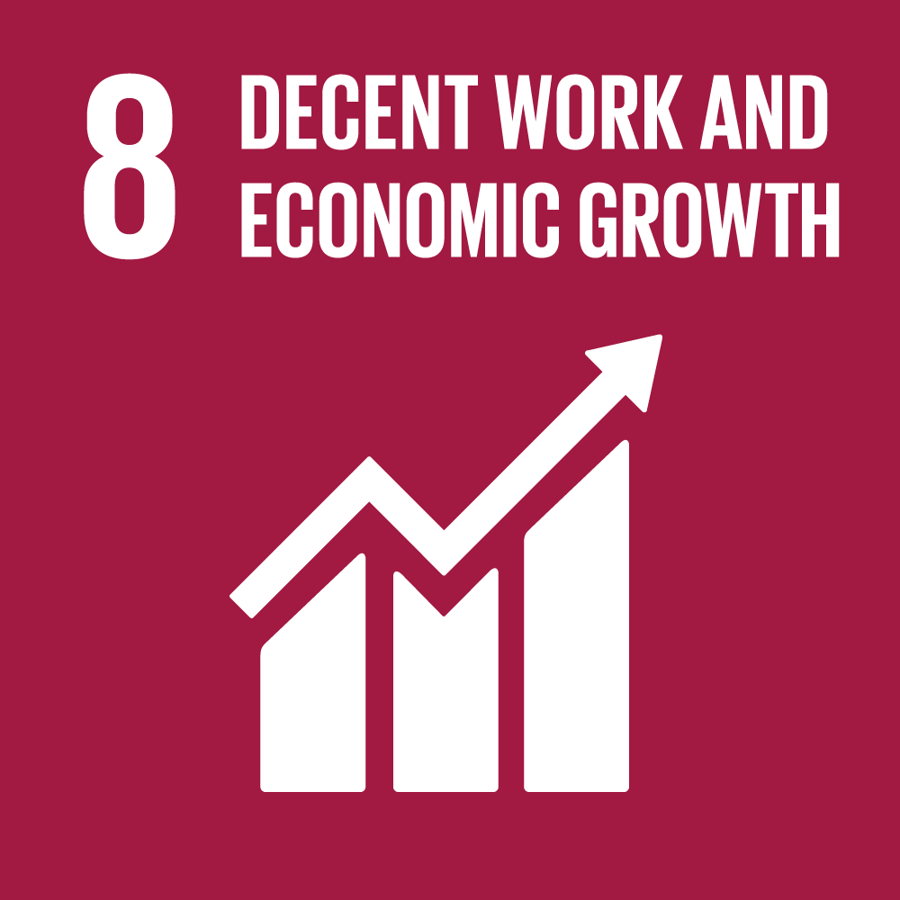 | 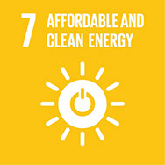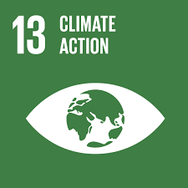 | 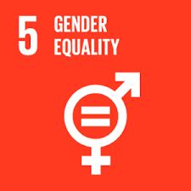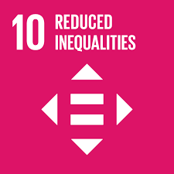 | 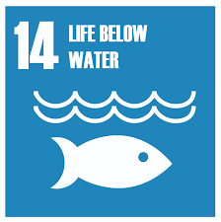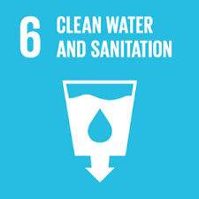 | 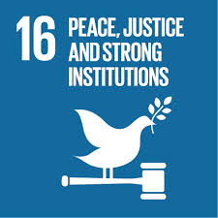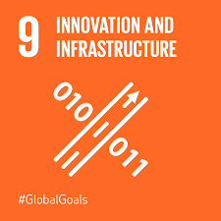
SMSC opportunities | Relationships/family diversity | Health and wellbeing  Sports awareness | Cultural traditions  Self esteem | Living in the wider world  Cultural traditions  Relating to others | Relationships | Empathy  Social skills- developing friendships
PSHE/ P4C | Getting to know me  Through this topic, children develop their sense of identity, learning to identify their strengths and the groups and communities they are a part of. Imagining themselves as superheroes, they reflect on what makes them special and how they can help people around them, before moving on to explore factors which affect our mental and physical health and wellbeing: diet, dental health, rest, relaxation and hydration |  | My place in the world  Incorporating their sense of identity into the context of the world they live in, children start to consider the concept of purpose; looking at the importance of different emotions they experience, understanding what we gain from each different food group as well as considering what roles they themselves play based on what they are good at and enjoy |  | Friendship  Understanding actions have consequences. Providing the children with the opportunity to consider different scenarios, and possible solutions.  Promotion of independence and tolerance.
MFL | Numbers to 20  Colours | Months of the year  Days of the week | Birthdays | Formal greetings  Conversational questions | Creating conversations  Recapping and applying learning | Numbers to 20  Colours
Themed weeks |  | Anti Bullying Week  World Hello Day

