Topaz Long Term Curriculum Overview EYFS 2019-2020
Our Vision: At Welbourn we aim to promote and develop Christian attitudes throughout the school, enabling children to make informed decisions and become aware and be tolerant of other cultures and religions. Our school mission statement, “trying our best to be our best,” provides a framework whereby we put children at the centre of all that we do and value aspirations, resilience and independent learning. It has at its heart our Christian focus and our desire to see children grow and develop their God given potential as part of a loving school community: Believe, Excite, Succeed, Together
Year group | EYFS- Topaz
 | Autumn 1 | Autumn 2 | Spring 1 | Spring 2 | Summer 1 | Summer 2
Key Question/themes  ( Topic name) | What is marvellous about me? Growth/our bodies  Families  Keeping Healthy  Owl Babies  Making friends  Playing outside  Autumn & Harvest  Funnybones | How do we celebrate?  Sharing and Giving  Festivals and food  Our senses  Diwali- making lanterns and acting out the story of Rama and Sita  Hanukah  Birthdays  Winter & Christmas  Oliver’s vegetables | Who is living in the deep, dark woods?  The Gruffalo  The Gruffalo’s Child  BeeBot maps  Stickman art and models  Animal Habitats  Looking at shadows-light/dark  Chinese New Year | What are our favourite animals? Similarities and differences in animals  Glow draw ipad app- animals  Animals and their young  Visits to and from animals | Who were the dinosaurs?  Dinosaur research  Become palaeontologists and excavate a finding!  Harry and the dinosaurs stories  Write our own dinosaur stories  Make dinosaur puppets | What is a superhero?  Design their own trusty side kick!  Superhero healthy foods  Comic Strips for our superheroes-ICT  Superhero powers- magnets, material testing  Superhero cape designs  Real life heroes
Driver | Understanding the World  The World (W) | Understanding the World  People and Communities | CLL-Julia Donaldson theme | Understanding the World  The World (W) | Understanding the World  The World (W) | CLL/ Understanding the World  People and Communities
Key events, experiences, trips | Visit from the nurse | Food tasting  Divali day | Forest school for the half term on site every other Friday pm | Visits from pets  Visit from Moss the guide dog | School trip to Belton House | Lincoln Theatre Royal Trip  Evil Pea incident
Parental engagement opportunities | Parent sharing morning | Nativity | Arts week activities | Easter service  Maths week | School trip to Belton House  Sports Day  Family Fridays
CLL stories to support learning: | Funny Bones and Owl Babies | The story of Rama and Sita  Oliver’s Vegetables | The Gruffalo,  The Gruffalo’s Child,  Stickman  Arts Week- Tinga Tinga Tales | Dear Zoo | Harry and the dinosaurs stories, Dear Dinosaur  Dino facts | Supertato stories  Traction man  Super hero Daisy  006 and a bit
Maths links and opportunities | Baseline assessments  Counting, Number recognition, SSM  Measuring our bodies | Counting, Number recognition, Money, Addition and Subtraction, positional language, money in the Farm Shop role play | Counting, Number recognition, SSM- size, weight and capacity , 2D shape,  Problem solving – what the ladybird heard | Counting, Number  recognition,  3D shape and time  Halving | Counting, Number  recognition,  addition/subtraction, doubling and halving, money | Counting, Number  recognition, Doubling, position, consolidation of areas  Super hero strengths- weight, superhero foods- capacity, problem solving
Understanding the World topic | (W)Developing an understanding of growth, decay and changes  over time.  (PC) Shows interest in different occupations and ways of life. | (PC)  They know about similarities and differences between themselves and others, and among  families, communities and traditions. | (W) They talk about the features of their own immediate environment and how environments might vary from  one another. | (W) They make observations of animals and plants and explain why some things occur, and talk about changes. | (W) They make observations of animals and plants and explain why some things occur, and talk about changes. | Understanding the World  People and Communities  Superheroes

 | Expressive Arts and Design  EMM  BI |  | Portraits/Our bodies  Manipulates materials to achieve a planned effect.  Constructs with a purpose in mind, using a variety of resources.  Uses simple tools and techniques competently and appropriately. | Uses simple tools and techniques competently and appropriately.  Selects appropriate resources and adapts work where necessary.  Selects tools and techniques needed to shape, assemble and join materials they are using. | Constructs with a purpose in mind, using a variety of resources.  Uses simple tools and techniques competently and appropriately.  Selects appropriate resources and adapts work where necessary. |  | Manipulates materials to achieve a planned effect.  Constructs with a purpose in mind, using a variety of resources.  Uses simple tools and techniques competently and appropriately | They safely use and explore a variety of materials, tools and techniques, experimenting with colour, design, texture, form and  function. | Uses simple tools and techniques competently and appropriately.  Selects appropriate resources and adapts work where necessary.  Selects tools and techniques needed to shape, assemble and join materials they are using.
 | Expressive Arts and Design  Begins to build a repertoire of songs and dances.  Explores the different sounds of instruments. |  | Body songs- Head, shoulders, knees and toes, I’ve got a body…a very busy body etc…  sounds are listened to, moved to, represented, written and performed in this fun and engaging topic. Children are encouraged to feel pieces of music by moving in ways they think convey its mood. | Nativity songs, dances and performances. | Learn The Gruffalo Song and others  Use instruments to accompany scenes from stories |  | Noah’s Ark song, Move like animals  Carnival of the animals | Dinosaur Stomp | Act out at being superheroes with sound effects form different instruments  Super heroes in real life
 | Physical Development |  | Travels with confidence and skill around, under, over and through balancing and climbing equipment. | Travels with confidence and skill around, under, over and through balancing and climbing equipment. | Experiments with different ways of moving.  Jumps off an object and lands appropriately. |  | Experiments with different ways of moving.  Jumps off an object and lands appropriately. | Children show good control and co-ordination in large and small movements.  Children move confidently in a range of ways, safely negotiating space | Sports Day  Children show good control and co-ordination in large and small movements.  Children move confidently in a range of ways, safely negotiating space  Working as a team
 | Computing |  | BeeBots  Uses ICT hardware to interact with age- appropriate computer software. | Using glow draw and ipads | Finding information about nocturnal woodland animals |  | Fact finding about different animals (books/ICT) | Using ICT to find facts, learn songs and dances | Type our names on laptops/
RE |  | LAS Unit  Myself  [Introduce people who belong to a religious group] Link to Marvellous Me topic |  | LAS Units  Special people to me  [Introduce people who are important to members of a religious group, e.g. Jesus, Prophet Muhammad, vicar, imam, etc.]  Link to celebrations- different faiths, family celebrations | RE- Special Books | The Easter Story  Salvation  UC F3 (core)  Why do Christians put a cross in an Easter garden? |  | Creation  UC F1 (core)  Why is the word ‘God’ so important to Christians? | LAS Unit  Our beautiful world  [Introduce stories about creation and some beliefs about the natural world, e.g. the duty to care for the environment]
Church school values |  | Justice |  | Peace and Forgiveness | Love and Compassion | Generosity and Thankfulness |  | Service and Stewardship | Equality
British values |  | Democracy  -class rules  -School Council elections |  | Mutual respect | Individual liberty | The rule of law |  | Tolerance | The best of being British
Global learning links/ international days |  | 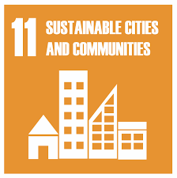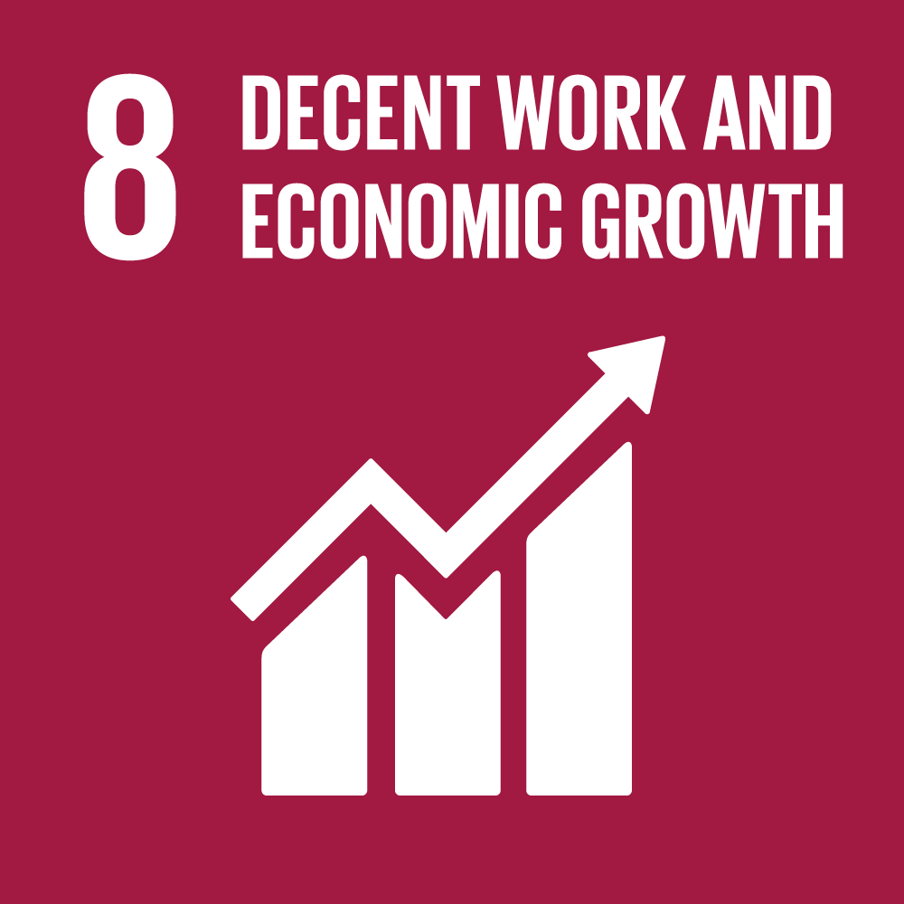 |  | 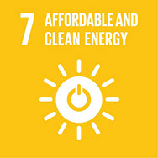 | 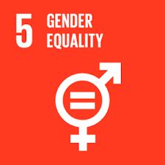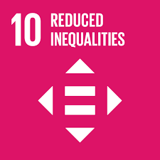 | 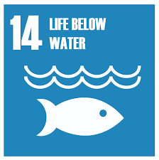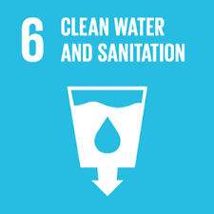 |  | 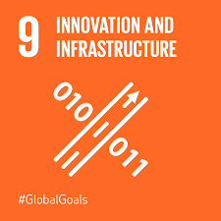
PSED |  | Me, myself and I – learning school rules, relationships with others. |  | Respecting others. Likes and dislikes, differences and similarities | Compassion for others and the world around us. Caring for the world/care for animals . |  |  | Transition Activities- What can we do now, Goals for the future, Being our best etc…Thoughts and letters to our new teacher, helping our New Reception children settle in through Transition days.
Themed weeks |  | Democracy week |  | Anti-Bullying Week  World Hello Day | Arts week | World Book day |  | Walk to school week | Aspirations week- what do we want to be when we grow up?

