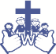
Welbourn Church of England Primary School
‘Believe, Excite, Succeed, Together’
Amethyst Class
Topic: What happened in World War II??
Subject: History
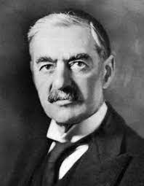
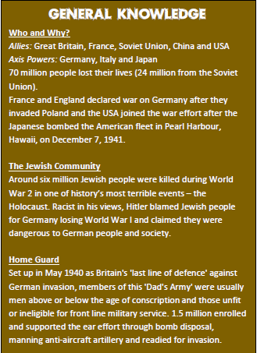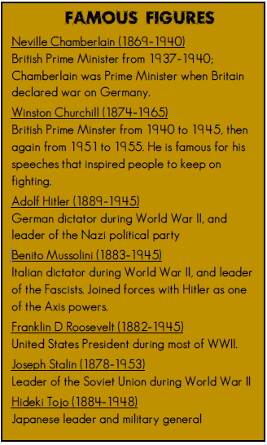
Winston Churchill
Neville Chamberlin
Adolf Hitler
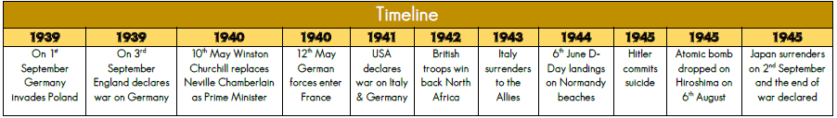
Key Vocabulary
Swastika: An ancient symbol of a cross with arms at a right angle, used as an emblem for the Nazi Party | Kristallnacht: On 9th-10th November 1939, Nazis torched synagogues and vandalised Jewish homes.
Evacuee: Designed to protect people, especially children, by moving them to areas of less risk. | Gas mask: Issued to all civilians at the start of the war, gas masks were used to protect from gas attacks.
Rations: Ration cards were given out and only a certain amount of food/clothes per family was allowed. | Blitz: The sustained aerial bombing against Britain by Nazis. Blitz means lightning in German.
Blackout: All windows and doors had to be covered at night to stop enemy aircraft seeing house lights. | Anderson shelter: Half buried in the ground and with earth on top, they protected people from bomb blasts.
Nazis: Adolf Hitler and his Nazi Party controlled  Germany between 1933 and 1945. | Star of David: Jews throughout Europe were forced to wear the star of David to clearly identify themselves.

