Welbourn Church of England Primary School
‘Believe, Excite, Succeed, Together’
Amethyst Class
Topic: Who were the Ancient Greeks?
Subject: History
Greek Gods  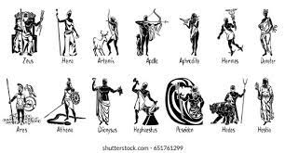 | Ancient Greece  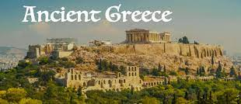
Key facts: Greek Gods | Key facts: Famous figures
Aphrodite – Goddess of love, rising from the sea,  enchanting anyone who sees her.  Athena – Daughter of Zeus. Goddess of the city and  farming. Her tree is the olive and the bird is the owl.  Hades – Brother of Zeus and god of the underworld, ruling over the dead and god of wealth. He wears a helmet which makes him invisible.  Hermes – Son of Zeus. Messenger of the gods with winged sandals making him the fastest of the gods. Carries a staff.  Poseidon – Brother of Zeus and the second most powerful  god. God of the sea who has a three-headed spear  (trident) which can shake the earth.  Zeus – Lord of the sky and the rain god who hurls  thunderbolts at those who displease him. The  most powerful of the gods. | Archimedes (287-212 B.C.)  Mathematician and philosopher who found a way of measuring water by placing an object in it and seeing how far it rose (hydrostatics). He jumped out of the bath and shouted ‘Eureka!’ meaning ‘I found it!’  Alexander the Great (356-332 B.C.)  King of Macedonia who conquered Greece, Persia, Egypt, and the Indus Valley, extending the empire as far away as India.  Hippocrates (460-370 B.C.)  A famous doctor known as the ‘father of Western medicine’. Doctors today still take the ‘Hippocratic Oath’ promising to be good at their job and do their best for patients.  Pericles (494-429 B.C.)  Athenian general who led Athens during the war with Sparta. He made sure that the poor as well as the rich citizens could take part in government and valued art and education.
Key Vocabulary
Acropolis: A large hill where city residents sought shelter and safety in times of war. Also, a meeting place for discussing issues. | Trojan horse: Wooden horse constructed by Greeks to obtain entry into the city of Troy. Soldiers hid inside and then sprang out!
Ampitheatre: Outdoor theatre with seats on all sides where singing, dancing and even sacrificing took place. | Philosophy: The practice of asking big questions with no clear/single answer. It means the ‘love of wisdom’.
Chiton: The chiton was a single sheet used as clothing wrapped around the body. | Pyxis: A cylindrical box with a separate lid used to store  trinkets, ornaments or cosmetics.
Democracy: A system of government in which citizens are able to vote in order to make decisions. | Parthenon: A former temple on the Athenian Acropolis dedicated to the goddess Athena.
Olympics: Athletes competing against each other. Began in Olympia and included religious festivals in honour of Zeus. | Vase: Pots made on a potters’ wheel often painted with aspects of daily life from which historians have learned from.:
