Welbourn Church of England Primary School
‘Believe, Excite, Succeed, Together’
Amethyst Class
Topic: What can we do to save our world?
Subject: Geography
Global warming  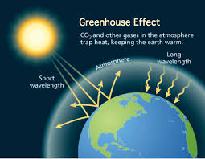 | Deforestation 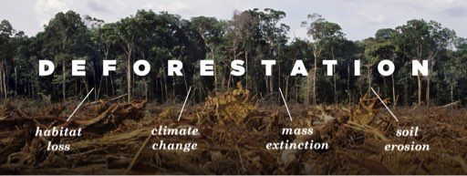
Key facts: Global warming | Key facts: Pollution
- CO2 levels are rising: they’re the highest they’ve been for 4 million years  - As CO2 rises so does the temperature, it’s already warmed 1°C since the Industrial Revolution.  - Climate models suggest it could warm a further 0.5°C to 5°C by the end of the century – depending on our actions | - Around 40% of the lakes in America are too polluted for aquatic life, swimming or fishing.  - Pollution kills over 1 million seabirds and 100 million mammals annually.  - Over 80 billion aluminium cans are used every year around the world. If you throw away aluminium cans, they can stay in that can form for up to 500 years or more
Key Vocabulary
Ecosystem: a community or group of living organisms that live in and interact with each other in a specific environment | Conservation: prevention of wasteful use of a resource
Biodiversity: The variety of life in the world or a particular habitat. | Biome: Large-scale ecosystem that covers a global region.
Habitat: The natural home or environment of an animal, plant or other organism. | Evaporation: Water heated by the sun becoming water vapour.
Pollution: the presence in or introduction into the environment of a substance which has harmful or poisonous effects | Global warming: a gradual increase in the overall temperature of the earth's atmosphere generally attributed to the greenhouse effect caused by increased levels of carbon dioxide, CFCs, and other pollutants.
Interconnected: Whereby each element of an ecosystem is dependent on the others. | Relief: The height or elevation of the land in an area.
Unsustainable: not able to be maintained at the current rate or level | Over consumption: the action or fact of consuming something to excess
Renewable: A source of energy that is not depleted by use, such as water, wind or solar power. | Deforestation: The clearing or removal of trees from a forest area.

