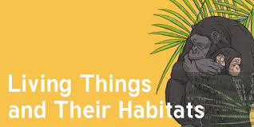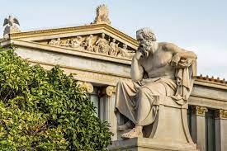 

Dear Parents and Year 4,5,6

In Amethyst this half term we will be exploring the history topic ‘Who were the Ancient Greeks?.

Our challenge questions are:

LC1: To know about the Ancient Greek Empire

LC2: To know how the political system worked in Ancient Greece

LC3: To know about the Ancient Greek Olympics

LC4: To know about the Battle of Marathon

LC5: To know about Greek Gods and Godesses

LC6: To know about the Trojan War.

As performers we will:

be practising for our end of term play! This will be Cinderella Rockerfella.

Parts will

be sent home

in due course.

As artists we will:

be developing our painting skills, and creating props for our upcoming play!

As scientists we will: be continuing to study ‘Living things and their habitats’, learning about the process of reproduction, the life cycles of mammals, amphibians,

insects and birds, and

classification.

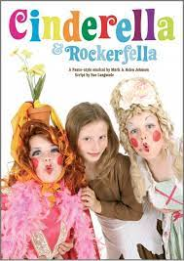

As writers we will:

be exploring

developing our spag knowledge through ‘Active English’

Who were the Ancient Greeks?

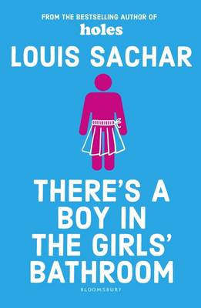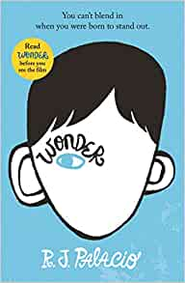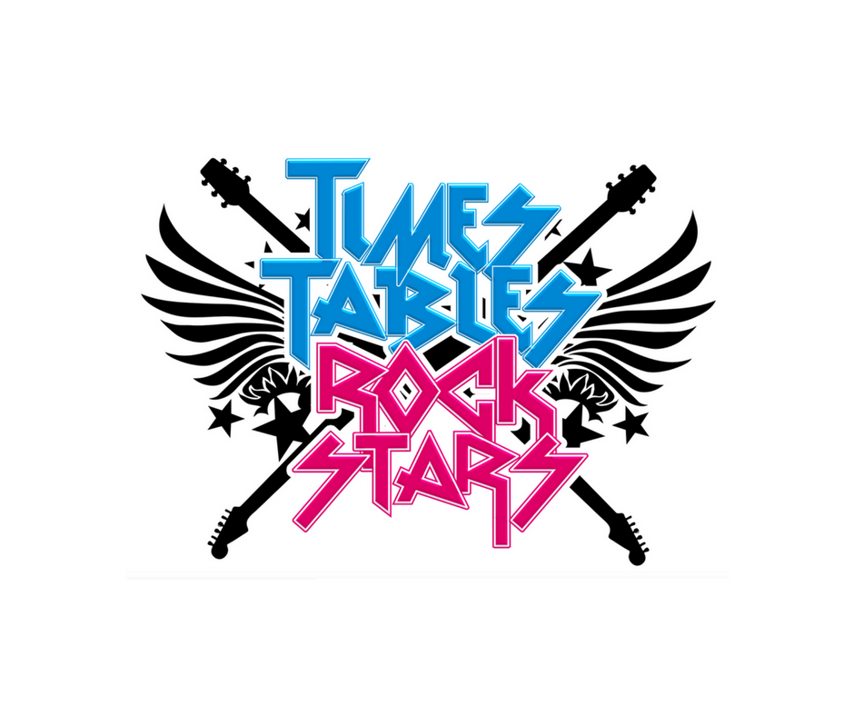

Wow Days:

We will be tasting Greek food, investigating images on Ancient Greek vases, researching and presenting Greek Gods.

As Musicians we will:

be completing the charanga

unit ‘Dancing in the Street’ and learning songs for the play.

‘

As Readers we will:

be continuing studying books that raise issues and dilemmas.. Wonder’ and ‘There’s a boy in

the girls bathroom’.

As mathematicians we will:

be continuing to learn about decimals before moving onto shape!

We will also

continue with

Times tables Rock stars!