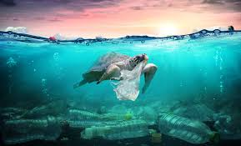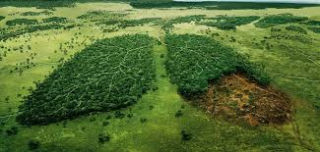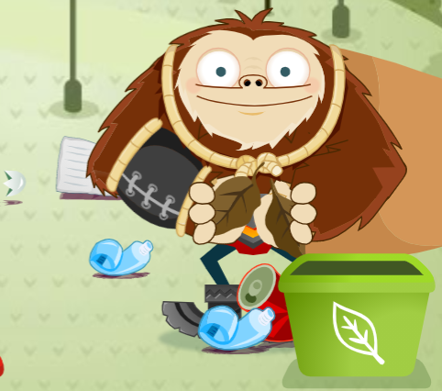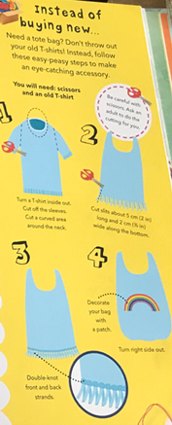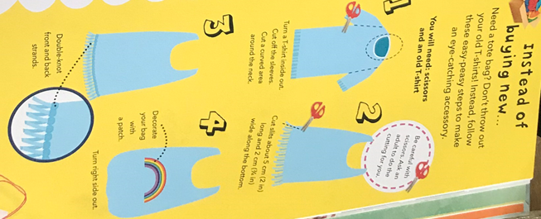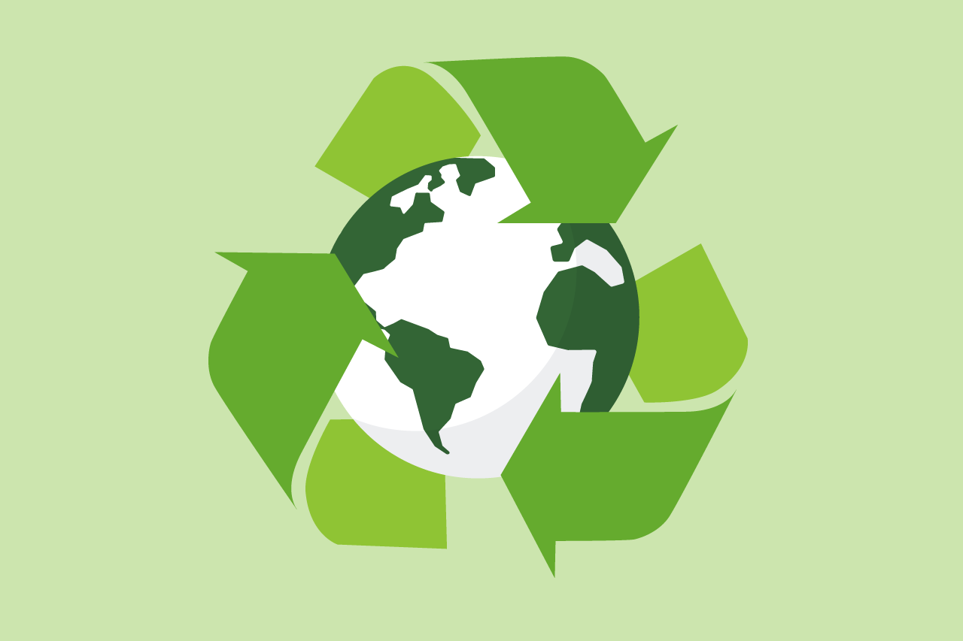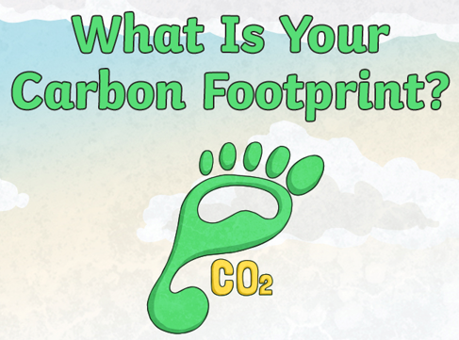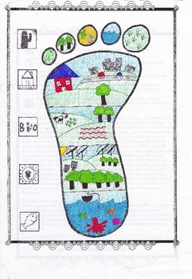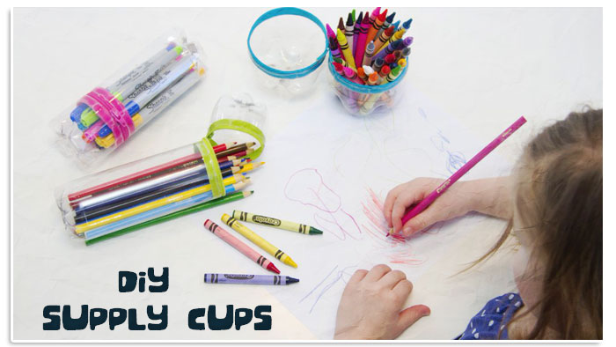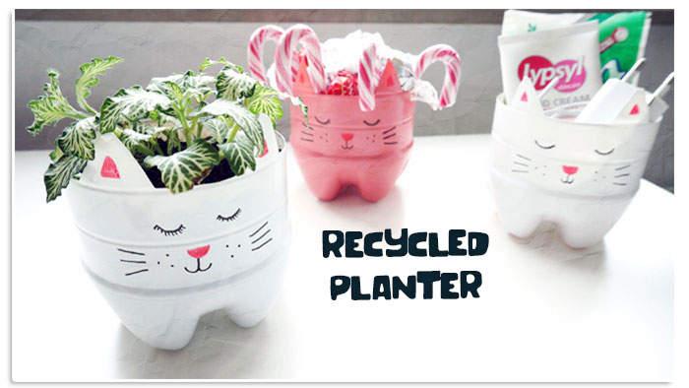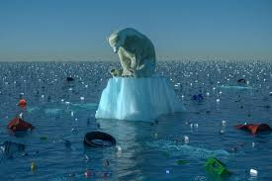

Task 4

**Recycle game**

Sort as much recycling as you can in 2 minutes on the online game at <https://kids.nationalgeographic.com/games/action-and-adventure/recycle-roundup-new/>

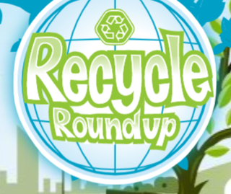

Resources you will need:

Task 5 **Draw your carbon footprint**

Draw around your foot to make your footprint. Then research ways you could reduce your carbon footprint and decorate your footprint with pictures and ideas.

There is a powerpoint and

video on teams

to help

with research.

Resources you will need:

Pencil, Your foot, colouring pencils

Welcome to Inspiration day! Today I would like you to explore how we can protect or world.

We will meet at 9am to introduce the topic and todays tasks!

Task 3 **Baking/cooking**

Have a go at making your own vegan recipe today! You can choose from vegan pancakes, banana bread, chocolate chip cookies or Mexican pizza!

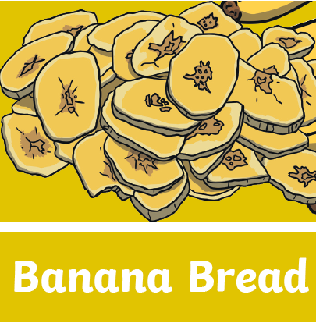

The recipes are in files on teams. Have a look in advance to see what ingredients you will need 😊

**How can we protect our wonderful world?**

Task 2 **Make a tote bag**

Help the planet by reusing

what you already have.

Use an old T shirt to

make your own Tote bag!

The instructions are on

teams

Resources you will need:

An old T shirt, scissors

Task 1 **Upcycle using plastic**

Look around your house and spot any single use plastic you have. Is there anything you could reuse? Look at the powerpoint on teams for some ideas. What can you create?!

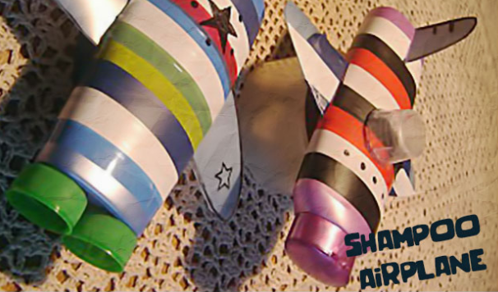

Resources you will need: Plastic bottles, scissors, paints/colouring pencils, string