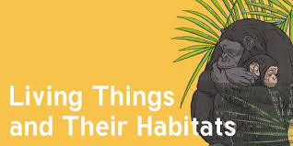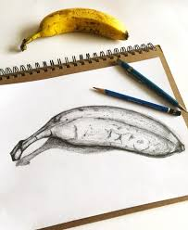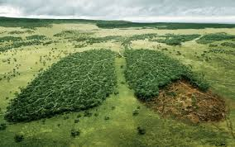 

Dear Parents and Year 4,5 and 6

In Amethyst this half term we will be exploring the geography topic ‘How can we save our world?.

Our challenge questions are:

LC1: To know why industrial areas and ports are important.

LC2: To know what biodiversity is and how humans have affected it.

LC3: To know how endangered animals have been affected by humans.

LC4: To know what climate change is.

LC5: To know how pollution affects the ocean.

LC6: To know what renewable energy is.

As artists we will:

be focusing on observational drawing to develop our drawing skills.

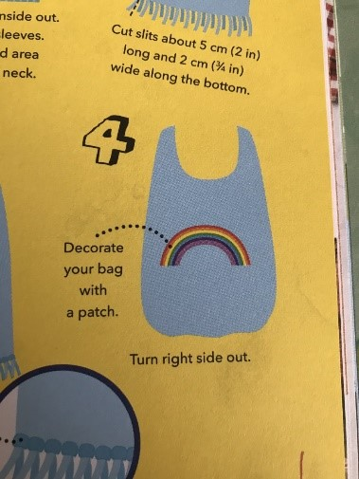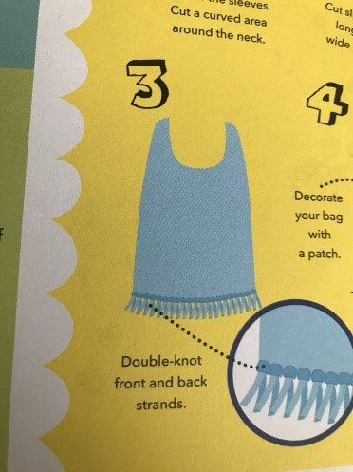

As scientists we will: be studying ‘Living things and their habitats’, learning about the process of reproduction and the life cycles of plants, mammals,

amphibians, insects and birds.



How can we save our world?

Wow Days:

We will be investigating the different ways in which we can help to save our planet, making vegan food, upcycling plastic, creating a tote bag from an old t-shirt and drawing our carbon footprint.

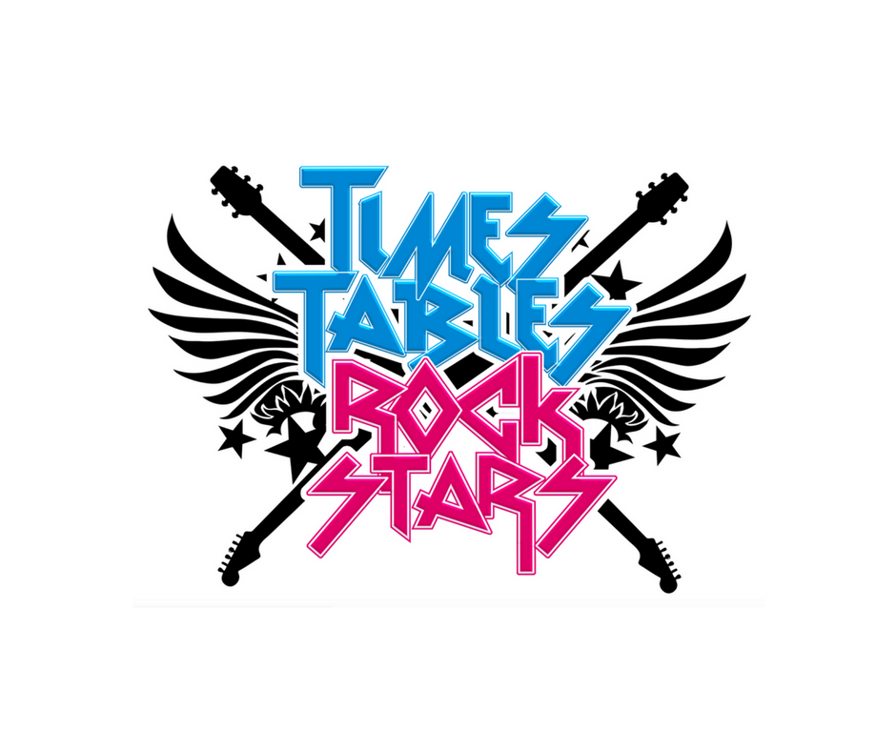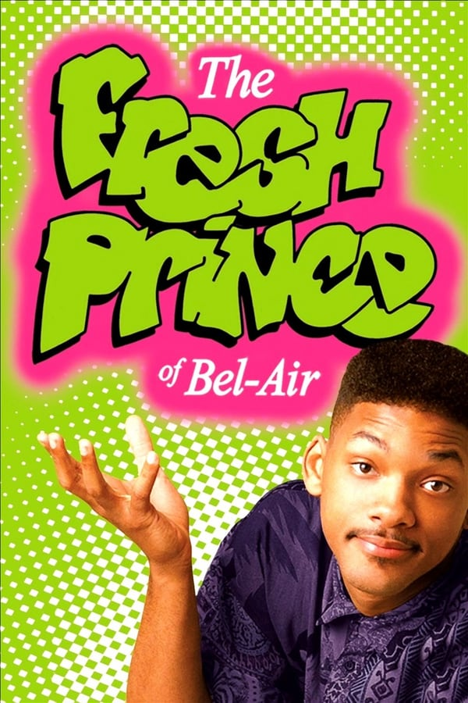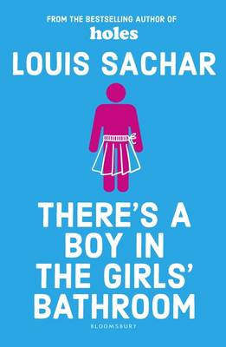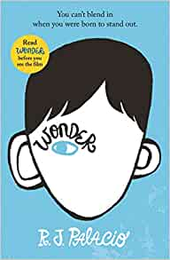

As writers we will:

be exploring the features of poetry, and refreshing our spag knowledge through ‘Active English’

As Musicians we will:

be completing the charanga

unit

‘Fresh

Prince of

Bel Air’

As Readers we will:

be focusing on book that raise issues and dilemmas. We will be starting . new books Wonder’

and ‘There’s a boy in

the girls bathroom’.

As mathematicians we will:

be continuing to learn about franctions before moving onto decimals!

We will also

continue with

Times tables Rock stars!