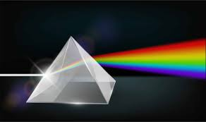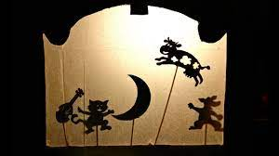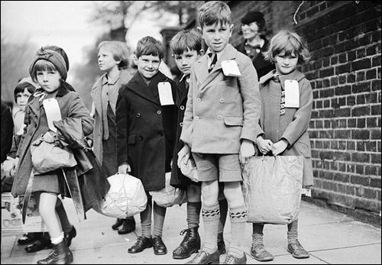

As scientists we will: be exploring the topic ‘Light. We will be focusing on how we see, reflecting light, refraction, and finally creating our own

shadow theatres.

As musicians we will:

Be studying the unit ‘Happy’ on charanga

Dear Parents and Year 5/6

In Amethyst this half term we will be exploring the history topic ‘What happened in WWII?’

Our challenge questions are:

LC1: To know about other Wars.

LC2: To know the events leading up to WWII.

LC3: To know about the Allies and the Axis

LC4: To know what life was like for evacuees.

LC5: To know how significant the impact on WWII was on women

LC6: To know about rationing

As athletes we will:

be developing our swimming skills and taking part in active maths sessions!



Wow Days and trips:

In DT we will be designing and making our own mini anderson shelters, considering how to make the best structure.

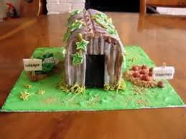

We will be visiting the bomber command centre on our school trip.

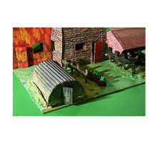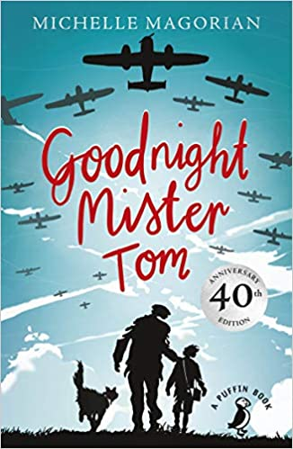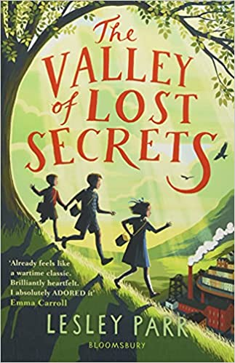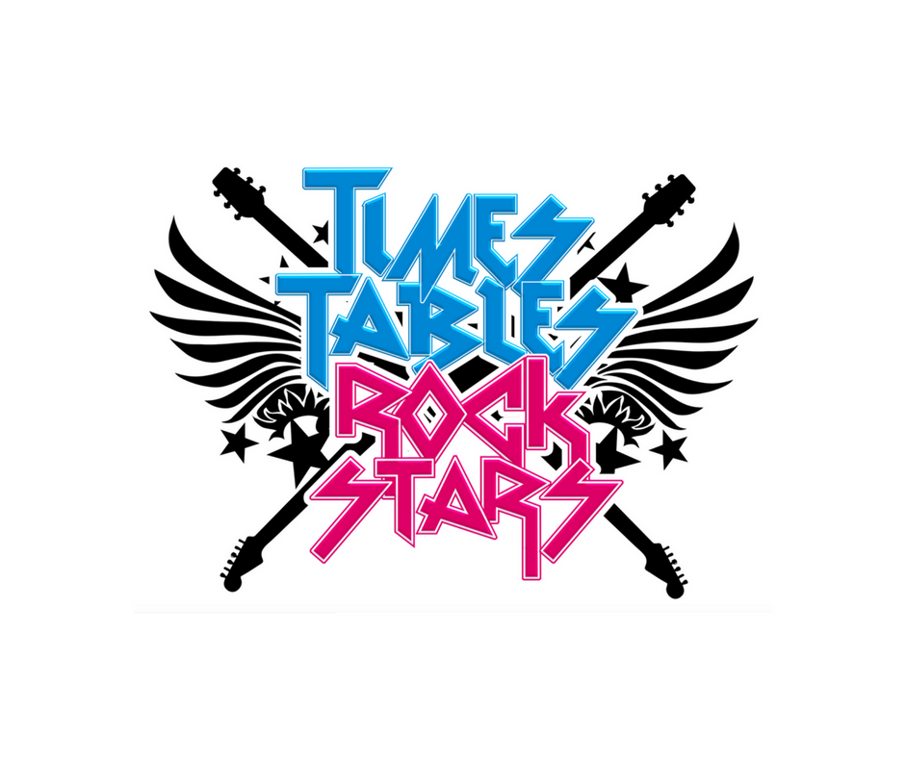

As Readers we will:

be reading the

book ‘Goodnight

Mister Tom’. Our

class book will be

‘The valley of lost secrets’.

What happened in WWII?

As mathematicians we will:

be learning about place value. We will also be having Active maths lessons every Monday.

We will also

continue with

Times tables

Rock stars!

As writers we will:

Be studying the features of job applications before applying for our own. We will then be focusing on narrative based on Goodnight Mister Tom, and finally WWII poetry.