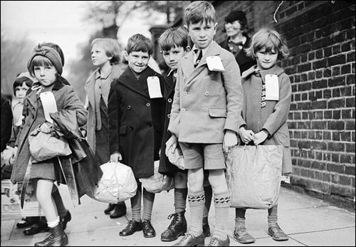

As scientists we will: be exploring the topic ‘Electricity. We will be exploring the history of electricity and important scientific discoveries, then making and experimenting with circuits

As musicians we will:

Be studying the unit ‘ Jazz ’ on charanga

Dear Parents and Year 5/6

In Amethyst this half term we will be continuing to explore the history/Geography topic ‘What happened in WWII?’

Our challenge questions are:

LC1: To know about The Blitz.

LC2: To know The Home Front

LC3: To know about Anne Frank

LC4: To know what happened during The Holocaust.

LC5: To know how the war affected our local area.

LC6: To know how the war ended.

As athletes we will:

be developing our swimming skills and taking part in yoga sessions



Wow Days and trips:

We will be making various WWII recipes including Spam hash, pear crumble, eggless cake and trench stew.

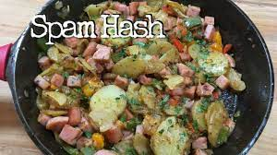

We will be visiting the bomber command centre on our school trip.

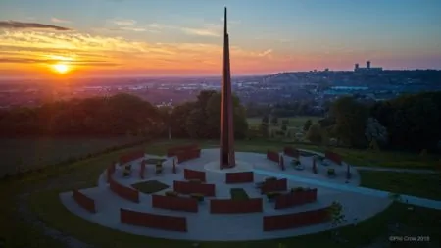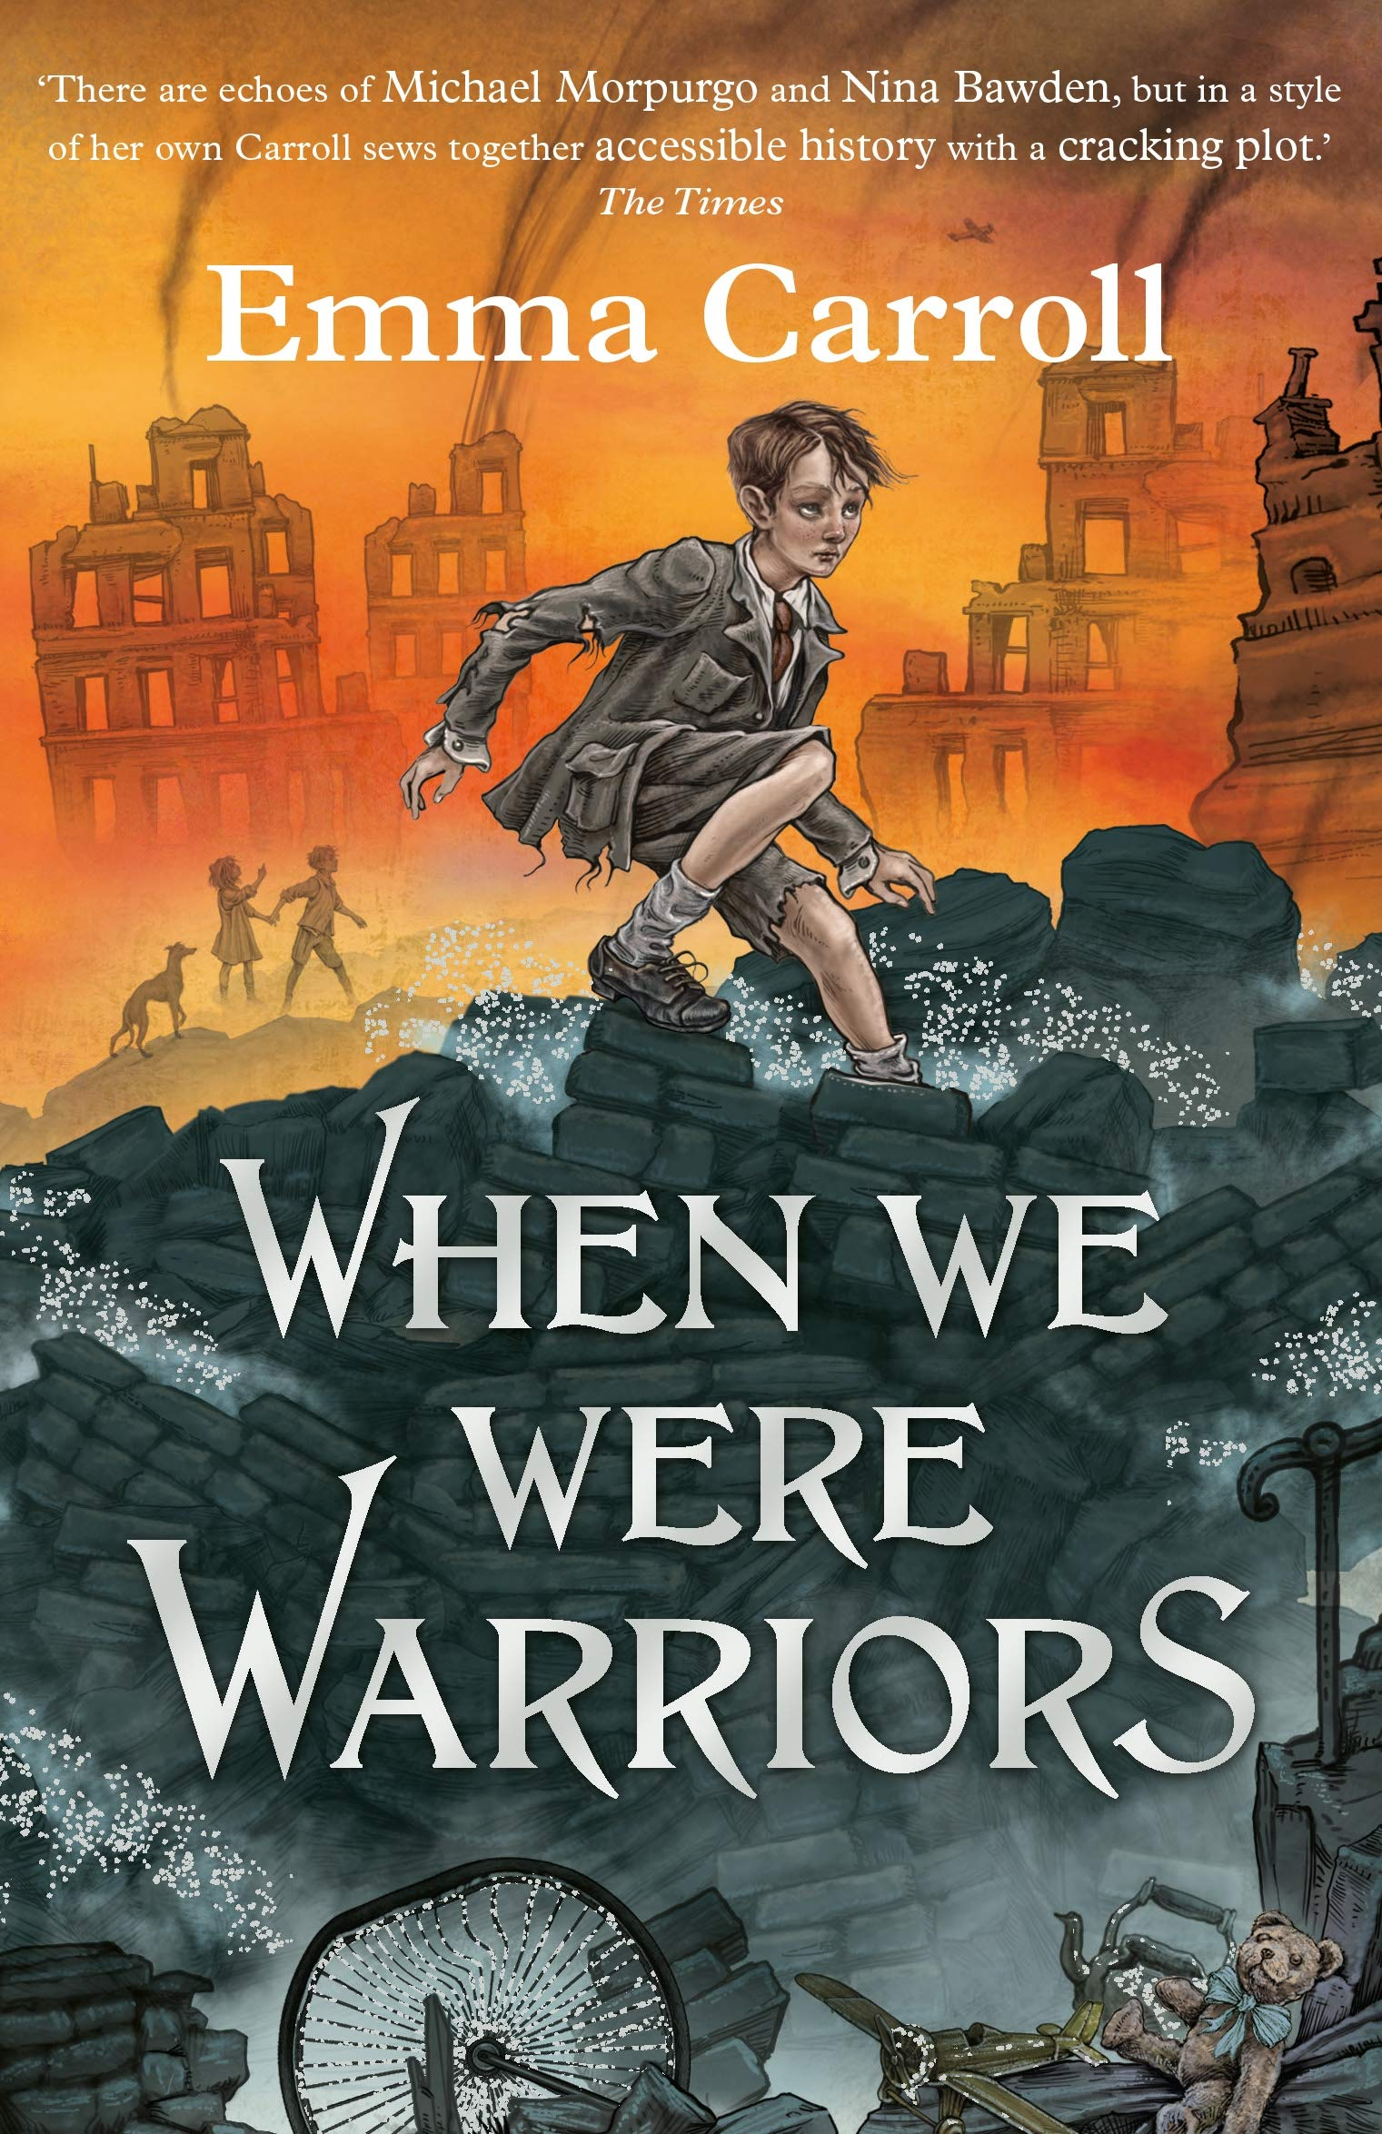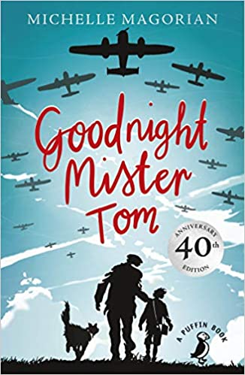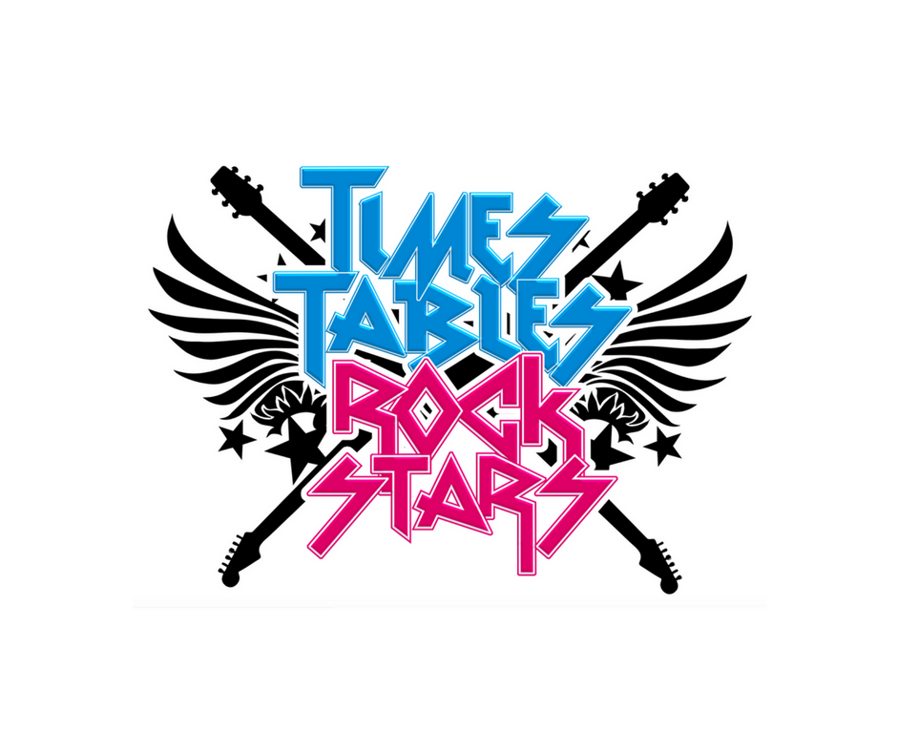

As Readers we will:

be reading the

book ‘Goodnight

Mister Tom’. Our

class book will be

‘Where the warriors were.

What happened in WWII?

As mathematicians we will:

be learning about multiplication and division, and then fractions.

We will also

continue with

Times tables

Rock stars!

As writers we will:

Be studying the features of instructions, before writing our own instructions on what to do in an air raid. We will also be looking at persuasion in Christmas adverts!