Long Term Curriculum Overview Year 5/6 2021 - 2022
‘Believe, Excite, Succeed, Together’
Year group | Year 5/6
 | Autumn 1 | Autumn 2 | Spring 1 | Spring 2 | Summer 1 |  | Summer 2
Key Question  ( Topic name) | What happened during WWII? |  | How diverse is Africa? | Who were the Anglo Saxons and Vikings? | Why is the Amazon Basin important? |  | Who were the Mayans?
Driver | History |  | Geography | History | Geography |  | History
Key events, experiences, trips | Museum of Lincolnshire life  Bomber Command Centre |  | African pen pals
Parental engagement opportunities | WW2 presentations |  | Clarinet performance |  | Class performance
English units and rich texts | Goodnight Mister Tom  The valley of secrets  When we were warriors |  | Journey to Jo’Burg  African tales – A barefoot collection | Viking Boy  Nordic tales  Voyagers | The Explorer  The Great Kapok tree |  | Middleworld  Mayan folktales  The story of chocolate
Maths links and opportunities | Weighing and measuring- rations |  |  | Chronology- dates | Temperatures  /graphs
Science topic | Light | Electricity | Forces |  | Animals Including Humans- Y5 |  | Animals Including Humans- Y6
WS skills opportunities | observing changes over different periods of time,  noticing patterns,  grouping and classifying things,  carrying out comparative and fair tests  and finding things out using a wide range of secondary sources | observing changes over different periods of time,  noticing patterns,  grouping and classifying things,  carrying out comparative and fair tests  and finding things out using a wide range of secondary sources | observing changes over different periods of time,  noticing patterns,  grouping and classifying things,  carrying out comparative and fair tests  finding things out using a wide range of secondary sources. |  | observing changes over different periods of time,  noticing patterns,  grouping and classifying things,  carrying out comparative and fair tests  and finding things out using a wide range of secondary sources |  | observing changes over different periods of time,  noticing patterns,  grouping and classifying things,  carrying out comparative and fair  tests and finding things out using a wide range of secondary sources.
Art |  | Henry Moore |  |  | Perspective within drawing |  | Mayan clay mask sculptures
DT | Anderson Shelter structures |  | Electrical circuits | Mechanisms – pulleys and gears
Music | Happy | Classroom Jazz 2 | Clarinet lessons | Clarinet lessons | Music and me |  | Play songs
PE | Swimming | Swimming | Gymnastics  Badminton | Tag Rugby  Dance | Rounders  Orienteering |  | Athletics  Volleyball
Computing | E safety- Sharing information | Repetition in games – Scratch | E-Safety day  Flat file data | Vector drawing - publisher | Website design |  | Selection in physical computing
RE | LAS Compulsory  Being Human - Hinduism | LAS Compulsory  Being Human - Islam | Salvation  UC 2b.7 (core)  What difference does the resurrection make for Christians? | Incarnation  UC 2b.4 (core)  Was Jesus the Messiah? | LAS Additional  Big Questions (including Christianity):  Why do we celebrate?
Church school values | Justice | Peace and Forgiveness | Love and Compassion | Generosity and Thankfulness | Service and Stewardship |  | Equality
British values | Democracy | Mutual Respect | Individual Liberty | The Rule of Law | Tolerance |  | The best of being British
Global learning links/ international days | 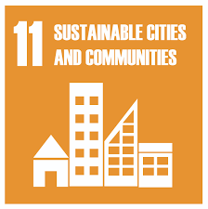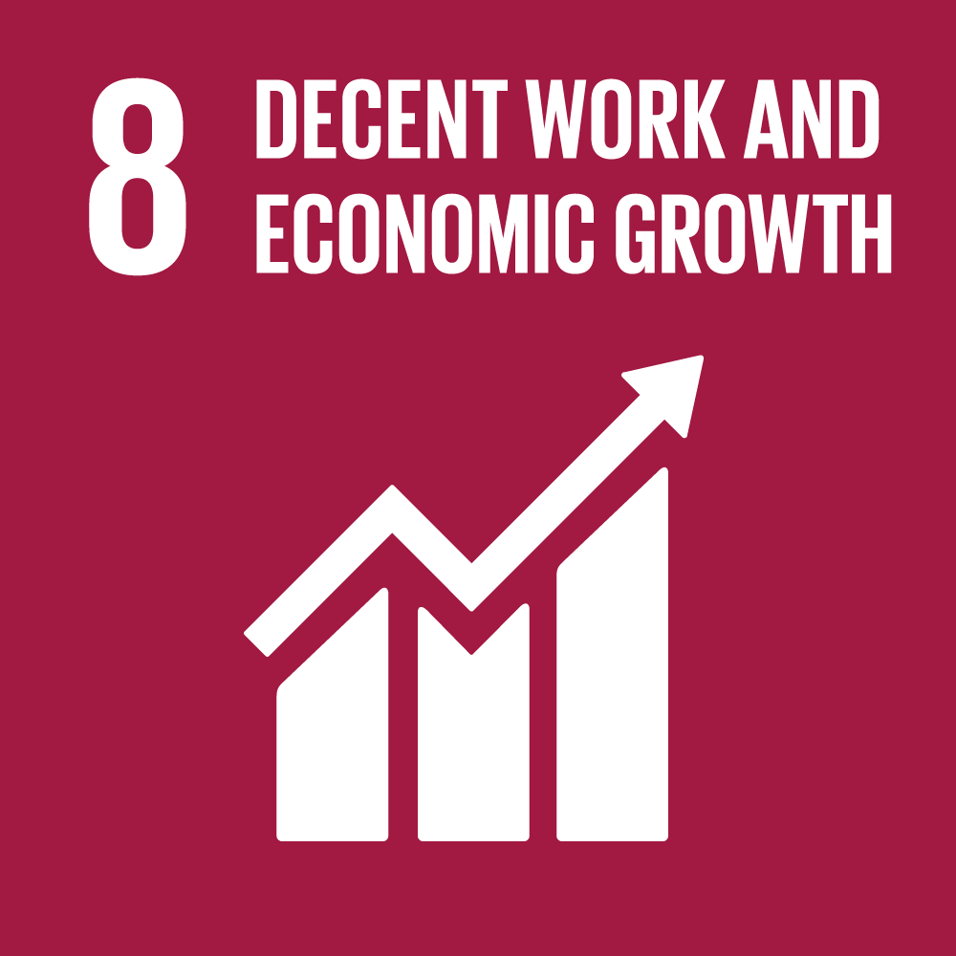 | 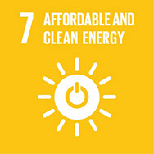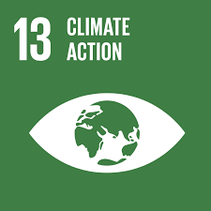 | 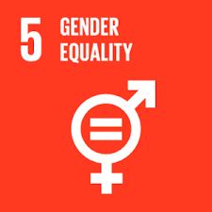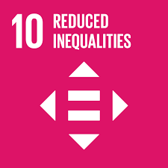 | 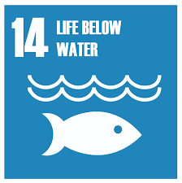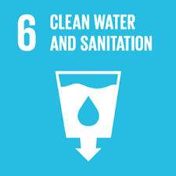 | 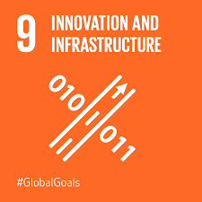
SMSC opportunities | Moral development Understanding the consequences of actions |  | Making appropriate choices about own life and justifying choices |  | Dealing with changes in life. Strategies for challenges and moral dilemmas.
PSHE/ P4C | Living in the wider world – rights and laws | Being responsible Stealing | Computer safety – making friends online | Water safety | Puberty - views | A world without judgement
MFL | French revision of key concepts |  | Life in my home |  | Meet the family , a week in the life
Themed weeks | Democracy Week | Anti-Bullying Week  World Hello Day  Remembrance day | Arts Week  E-Safety Day | World Book Day  Easter | Science week- growing |  | Sports day  Transition

