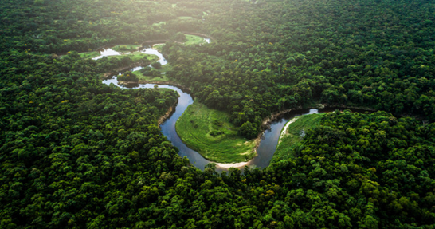

Dear Parents and Year 5/6

In Amethyst this half term we will be looking at the Geography topic ‘Why is the Amazon rainforest important?’

Our challenge questions are:

LC1: To know the locations of the worlds rainforests, and the conditions that create them.

LC2: To know the names and locations of the countries in the Amazon Basin

LC3: To know and label the layers of a rainforest.

LC4: To know how daily life and climate in the Amazon is different to the UK

LC5: To know the effects of deforestation on the Amazon Rainforest.

LC6: To understand the impact of human geography on the rainforest and environmental issues caused by this.

As musicians we will:

Be studying the unit ‘ Music and me’ on charanga

As athletes we will:

Be developing our skills in rounders and orienteering

As scientists we will: be exploring the topic ‘Animals including humans’. We will be learning about changes to the body over time, including puberty,

gestation and life expectancy.



Wow Days and trips:

We will be creating rainforest artwork, and rainforests in a jar.

We will be visiting the Yorkshire wildlife park to learn more about animals in the rainforest on our school trip.

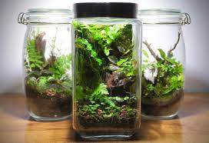

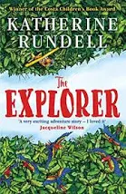

As mathematicians we will:

be focusing on SATs revision, before moving onto measures, area and perimeter.

We will also

continue with

Times tables

Rock stars!

As writers we will:

Be studying the features of poetry, before creating our own. We will then be looking at biographies

As Readers we will:

be reading the

book ‘The

Explorer’ by

Katherine

Rundell

Why is the Amazon Rainforest important?