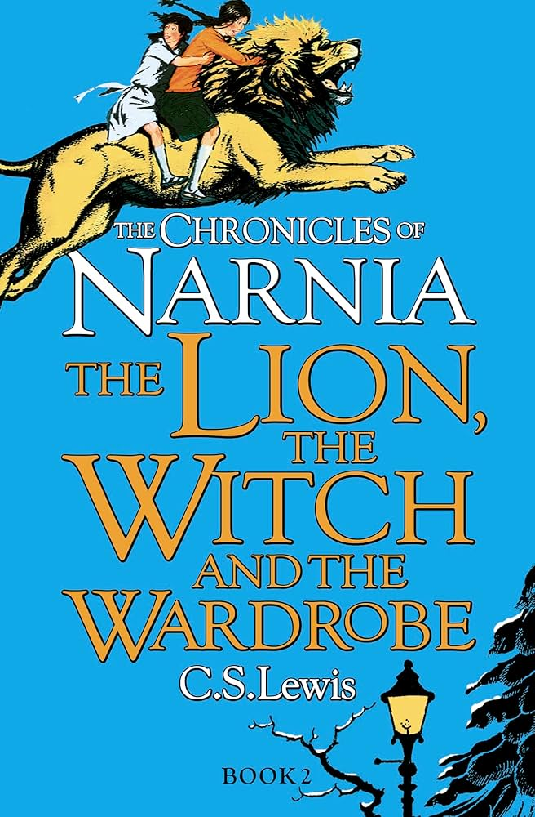

**As readers we will:** be reading ‘The Lion, the Witch and

the Wardrobe’ during our

daily guided reading

sessions.

As our class book, we will continue Steven Butler’s

‘You Ain’t Seen Nothing

Yeti.’

**As musicians we will:** continue our Friday afternoon sessions with The Lincolnshire Music Service.

**As mathematicians we will:** finish our decimals learning from last term, including: partitioning decimals, comparing and ordering them and rounding them to the nearest whole number. We will then apply our learning to money, including adding, subtracting and estimating money. We will also calculate change and solve problems. At the end of the term we will recap shape, mass and capacity and statistics. Please continue to encourage your child to practise their times tables on TT Rockstars.

**As designers we will:** be designing and creating our own wooden, light up boxes!

**Dear Parents and Year 3 and 4 children,**

This term we will be exploring the Geography topic ‘Why are mountains important?

**Our learning challenges for this term are:**

|  |
| --- |
| To know where the main mountain regions are in the UK. |
| To know how mountains are used around the world (tourism) |
| To know some of the dangers of climbing mountains. |
| To know how mountains are formed. |
| To know the names of the world’s highest mountains. |
| To know how the land has changed over time and how the Earth’s crust is made. |

Why are mountains important?

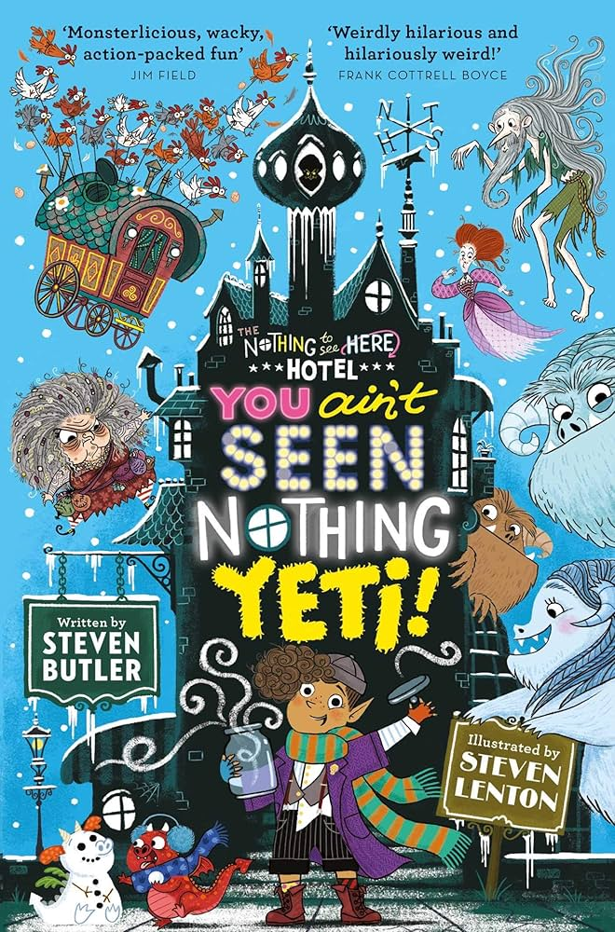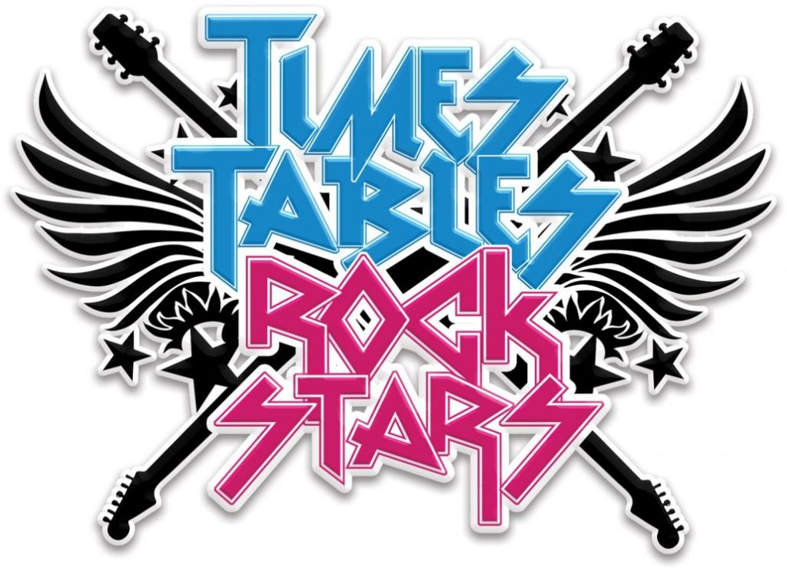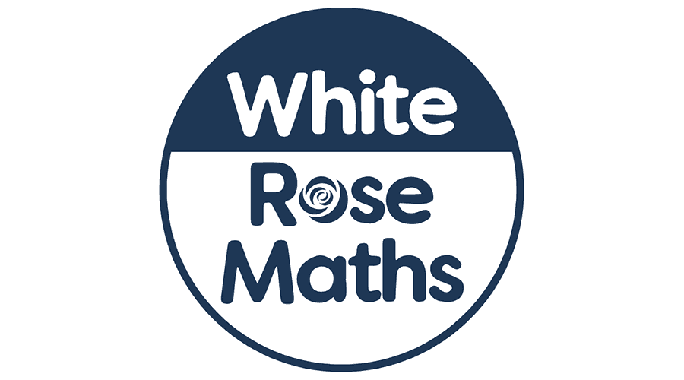

**In French we will:** be learning how to talk about time, including days of the week with Mrs Parry.

**In PSHE we will:** be learning all about living and working in our world, including how we can take care of it.

**As athletes we will:** continue our twice weekly sessions with coach (Monday and Wednesday). We will also be swimming each Thursday morning.

**As authors we will:** complete our information texts about the Anglo Saxons using our knowledge form last term’s learning. For the last few weeks of term we will read Valerie Bloom’s poem, ‘The River’ before writing our own versions of the poem, linked to our topic learning.

**As scientists we will:** be learning about the life cycle of a plant, identifying and describing the functions of different parts of a plant. We will also do some growing of our own!

**In Computing we will:** learn photo editing.

**In R.E we will:** explore the question ‘What does it mean to be a Muslim in Britain today?’.