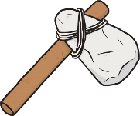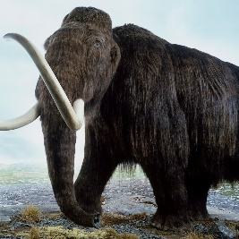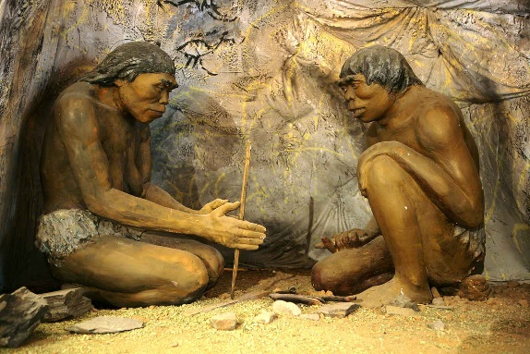

In **PSHE** the children will explore diversity, race and ethnicity alongside positive, caring friendships.

In **Science** we will be learning about forces and magnets. We will compare how things move on different surfaces and observe how magnets attract and repel.

In **Art** the children will be designing and creating their own Stone Age jewellery using clay. They will also create their own cave paintings using sticks and berries.

Emerald

Would you like to live in The Stone Age?

We will be following the White Rose scheme for **Maths** and focussing on addition and subtraction and multiplication and division.

Read Write Inc will continue for our **Reading and Writing**. For some children, **Active English** and **English** lessons will begin.

In **Music** the children will be learning a new Christmas song and developing their listening, appraising and performing skills also using instruments.

In **Computing** we will be learning to programme using Scratch Junior.

In **PE** we will be developing our athletic skills and a range of fundamental skills.

In **RE**, we will explore the question ‘Why does Christmas matter to Christians?’

In **History** this term the children will be exploring the following learning challenges:

LC1 To know where to locate The Stone Age on a timeline

LC2 To know about Stone Age homes

LC3 To ask and answer questions about Stone Age artefacts

LC4 To know about The Stone Age diet

LC5 To know what Skara-Brae is

LC6 To know about The Iron Age and The Bronze Age

Our learning will include a Stone Age experience day from **Wild Woodcraft**!