Long Term Curriculum Overview Year 2/3 2020-2021
Our Vision: At Welbourn we aim to promote and develop Christian attitudes throughout the school, enabling children to make informed decisions and become aware and be tolerant of other cultures and religions. Our school mission statement, “trying our best to be our best,” provides a framework whereby we put children at the centre of all that we do and value aspirations, resilience and independent learning. It has at its heart our Christian focus and our desire to see children grow and develop their God given potential as part of a loving school community: Believe, Excite, Succeed, Together
Year group
 | Autumn 1 | Autumn 2 | Spring 1 | Spring 2 | Summer 1 | Summer 2
Key Question  ( Topic name) | Recovery curriculum / Would you want to step back into the ages? | Would you want to step back in the ages? | Would you like to live in India? | Why is the earth so angry? | What was life like for The Ancient Egyptians? | Which continent would you like to live in?
Driver | History | History | Geography | Geography | History | Geography
Key events, experiences, trips | Art week | Stone Age experience day | Indian experience day. Roots to food. | Magna Science Centre – volcano workshop | Ancient Egypt workshop. The Collection, Lincoln. | Continent experience day.
Parental engagement opportunities | Presentation of work on Microsoft Teams. | Presentation of work on Microsoft Teams.  Nativity. | Presentation of work on Microsoft Teams. | Easter service. | Presentation of work on Microsoft Teams. | Sports day.
English units and rich texts | Stone Age Boy.  Stig of the Dump.  How to Wash a Wooly Mammoth.  Ug: Boy Genius of The Stone Age. | Stone Age Boy.  Stig of the Dump.  How to Wash a Wooly Mammoth.  Ug: Boy Genius of The Stone Age. | Grandma and the Great Gourd. Get off That Camel! T is for Taj Mahal. Ganeesha’s Sweet Tooth. Indian Tales. | Extreme Earth. This Little Pebble. The Pebble in my Pocket. Escape from Pompeii. The Street Beneath my Feet. Under Earth, Under Water. | The Egyptian Cinderella. The Great Egyptian Grave Robbery. The Scarab’s Secret. The Time Travelling Cat and the Egyptian Goddess. | Here We Are. Shine. The Boy Who Sailed the Ocean in an Armchair. To the Edge of the World.
Maths links and opportunities | Tables in science to sort rocks. Measuring. | Tables in science to sort rocks. Measuring. | Rangoli patterns (shapes). Eat well plate – fractions. | Measures. Recording earthquake readings. Graphs. | Properties of shape. Patterns. | Weather and population around the world. Comparing data.
Science topic | Rocks and soils  1. compare and group together different kinds of rocks on the basis of their appearance and simple physical properties  2. describe in simple terms how fossils are formed when things that have lived are trapped within rock  3. recognise that soils are made from rocks and organic matter. | Forces and magnets  1. compare how things move on different surfaces  2. notice that some forces need contact between two objects, but magnetic forces can act at a distance  3. observe how magnets attract or repel each other and attract some materials and not others  4. compare and group together a variety of everyday materials on the basis of whether they are attracted to a magnet, and identify some magnetic materials  5. describe magnets as having two poles  6. predict whether two magnets will attract or repel each other, depending on which poles are facing. | Animals including humans. Year 2.  1. notice that animals, including humans, have offspring which grow into adults  2. find out about and describe the basic needs of animals, including humans, for survival (water, food and air)  3. describe the importance for humans of exercise, eating the right amounts of different types of food, and hygiene. | Animals including humans. Year 3.  1. identify that animals, including humans, need the right types and amount of nutrition, and that they cannot make their own food; they get nutrition from what they eat  2. identify that humans and some other animals have skeletons and muscles for support, protection and movement. | Plants. Year 2.  1. observe and describe how seeds and bulbs grow into mature plants  2. find out and describe how plants need water, light and a suitable temperature to grow and stay healthy.  N/S. Set up a comparative test to show that plants need light and water to stay healthy.  N/S. Introduce the requirements of plants for germination, growth and survival, as well as to the processes of reproduction and growth in plants | Plants. Year 3.  1. identify and describe the functions of different parts of flowering plants: roots, stem/trunk, leaves and flowers  2. explore the requirements of plants for life and growth (air, light, water, nutrients from soil, and room to grow) and how they vary from plant to plant  3. investigate the way in which water is transported within plants  4. explore the part that flowers play in the life cycle of flowering plants, including pollination, seed formation and seed dispersal.
SC1 skills opportunities | Investigation into how durable and permeable rocks are.  Chocolate rock cycle. | Predicting and testing which materials are magnet. Observing changes. | Recording data about animals and comparing it. Asking and answering questions. |  | Children to plant and observe growing bulbs/seeds throughout the summer term. Children to also set up comparative tests. Food colouring plant experiment to show how water is transported.
Geography |  |  | KS1/2 Place Knowledge. Human and physical geography. Locational Knowledge. India | KS1/2 Human and physical geography. Volcanoes and earthquakes. | KS1/2 Place Knowledge. Locational Knowledge. Locate Africa and Egypt on a map. Compare to UK. | KS1/2 Geographical skills and fieldwork. Locational Knowledge. The seven continents and oceans.
History | KS2 -  changes in Britain from the Stone Age to the Iron Age | KS2 -  changes in Britain from the Stone Age to the Iron Age |  |  | KS2 -  the achievements of the earliest civilizations
Art |  | Prehistoric Art.  Clay work. |  | Art and design skills. Kapow. |  | Formal elements of art. Repeating patterns and drawings.
DT | Textiles  Weaving |  | Cooking and nutrition. Food: a balanced diet.  Prepare a savoury dish (Roots to food) |  | Structures: Design and make a pyramid.
Music | South African music | Festivals and Christmas | Playing together in a band | Reggae and animals | A song about being friends | The history of music
PE | Multi skills  Running, throwing, jumping and dribbling  Athletics | Multi skills  Running, throwing, jumping and dribbling  Athletics | Invasion games  Gymnastics: Movement. | Invasion games  Dance: Extreme Earth. | Striking and fielding  Gymnastics: Shape. | Striking and fielding  Dance
Computing | Word processing  E Safety | Scratch | Networks and the internet | Top trumps and data bases | Story board / film | Email
RE | How do different religions show thankfulness? | Why does Christmas matter to Christians? | How are deities and key figures described in Hindu sacred texts and stories? | Why does Easter matter to Christians?  Why do Christians call the day Jesus died ‘Good Friday’? | What is a pilgrimage? | What does it mean to live a good life?
Church school values | Justice | Peace and Forgiveness | Love and Compassion | Generosity and Thankfulness | Service and Stewardship | Equality
British values | Democracy  -class rules  -School Council elections | Mutual respect | Individual liberty | The rule of law | Tolerance | The best of being British
Global learning links/ international days | 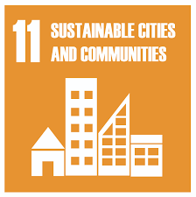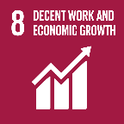 | 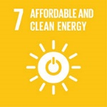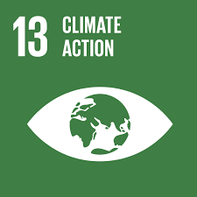 | 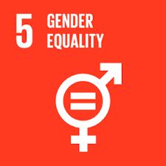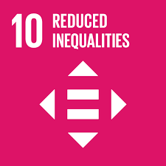 | 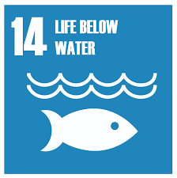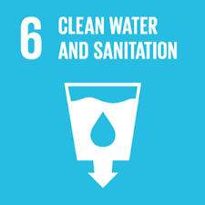 | 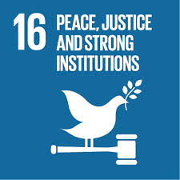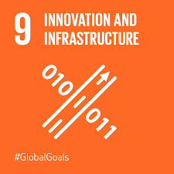
SMSC opportunities

PSHE/ SRE | Families and people who care for me | Caring friendships | Respectful relationships | Mental wellbeing | Being safe | Online relationships
Themed weeks | Well being week / transition / new starts | Anti Bullying Week  World Hello Day | Chinese new year |  | KS1 & KS2 SATs weeks  Sports day | Move up morning - transition

