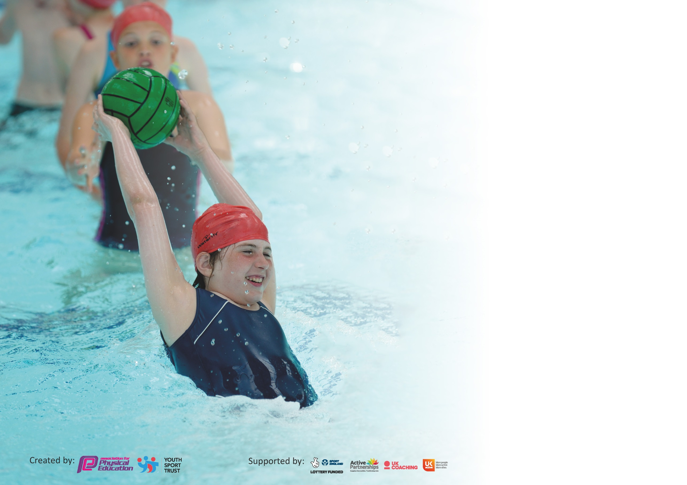

It is important that your grant is used effectively and based on school need. The Education Inspection Framework (Ofsted 2019 p64) makes clear there will be a focus on ‘whether leaders and those responsible for governors all understand their respective roles and perform these in a way that enhances the effectiveness of the school’.

Under the Quality of Education criteria (p41) inspectors consider the extent to which schools can articulate their curriculum (INTENT), construct their curriculum (IMPLEMENTATION) and demonstrate the outcomes which result (IMPACT).

To assist schools with common transferable language this template has been developed to utilise the same three headings which should make your plans easily transferable between working documents.

Schools must use the funding to make additional and sustainable improvements to the quality of Physical Education, School Sport and Physical Activity (PESSPA) they offer. This means that you should
use the Primary PE and Sport Premium to:

- Develop or add to the PESSPA activities that your school already offer
- Build capacity and capability within the school to ensure that improvements made now will benefit pupils joining the school in future years

Please visit gov.uk for the revised DfE guidance including the 5 key indicators across which schools should demonstrate an improvement. This document will help you to review your provision and to report your spend. DfE encourages schools to use this template as an effective way of meeting the reporting requirements of the Primary PE and Sport Premium.

We recommend you start by reflecting on the impact of current provision and reviewing the previous spend.

Schools are required to publish details of how they spend this funding as well as on the impact it has on pupils’ PE and sport participation and attainment by the end of the summer term or by 31st July 2020 at the latest.

We recommend regularly updating the table and publishing it on your website throughout the year. This evidences your ongoing self-evaluation of how you are using the funding to secure maximum, sustainable impact. Final copy must be posted on your website by the end of the academic year and no later than the 31st July 2020. To see an example of how to complete the table please click HERE.

Support for review and reflection - considering the 5 key indicators from DfE, what development needs are a priority for your setting and your pupils now and why? Use the space below to reflect on previous spend and key achievements and areas for development.

Key achievements to date until July 2020: | Areas for further improvement and baseline evidence of need:
- 86% of KS2 attended a sporting event  - 100% of KS1 attended an event  - 61% of the school have attended an extra curriculum club  - Staff have increased confidence in the delivery of Physical Activity  - 86% of the school are at a ‘healthy’ weight (5.3.2020 fitness profiling) | - To maintain good levels of fitness testing data and to improve upon this year’s data.  - Increase active travel to school and push cycle to school week.  - Increase numbers of whole school in extra curriculum clubs  - To increase the percentage of children in inter school events to 100%  - Incorporate active English and SPAG for 2020/21 to increase active minutes in the school day.

Meeting national curriculum requirements for swimming and water safety.
What percentage of your current Year 6 cohort swim competently, confidently and proficiently over a distance of at least 25 metres?  N.B. Even though your pupils may swim in another year please report on their attainment on leaving  primary school at the end of the summer term 2020. | Swimming was due to take place in term 5/6. Unfortunately, this did not happen due to Coronavirus.
What percentage of your current Year 6 cohort use a range of strokes effectively [for example, front crawl, backstroke and breaststroke]?
What percentage of your current Year 6 cohort perform safe self-rescue in different water-based situations?
Schools can choose to use the Primary PE and Sport Premium to provide additional provision for swimming but this must be for activity over and above the national curriculum requirements. Have you used it in this way? | No

Action Plan and Budget Tracking
Capture your intended annual spend against the 5 key indicators. Clarify the success criteria and evidence of impact that you intend to measure to evaluate for pupils today and for the future.

Academic Year: 2019/20 | Total fund allocated: £16870 | Date Updated: 3rd July 2020
Key indicator 1: The engagement of all pupils in regular physical activity – Chief Medical Officer guidelines recommend that primary school pupils undertake at least 30 minutes of physical activity a day in school |  |  |  | Percentage of total allocation:
 |  |  |  | %
Intent | Implementation |  | Impact
Your school focus should be clear what you want the pupils to know and be able to do and about  what they need to learn and to  consolidate through practice: | Make sure your actions to achieve are linked to your intentions: | Funding allocated: | Evidence of impact: what do pupils now know and what can they now do? What has changed?: | Sustainability and suggested next steps:
To support children to be more physically active during the school day.  Delivered active maths lessons interventions with KS1 weekly over the year.  Increase children’s activity levels during break and lunchtimes. | Support the County’s Bikeablilty programme for year 5/6  Attended the Carres Outreach sport conference 12.10.19  Attended Inspire+ conference September 2019.  PE lead delivered staff meeting on ensuring PE sessions are fully active  Utilised the Active School Heatmap toolkit  Purchased circus play equipment for break and lunch activities | £500  FREE  FREE  FREE  FREE  £500 | KS2 children have an understanding of safe, active travel to and from school.  PE lead gained up to date knowledge of changed Ofsted and completed the YST quality mark. (Silver)  Staff meeting increases the profile and understanding  The Heatmaps will allow staff to alter their planning and consider active ways of engaging the children  Children more active at break times | Encourage children to get to school in more active ways and look into incentives (push cycle to school week).  Use the learning from the conferences to influence this and future plans  Next year look at what is needed to secure YST Gold quality mark.  Consider the development or Active English based on heat map tool. Consider more ways of creating an active curriculum including active English and active SPAG.  See heatmaps for next steps  Look into more playground resources to engage children at break times.
Key indicator 2: The profile of Physical Education, School Sport and Physical Activity (PESSPA) being raised across the school as a tool for whole school improvement |  |  |  | Percentage of total allocation:
 |  |  |  | %
Intent | Implementation |  | Impact
Your school focus should be clear what you want the pupils to know and be able to do and about  what they need to learn and to  consolidate through practice: | Make sure your actions to achieve are linked to your intentions: | Funding allocated: | Evidence of impact: what do pupils now know and what can they now do? What has changed?: | Sustainability and suggested next steps:
To achieve a School Games Mark in order to celebrate the achievements within PE, School Sport and Physical Activity  Raising the importance of the daily 60 minutes to the whole school community  Utilise consultancy support from Carre’s Outreach  Inspire+ ambassadors to deliver whole school assemblies. | Working with Carre’s Outreach, develop the inter-school sport calendar in order for all children to participate in sporting competition each term  Shared assembly outlining the importance of 60 daily active minutes via website, twitter and email.  Purchased skipping ropes for the entire school and delivered them to families to encourage daily 60 minutes during lockdown.  Meetings with PE lead and ME to discuss new incentives to encourage daily active minutes.  We will refresh our ideas and approaches towards PESSPA  Children received assemblies from SR, SO, SA, JB-E and BS. | Part of Carre’s Outreach membership  Part of Carre’s Outreach membership  £300  Part of Carre’s Outreach membership | Children experience competition and learn to apply their skills within an appropriately competitive environment.  Children inspired and could recall the names and histories of sporting athletes and Paralympian’s. | To maintain increased number of events attended from term 1 – term 3 before COVID-19.  Work towards sustaining the Gold Games mark in the hope of achieving Platinum in 2 years’ time.  To develop the role of the School Sport Crew so that sport and participation has a voice within the school  Buy-in to Carre’s 2020/21  Look to continue this for next year.

Key indicator 3: Increased confidence, knowledge and skills of all staff in teaching PE and sport |  |  |  | Percentage of total allocation:
 |  |  |  | %
Intent | Implementation |  | Impact
Your school focus should be clear | Make sure your actions to | Funding | Evidence of impact: what do | Sustainability and suggested
what you want the pupils to know | achieve are linked to your | allocated: | pupils now know and what | next steps:
and be able to do and about | intentions: |  | can they now do? What has
what they need to learn and to |  |  | changed?:
consolidate through practice:
Staff to work with Carre’s Outreach in order to feel more confident in the delivery of a range of PE sports and activities  Staff to attend KS1 and KS2 PE training.  Use ASCO to develop the confidence of the NQT in teaching PE | Carre’s Outreach will deliver weekly CPD with teachers following the ‘2 2 2’ approach where appropriate with the teacher.  Access the FA Primary Teachers Award  CS worked weekly with MG over two terms covering invasion game based skills | Part of Carre’s Outreach membership  Free  Part of Carre’s Outreach membership | Children’s surveys will show a positive experience of PE and Sport Activities  PE lead liaise with staff and shared in staff briefing. Teacher appeared more confident when teaching.  NQT more confident in delivering KS2 sport sessions. | See children’s audit results in T6 PE Forum  PE Leader to attend local PE Forums to continue to develop their knowledge and skills  Staff to be supported to develop their teaching practice  AS to have support in delivering PE across three KS2 year groups

Key indicator 4: Broader experience of a range of sports and activities offered to all pupils |  |  |  | Percentage of total allocation:
 |  |  |  | %
Intent | Implementation |  | Impact
Your school focus should be clear | Make sure your actions to | Funding | Evidence of impact: what do | Sustainability and suggested
what you want the pupils to know | achieve are linked to your | allocated: | pupils now know and what | next steps:
and be able to do and about | intentions: |  | can they now do? What has
what they need to learn and to |  |  | changed?:
consolidate through practice:
Children will have positive, memorable experiences that increase their understanding of the range of sports there are  Broaden the opportunities within school for children to be physically active and engaged in sports  Improve confidence of children through delivery of sport  New Sports introduced to school  To give a wider range of sporting opportunities through PE | Carre’s Outreach will deliver sporting sessions with their expert knowledge  Purchase extra after school clubs where the Carre’s Outreach to increase the experience for KS1 pupils  ASCo MG to deliver range of sports to an intervention group  Purchase softball equipment | Part of Carre’s Outreach membership  £1000  Part of Carre’s Outreach membership  £350 | Children experience new skills and consider how to transfer some of their existing skills into new sports  Children have increased confidence and are now able to take that confidence into the classroom and other situations outside of school.  61% of school in Extra curriculum Clubs up till Term 4 | Using expert knowledge of Outreach, draw upon new sports that they become aware of and bring them into the curriculum.  Continue to review the PE curriculum with ME  Work with less active children to find activities they enjoy in a fun environment. (Use Disney Resource)

Key indicator 5: Increased participation in competitive sport |  |  |  | Percentage of total allocation:
 |  |  |  | %
Intent | Implementation |  | Impact
Your school focus should be clear | Make sure your actions to | Funding | Evidence of impact: what do | Sustainability and suggested
what you want the pupils to know | achieve are linked to your | allocated: | pupils now know and what | next steps:
and be able to do and about | intentions: |  | can they now do? What has
what they need to learn and to |  |  | changed?:
consolidate through practice:
To develop the inter school competitions and get 100% of KS2 to an event.  Engage with the local School Games Organiser (SGO) to access their free offer and utilise the enhanced Outreach Events programme so that our children experience our value of “Succeed and Together” when representing their school | Offer to host more events  Attended events  Use of staff and parents to transport to events  Additional hours to be paid to TA staff in order to cover or attend sporting events/activities  Push virtual events through schools social media. | Part of Carres Outreach membership  Free | Maintain the School Game Gold Mark  Children can articulate the link between our school values and their presence in sport; particularly Unity and Friendship  Children are exposed to new activities and environments  86% of KS2 children have represented the school this year in an event up till term 4  100% of KS1 have represented the school in and event up till term 4. | Maintain School Games Gold Mark 2020/2021  Look at the reframe competition, sport formats and play resources on www.yourschoolgames.com  Continue to work with Carre’s and develop the sporting events we attend  Maintain level of engagement in school sport  Boys / girls data aiming to hit 100% next year.

Signed off by
Head Teacher:
Date:
Subject Leader:
Date:
Governor:
Date:

