Talking to your child who is worried about coronavirus (COVID-19)

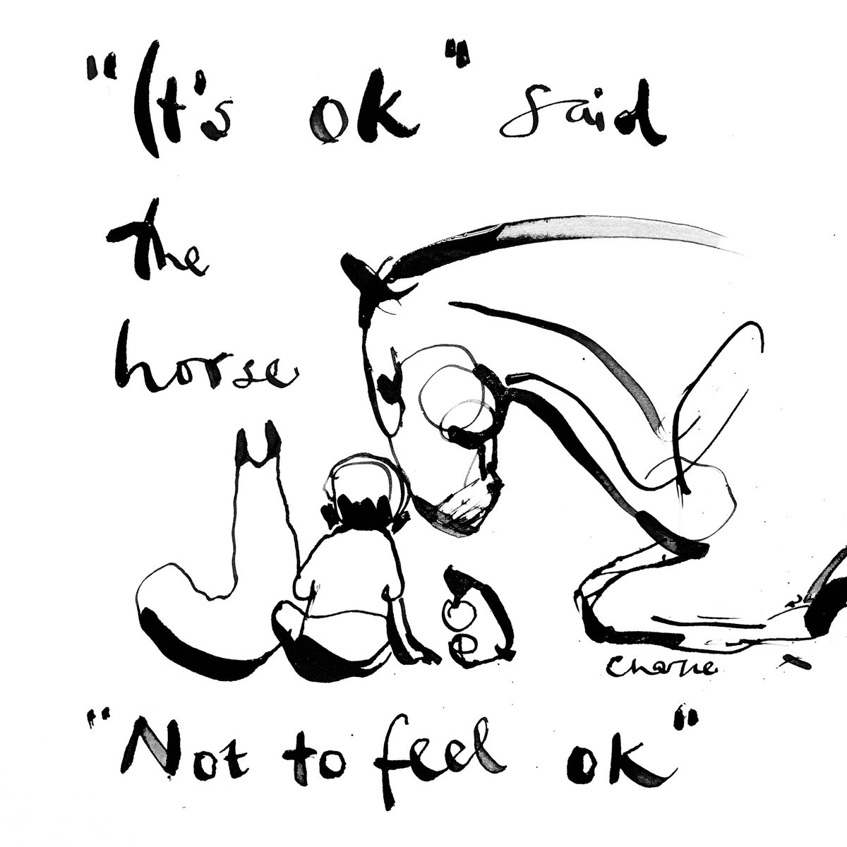

If your child is anxious or worried about coronavirus (COVID-19), there are things you can do to help. And if they're struggling with their mental health, we have advice to help you support them and keep them safe.

There's a lot of uncertainty in the world at the moment. And there won't always be answers to the questions your children are asking. But we can help you have these conversations in a safe and open way.

- Encourage your child to talk to you or another trusted adult about how they’re feeling. We’ve got tips on how and where to have difficult conversations. Remember, this doesn’t always have to be face-to-face – they might find it easier writing their thoughts down. You could create a ‘feelings box’ where you all put good, sad or difficult feelings in and then talk about them at the end of the day.

- For younger children, play can be a great way to help them talk about their worries or give them a good distraction when they're upset. But not being able to play with their friends can be hard. Set aside time to play together and have fun.

- You might notice some changes in your children's behaviour. Younger children may start thumb sucking or bedwetting and older children may have mood swings and be irritable. You might also notice changes in appetite or sleep patterns. These can be ways your child is experiencing stress. It takes time to adjust to the new "normal" and children may need lots of support and reassurance to help them through it.

- Your child might have a very real fear of the people they love and care for dying or getting seriously ill. It can be difficult but it's okay to have conversations about death. Marie Curie has advice on talking to children about death and Childline has advice for young people when someone dies.

- Some young people might be anxious about if there will be enough food. Have conversations about how what they might see in the news or online isn't always the same as what's happening. Involve them in deciding on the food shopping and be mindful of conversations you might have with other adults about frustrations buying food.

- For children with eating disorders, worries about food can be really challenging. Talk to them about their worries and speak to Beat, the eating disorder charity, if you need advice. Read their advice on eating disorders and coronavirus (COVID-19) for up-to-date information and support.

- Rolling news and social media can cause a lot of anxiety. Remind children of the facts and explain what false or sensationalised information is. It's important to allow your children to ask questions about the things they see online. And if you don't know the answer, letting them know that some things aren't certain or known yet is okay.

Keeping in touch with family and friends and balance screen time

- It’s important to understand the huge impact of missing family, friends and schoolmates can have on children of all ages. Let your child express these emotions and don’t minimise their feelings.

- Finding ways to have social interactions can be tricky, especially if you’re worried about screen-time, but it's possible to find the right balance with using smartphones and webcams to keep in touch. Talk together about how you can all manage your screen-time as a family. The benefits of alleviating anxiety by staying connected to friends and family cannot be underestimated.

- With most socialising moving online, it's important to have conversations on how an increase in screen-time can have an impact on everyone's mental health and self-esteem. It's okay to let your children know that the way they might feel is a normal response to an abnormal situation.

Try to create structure and routine

- It's normal for a lack of routine and structure to make children and young people feel anxious and upset. It can be challenging to find a routine that works for everyone, especially if you're juggling working from home with taking care of children with different needs.

- A rota or timetable, even a loose one, can help alleviate anxiety. Structure can help children see what's happening next in the day, look forward to rest of the week and differentiate between weekdays and weekends.

- Finding practical things to do to alleviate anxiety and worries can feel tricky when you're mostly indoors. Some things you can try are yoga, mindfulness, puzzle games, crafting projects, cooking, exercise classes and growing plants from seeds.
Help give children a sense of control

- Uncertainty about the future, like exam results and when they'll be allowed to go out, can be stressful. While there's no right answer, there are lots of free online tools and resources that can help children work through their worries. Have a look online together to find ones that work best for your child and help them feel like they have control.

- Let your children read advice and information that's tailored to them. Childline have advice on coronavirus and lots of tools to help alleviate anxiety. Young Minds have advice for young people on looking after your mental health while self-isolating.

- Share Childline's Calm Zone, a unique space for children and young people filled with breathing exercises, activities, games and videos to help let go of stress.

Signs of depression or anxiety in children

Knowing how to talk to your child about their mental health, or recognising the signs that they might be struggling, can be really hard. Signs of depression or anxiety in children can sometimes look like normal behaviour, particularly in teenagers who can keep their feelings to themselves.

It’s also natural for children or young people to feel stressed or anxious about things like exams or moving to a new school. But while these experiences can be very difficult, they’re different from longer term depression or anxiety, which affect how a child or young person feels every day.

It can help to think about what’s normal for your child and if you’ve noticed signs that they’ve been behaving differently recently.

Signs of depression in children and teenagers can include:

- persistent low-mood or lack of motivation
- not enjoying things they used to like doing
- becoming withdrawn and spending less time with friends and family
- experiencing low self-esteem or feeling like they are ‘worthless’
- feeling tearful or upset regularly
- changes in eating or sleeping habits.

Signs of anxiety in children and teenagers can include:

- becoming socially withdrawn and avoiding spending times with friends or family
- feeling nervous or ‘on edge’ a lot of the time
- suffering panic attacks
- feeling tearful, upset or angry
- trouble sleeping and changes in eating habits.

Helping a child with anxiety or depression

Realising that your child may be struggling with their mental health and experiencing anxiety or depression can be hard to accept. Sometimes parents can feel like it’s their fault or want to know why their child is struggling with a mental health problem. This is completely understandable, but the most important thing you can do is to reassure your child and not judge them for how they’re feeling.

Ways to help a child who’s struggling include:

- letting them know you’re there for them and are on their side
- try talking to them over text or on the phone if they don’t feel able to talk in person
- being patient and staying calm and approachable, even if their behaviour upsets you
- recognising that their feelings are valid and letting them know it’s okay for them to be honest about what it’s like for them to feel this way
- thinking of healthy ways to cope you could do together, like yoga, breathing exercises or mindfulness
- encouraging them to talk to their GP, someone at their school or Childline. Especially if they’re finding it hard to talk at home.
- take care of yourself and get support if you need to. Try not to blame yourself for what’s happening and to stay hopeful about your child’s recovery.

Organisations and websites to support families

www.anxietyuk.org.uk
Anxiety UK is a national charity with local services all over the UK. The website includes resources for parents concerned about their child’s anxiety.
Phone: 0344 477 5774
Email: support@anxietyuk.org.uk
Text: 07537 416 905
Live Chat advisory service: Available during office hours via the website.

www.childline.org.uk
If you’re under 19 you can confidentially call, chat online or email about any problem big or small.
24/7 helpline: 0800 1111
Chat 1:1 with an online counsellor:
www.childline.org.uk/get-support/1-2-1-
counsellor-chat
To email: Sign up on the website, so you can
send your message without needing to use
your name or email address, at
www.childline.org.uk/registration
Tips on managing anxiety:

www.nopanic.org.uk
Support for people suffering from panic attacks, OCD, phobias, and other issues related to anxiety. Also provides support for carers of sufferers.
Helpline (open daily 10am-10pm):
0844 967 4848
Youth Helpline: 0330 606 1174

NHS England
www.nhs.uk/conditions/anxiety-disorders-inchildren/
Provides an overview of anxiety symptoms,
tips that can help, treatment options and
details of anxiety specific support services

Young Minds Parents Lounge
www.youngminds.org.uk/find-help/forparents/parents-lounge
Our Parents Helpline experts answer questions about anxiety.
https://youngminds.org.uk/find-help/for-parents/parents-guide-to-support-a-z/

Beat eating disorders
https://www.beateatingdisorders.org.uk/coronavirus
Advice here for anyone struggling with an eating disorder and ways to deal with food anxiety.

Bereavement and Loss

Hope Again
Cruse Bereavement Care’s website for young people with information, vlogs, podcasts, videos and personal stories.
To access support, young people can email hopeagain@cruse.org.uk

winstonswish.org
Information, advice and guidance on supporting bereaved children and young people during the coronavirus outbreak and our updated services and opening times.

https://www.childbereavementuk.org
Information, advice and support for bereaved children.

https://www.mariecurie.org.uk/help
For support with terminal illness and talking to children about bereavement.

And finally…
Focus on what you’re doing to stay safe. An important way to reassure children is to emphasise the safety precautions that you, and others around you, are taking. Children feel empowered when they know what to do to keep themselves safe. Remind your children that washing their hands is actually helping everyone by stopping the spread of the virus. Involve them in your family’s ongoing safety plan. That could mean letting them choose masks for the family, or coming up with a new 20-second song (we’re all a little tired of Happy Birthday!) to sing while you wash your hands.
Stay safe and well

