Welbourn Church of England Primary School
‘Believe, Excite, Succeed, Together’
Topaz
Topic: How did The Great Fire of London start? |  | EYFS/ Year 1
Important People
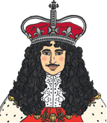
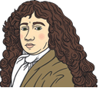

Samuel Pepys Thomas Farriner King Charles II

Key Vocabulary
bakery | A place that makes bread, cakes, etc…
St. Paul’s Cathedral | A very large church in London. A new St Paul’s Cathedral was built after the fire.
diary | A book that people write about their lives in.
firebreak | A gap that stops a fire spreading to nearby buildings.

Map of London showing the spread of the fire

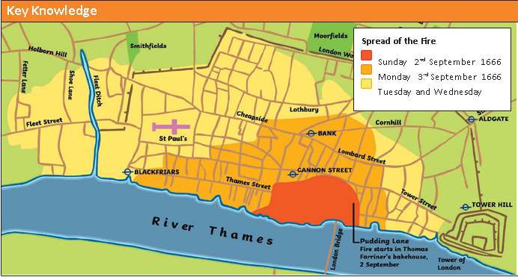
Key Events and Facts
When and where did the fire start? | The fire started on Sunday 2nd September 1666 in Thomas Farriner’s bakery on Pudding Lane.
Why did the fire start? | The fires used for baking were not put out properly.
Why did the fire spread so quickly? | In 1666, the buildings in London were made of wood and straw and they were very close together, making it easy for the flames to spread. It had also been a dry summer, so the buildings were dry. Strong winds were blowing, which helped the flames to spread.
How did people try to put the fire out? | People used leather buckets and water squirts to try to put the fire out, but these did not work. Later in the week, King Charles II ordered buildings to be pulled down to stop the flames from spreading.
How and when was the fire put out? | By Thursday 6th September, the wind had died down. This meant that people were able to put out the flames.
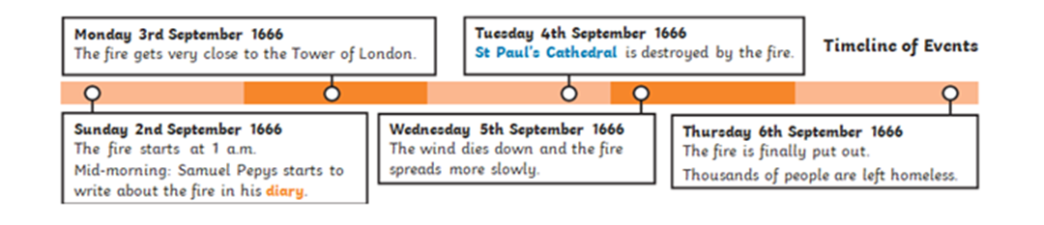

The Great Fire of London monument Many people escaped the fire by boat.
to commemorate the fire.
