Welbourn C of E Primary School
‘Believe, Excite, Succeed, Together’
History and Geography Long Term Overview – Cycle A
 | Autumn | Spring |  | Summer
Rec/Y1 | What happens to the letters we post?  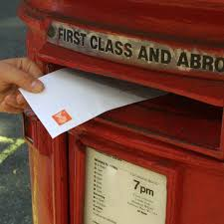 | How are toys different to a long time ago?  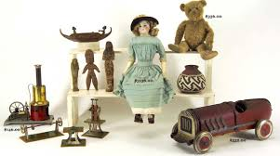 | Would you rather live in Kenya or Welbourn?  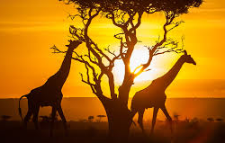 | How did the Great Fire of London start?  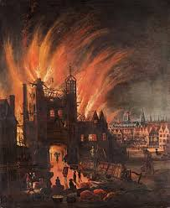 | What type of animals live in the jungle?  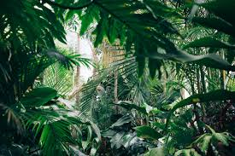
Year 2/3 | Would you want to step back into the ages?  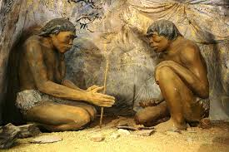 | Would you like to live in India?  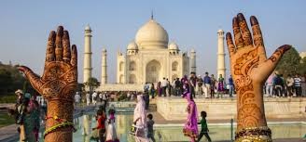 | Why is the earth so angry?  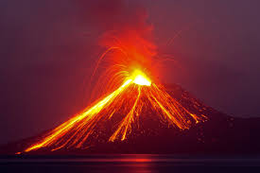 | What was life like for the Ancient Egyptians? 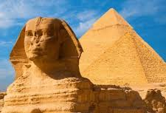 | Which continent would you like to live in?  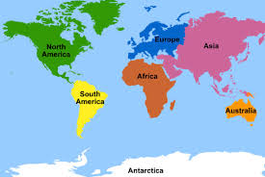
Year 4/5/6 | How did life change in the Victorian era?  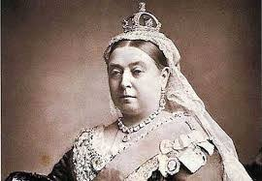 | Why is our world wonderful? 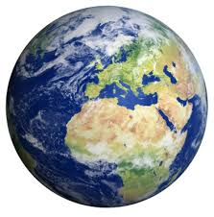 | How can we save our planet? 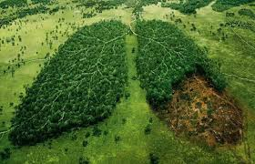 | Who were the Ancient Greeks?  