Welbourn C of E Primary School
‘Believe, Excite, Succeed, Together’
History and Geography Long Term Overview – Cycle B
 | Autumn |  | Spring |  | Summer
Rec/Y1 | What is marvellous about me? |  | Why were castles built?  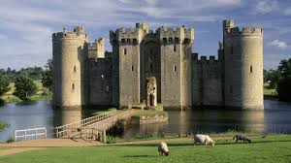 | What causes a commotion in the ocean?  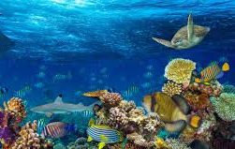 | Who were Florence Nightingale and Mary Seacole?  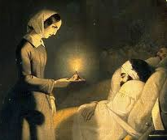 | Why do we like to be beside the seaside?  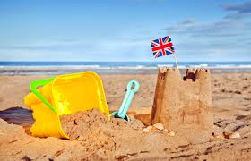
Year 2/3 | What did the Romans do for us?  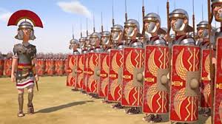 | What was life in Roman Lincoln like?  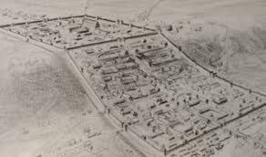 | Who explored the world?  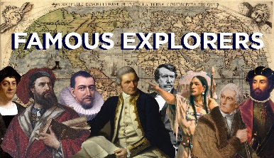 | Where does the river flow?  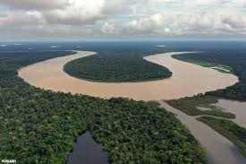 | What was life like for the Saxons?  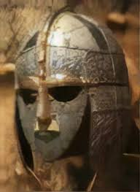 | Why are mountains important?  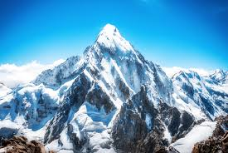
Year 4/5/6 | How have wars affected us today?  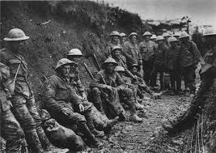 |  | How diverse is Africa?  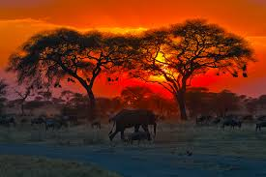 | Who were the Anglo Saxons and Scots?  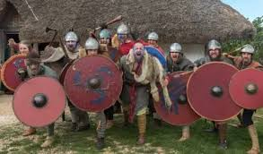 | Why is the Amazon Basin important?  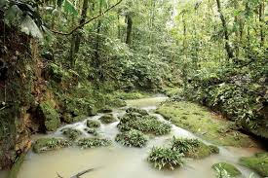 | Who were the Mayans?  