Long Term Curriculum Overview Year 4/5/6 2020 - 2021
Our Vision: At Welbourn we aim to promote and develop Christian attitudes throughout the school, enabling children to make informed decisions and become aware and be tolerant of other cultures and religions. Our school mission statement, “trying our best to be our best,” provides a framework whereby we put children at the centre of all that we do and value aspirations, resilience and independent learning. It has at its heart our Christian focus and our desire to see children grow and develop their God given potential as part of a loving school community: Believe, Excite, Succeed, Together
Year group
4/5/6
 | Autumn 1 | Autumn 2 | Spring 1 | Spring 2 | Summer 1 | Summer 2
Key Question  (Topic name) | Would you like to be a Victorian? |  | Our wonderful world |  | Who were the Ancient Greeks?
Driver | History |  | Geography |  | History and Geography
Key events, experiences, trips  (Covid dependent) | Dress as a Victorian day  Victorian Christmas  Southwell workhouse trip |  | Planetarium |  | Greek workshop
Parental engagement opportunities | Victorian Christmas |  |  | Easter service |  | Sports day
English units and rich texts | Cogheart (All)  Gaslight (5/6)  Hetty Feather (4/5)  Street Child (5/6) |  | Orphans of the tide  Cosmic | Wonder (5/6)  Theres a boy in the girls bathroom (4/5) | Who let the Gods out (All)  Greek Myths (All)
Maths links and opportunities | Place value  Addition and subtraction  Science – Venn diagram and sorting activities
Science topic | Properties of materials (Y5)  (Magnets recap) |  | Earth and Space (5) | Living things and their habitats (5) | Classification (6) | Evolution and inheritance (6)  (Rocks and soils recap)
SC1 skills opportunities | Skills covered:  Asking relevant questions and using different types of scientific questions to answer them.  Setting up simple practical enquiries, comparative and fair tests.  Making systematic and careful observations, and where appropriate, taking accurate measurements using standard units, using a range of equipment, including data loggers and thermometers.  Gathering, recording, classifying and presenting data in a variety of ways to help in answering questions.  Recording findings using simple scientific language, drawings, labelled diagrams, keys, bar charts, and tables.  Using results to draw simple conclusions, make predictions for new values, suggest improvements and raise further questions.  Identify differences, similarities or changes related to simple scientific ideas and processes. | Skills covered:  Asking relevant questions and using different types of scientific questions to answer them.  Setting up simple practical enquiries, comparative and fair tests.  Making systematic and careful observations  Gathering, recording, classifying and presenting data in a variety of ways to help in answering questions.  Recording findings using simple scientific language, drawings, labelled diagrams, keys, bar charts, and tables.  Reporting on findings from enquiries, including oral and written explanations, displays or presentations of results and conclusions. | Skills covered:  Setting up simple practical enquiries, comparative and fair tests.  Making systematic and careful observations, and where appropriate, taking accurate measurements using standard units, using a range of equipment, including data loggers and thermometers.  Gathering, recording, classifying and presenting data in a variety of ways to help in answering questions.  Recording findings using simple scientific language, drawings, labelled diagrams, keys, bar charts, and tables.  Reporting on findings from enquiries, including oral and written explanations, displays or presentations of results and conclusions.  Using results to draw simple conclusions, make predictions for new values, suggest improvements and raise further questions.  Identify differences, similarities or changes related to simple scientific ideas and processes.  Using straightforward scientific evidence to answer questions to support findings. |  | Skills covered:  Setting up simple practical enquiries, comparative and fair tests.  Making systematic and careful observations, and where appropriate, taking accurate measurements using standard units, using a range of equipment, including data loggers and thermometers.  Gathering, recording, classifying and presenting data in a variety of ways to help in answering questions.  Recording findings using simple scientific language, drawings, labelled diagrams, keys, bar charts, and tables.  Reporting on findings from enquiries, including oral and written explanations, displays or presentations of results and conclusions.  Using results to draw simple conclusions, make predictions for new values, suggest improvements and raise further questions.  Identify differences, similarities or changes related to simple scientific ideas and processes.  Using straightforward scientific evidence to answer questions to support findings. | Skills covered:  Asking relevant questions and using different types of scientific questions to answer them.  Setting up simple practical enquiries, comparative and fair tests.  Making systematic and careful observations, and where appropriate, taking accurate measurements using standard units, using a range of equipment, including data loggers and thermometers.  Gathering, recording, classifying and presenting data in a variety of ways to help in answering questions.  Recording findings using simple scientific language, drawings, labelled diagrams, keys, bar charts, and tables.  Using results to draw simple conclusions, make predictions for new values, suggest improvements and raise further questions.  Reporting on findings from enquiries, including oral and written explanations, displays or presentations of results and conclusions.  Using straightforward scientific evidence to answer questions to support findings.
Geography |  |  | As above (Topic) | As above (Topic) | As above (Topic)
History | As above (topic) |  |  |  | As above (Topic)
Art |  |  | Famous artists, architects and designers | Observational drawing | Painting skills
DT | Textiles (Weaving) | Woodwork Lanterns |  |  |  | Cooking
Music | Livin’ on a prayer | Classroom Jazz 1 | Make you feel my love | The Fresh Prince of Bel-Air | Dancing in the Street | Reflect, Rewind and Replay
PE | Orienteering  Athletics | Lacrosse  Dance | Volleyball  Gymnastics | Tag Rugby  Dance | Swimming  Quick-Cricket | Swimming  Tennis
Computing | Online safety-  The internet - reliability | Repetition in shapes – editing a screen turtle | Data logging | Photo editing | Audio editing-  Audacity | Scratch – Recap of skills  Film
RE | LAS Additional  Expressing Beliefs through the Arts (including Christianity) | LAS Compulsory  Community- Hinduism | LAS Compulsory  Community –Islam | Creation  UC 2a.1 (core)  What do Christians learn from the creation story? | LAS Additional  Pilgrimage (including Christianity)
Church school values | Justice | Peace and Forgiveness | Love and Compassion | Generosity and Thankfulness | Service and Stewardship | Equality
British values | Democracy  -class rules  -School Council elections | Mutual respect | Individual liberty | The rule of law | Tolerance | The best of being British
Global learning links/ international days | 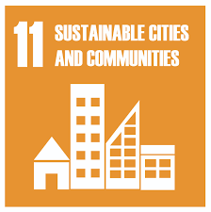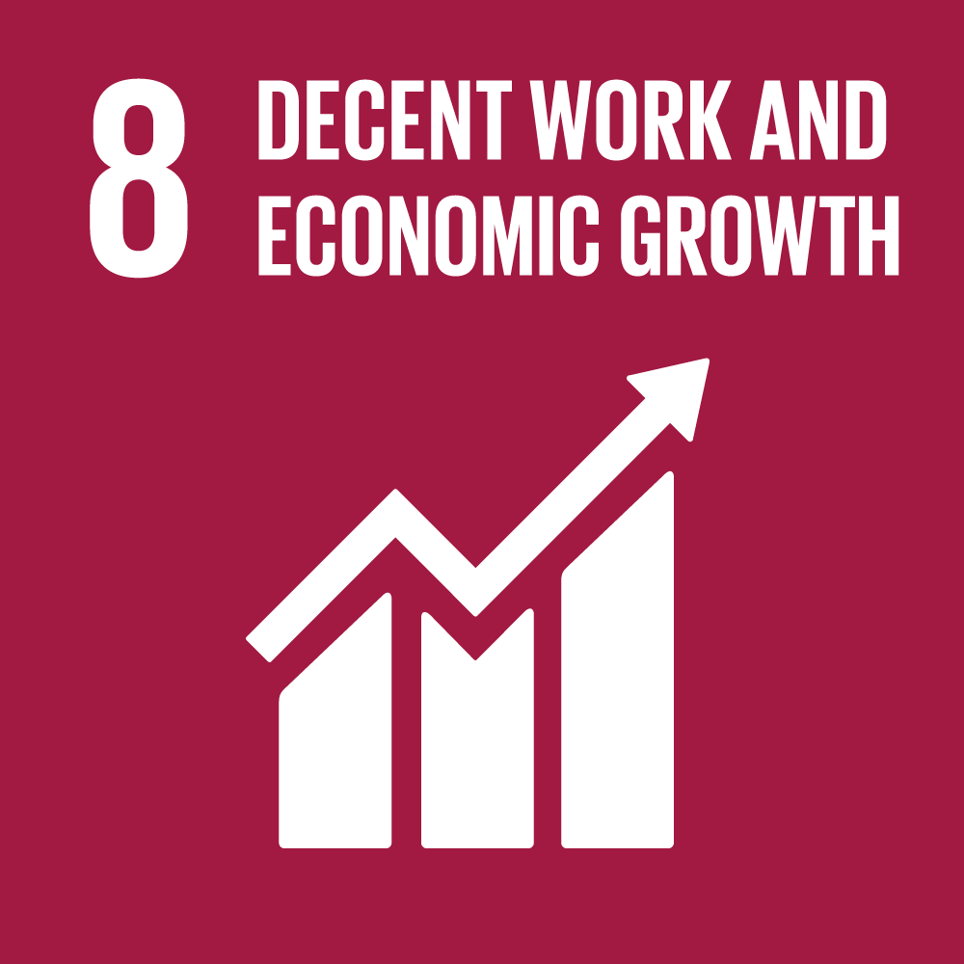 | 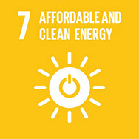 | 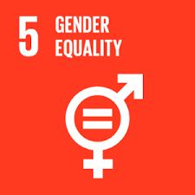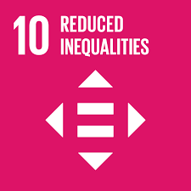 | 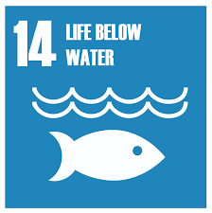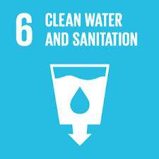 | 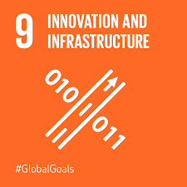
SMSC opportunities | Relationships/family diversity | Health and wellbeing  Sports awareness | Cultural traditions  Self esteem | Living in the wider world  Cultural traditions  Relating to others | Relationships | Empathy  Social skills- developing friendships
PSHE | Puberty/ appropriate touch | Being safe – cycle safety/ peer pressure | Feelings and emotions  (jealousy/ anger) | Bullying/online safety | Healthy living | Being responsible
MFL | Recovery curriculum | Recap basics (days/months/numbers/colours) | All about me | Food | Hobbies | Family
Themed weeks |  | Anti Bullying Week  World Hello Day |  | World Book day  Science week

