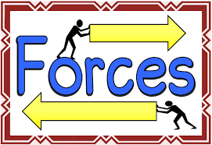
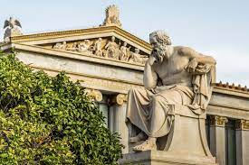
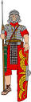
As global citizens we will: be exploring the topic of inspirational women and
their religions.

As designers we will: be exploring the: Sculpture and 3D
Interactive Installation unit.

Dear Parents and Year 5 and 6
In Moonstone this half term we will be exploring the history topic ‘Who were the Ancient Greeks?.
Our challenge questions are:
LC1: To know about the Ancient Greek Empire
LC2: To know how the political system worked in Ancient Greece
LC3: To know about the Ancient Greek Olympics
LC4: To know about the Battle of Marathon
LC5: To know about Greek Gods and Godesses
LC6: To know about the Trojan War.

As scientists we will: be studying the topic of ‘Forces’ We will be exploring gravity, air resistance, water resistance,
friction and the use of different
levers and mechanisms.

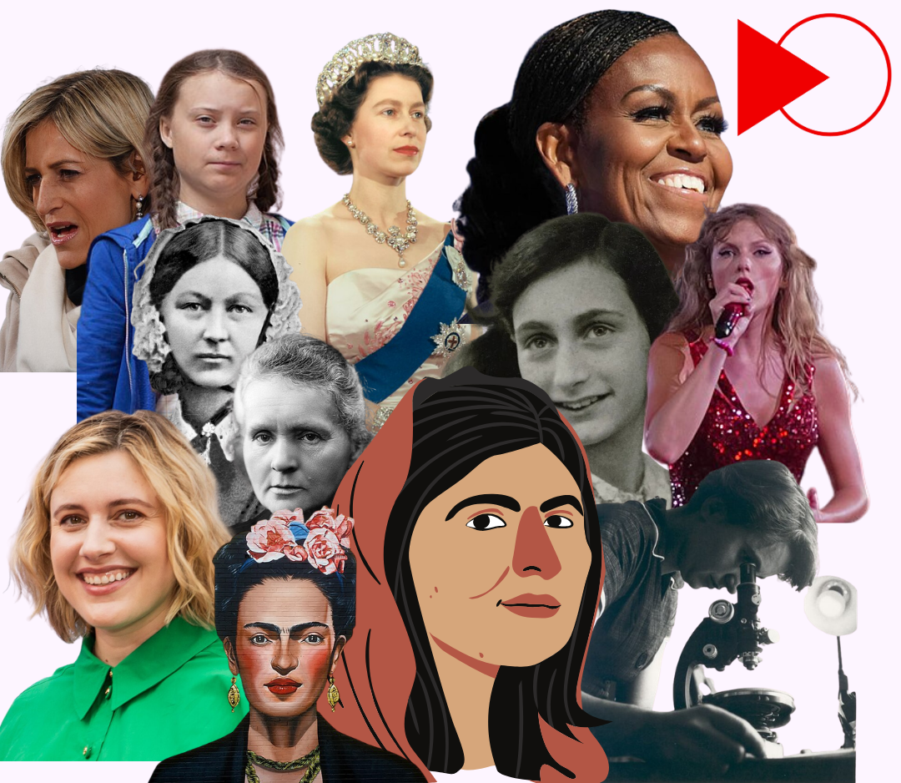

As writers we will:
be writing a newspaper report and an explanation text. We will also be developing
our spag knowledge through ‘Active English’ and revising for the SATs.

Who were the Ancient Greeks?
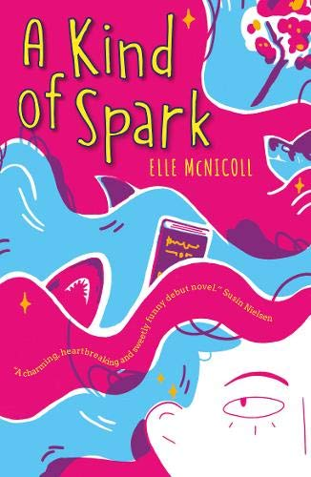
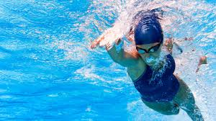
In PSHE, we will be: looking at the ‘Engage’ module on My Happy Mind

In PE, some children will be starting swimming lessons every Monday. We will also be developing
skills in tennis
and cricket.

In IT, we will be: learning about spreadsheets and how to use them.

As mathematicians we will be learning about fractions, decimals and percentages, before moving onto algebra and ratio. Y6 will also be having revision sessions in preparation for SATS.
As readers we will:
be finishing our current text ‘A Kind of Spark’.
We will also be
reading short
SATs style texts.

