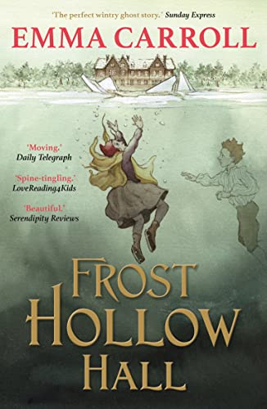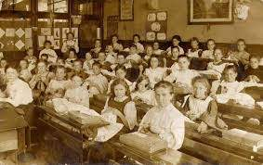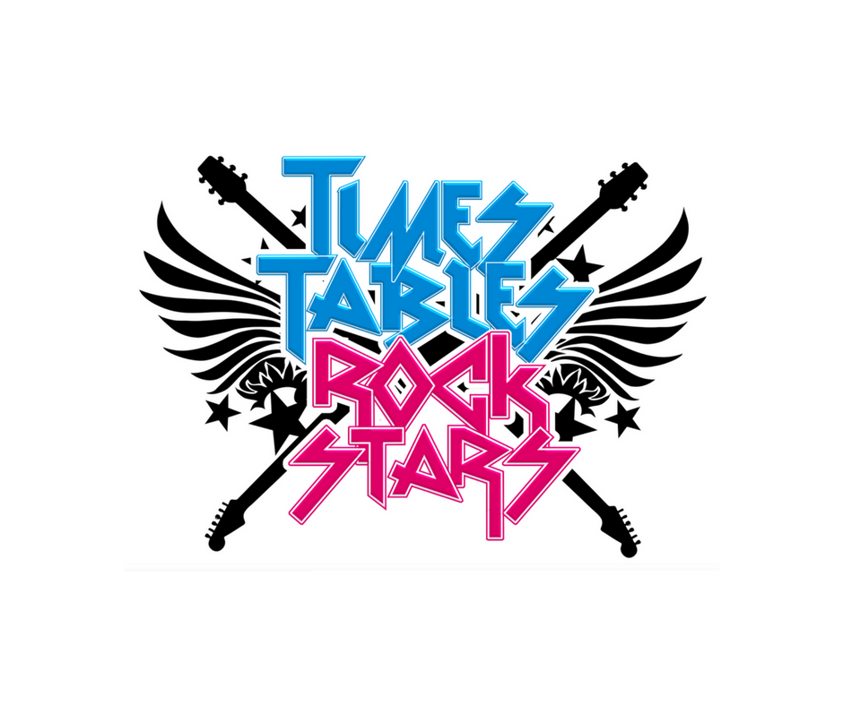=-6

In RE lessons we will: be exploring the unit ‘How is Muslim worship expressed collectively?

As artists we will: be focusing on drawing: Depth, emotion and movement.

In PSHE we will: be learning about staying safe and continuing ‘My happy mind’

In ICT be learning about systems and searching.

In PE we will: be developing our teamwork skills with coach George from Lincoln City.

Dear Parents and Year 5 and 6 children:

Welcome to the new academic year in Moonstone. This term we will be exploring the history topic ‘How did life change in the Victorian era?’

We will be learning:

To know what happened during the Industrial Revolution.

To know who Queen Victoria was.

To know about Victorian childhood.

To know what life was like in the workhouse.

To know about developments and advances in technology.

To know about Victorian homes.

To know about Victorian leisure.

As scientists we will:

be focusing on the topic ‘Properties and changes of materials We

will be exploring thermal

conductors and insulators, irreversible changes, dissolving and separating mixtures!

As readers we will:

be reading ‘Gaslight’

by Eloise Williams.

We will be

concentrating on pace

and punctuation and then

will be comparing it

to our Victorian topic

and to our class

book, Frost Hollow

Hall.

As authors we will: be writing a narrative focusing on character descriptions, based on the characters in ‘Gaslight’. We will then be writing a non-fiction information text based on the Victorians. We will continue to revisit and develop SPAG knowledge through Active English.

As mathematicians we will:

be focusing on number and place value, addition and subtraction, measurement and statistics.

We will also be climbing the leader board on Times Tables Rock Stars!

How did life change in the Victorian era?