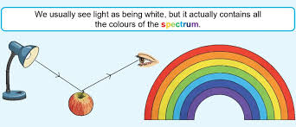
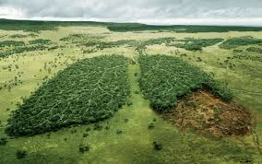
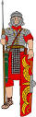
Dear Parents and Year 4,5 and 6
In Amethyst this half term we will be exploring the geography topic ‘How can we save our world?.
Our challenge questions are:
LC1: To know about developing countries.
LC2: To know what biodiversity is and how humans have affected it.
LC3: To know how endangered animals have been affected by humans.
LC4: To know what climate change is.
LC5: To know how pollution affects the ocean.
LC6: To know what renewable energy is.

Wow Days:
We will be visiting the recycling plant in Hykeham as part of our focus in Geography on recycling and saving our planet. 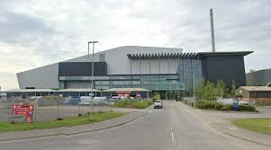

As scientists we will:
be studying ‘Light’. We will be looking at the parts of the eye, how
light travels, reflection
and refraction.

As designers, we will:
be researching and designing a device to alert people when the temperature of an animal enclosure is too high or low using micro bits.
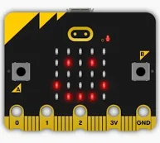

How can we save our world?
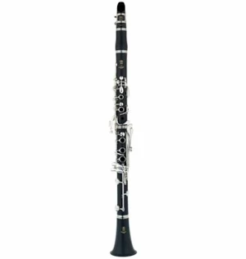
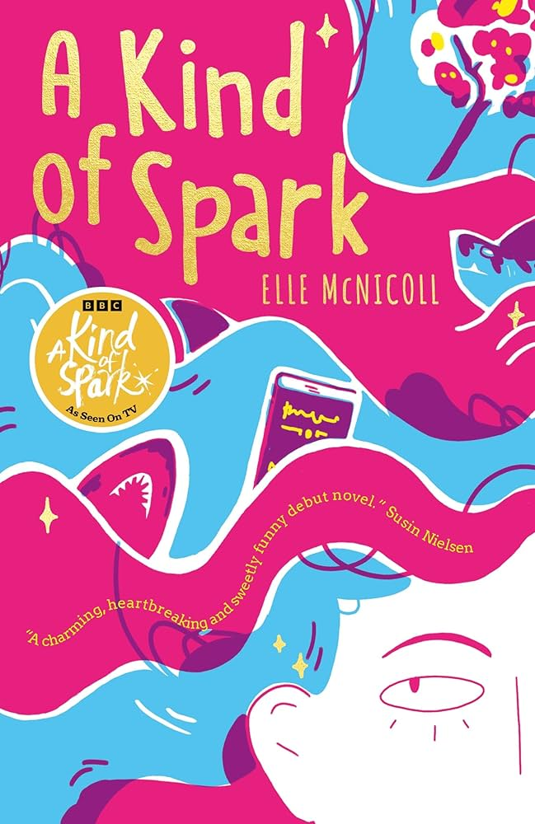
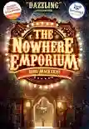
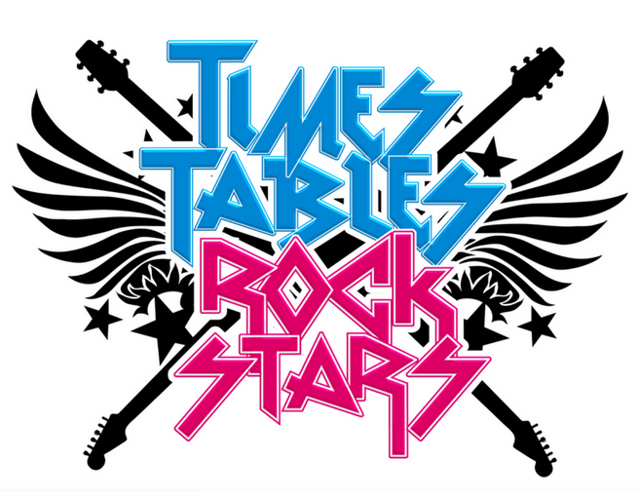
As writers we will:
Be writing our own narrative, and refreshing our spag knowledge through ‘Active English’
As Musicians we will:
be continuing to learn how to play the
clarinet
with
Mr Roberts

As Readers we will:
be finishing our book ‘The nowhere Emporium’ before beginning our next
book ‘A kind of spark’.
We will also be
Celebrating world book
Day on Thursday 5th
March.
.

As mathematicians we will:
be continuing to learn about fractions before moving onto decimals!

We will also
continue with
Times tables Rock stars!

