

Welbourn Church of England Primary School

‘Believe, Excite, Succeed, Together’

Friday 13th December 2019

Dear Parents and Carers,

I can’t believe it is December already! We’ve certainly been getting into the Christmas spirit. Our School and Worship Councils have been busy decorating the hall and delivering Christmas cards to classes. We have a post-box in school if your child would like to post Christmas cards for their friends. Topaz and Emerald Class are busy preparing for their Nativity performance.

Our choir sang beautifully at Sir William Robertson school last week and continue to practise their songs in preparation for their performances at the Carol Service at St Chad’s church this Sunday, the Christingle Service and at the local residential homes.

Thank you to all of the parents who donated pyjamas to the Children’s ward, two School Council members delivered them all last Friday, their photograph is in the newspaper. Thank you also to everyone who came to school in a Christmas jumoer to raise money for Save the Children.

I would like to say a huge congratulations to Mrs Puttock (was Miss Cottam) for completing and passing her SEND accreditation with Northampton University.

There will be another Christmas newsletter next week to share our festive celebrations and events. Please also follow Twitter for updates.

Kind regards

Mrs Boulter

Dates for your diary

**13.12.19. – 5.30pm** Christmas Fayre at school

**17.12.19. -** Topaz & Emerald singing Carols at Welbourn Manor and Amethyst singing at Welbourn Hall

1.30pm - Moonstone VE day party for parents

After school club party and parent sharing

**18.12.19. –** 10.30am Christingle and Carol service at St Chad’s Church

Good Lookin Cookin Christmas lunch

2.00pm - Topaz and Emerald Nativity play at the village hall

Village Christmas Fair from 3.30pm at The Joiners, Carols on the Green at 6.00pm

**19.12.19.** - Special visitor in school/ last day of term

**06.01.20.** - First day of term/Inspiration day

Sir William Robertson Academy Performance

Moonstone Class enjoyed the performance, ‘Into the Woods’ at SWRA, it was fantastic and great to see ex pupils performing too.

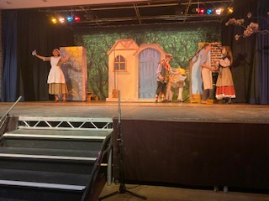 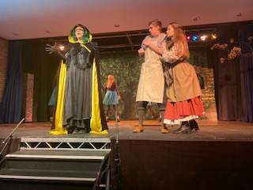

P.E. Kit

Please can you ensure that your child has a full P.E kit in school each week. This includes a pair or indoor and outdoor footwear and tracksuit bottoms.

Polite Notice

Please can you ensure that you do not park in front of our local resident driveways or directly in front of our school building. Sometimes this prevents residents from accessing their home and restricts the view of pedestrians, which could put our children in danger when crossing the road.

Attendance

This week’s attendance is: 85%! Your child is expected to have at least 97% attendance and should aim for 100%, we will not authorise any holidays during term time, please help us to keep the attendance above 96%. The gate opens at 8.45 for morning activities and interventions so please try to arrive on time.

**Let’s take a look at some learning from our week …**

Topaz class enjoyed their music lesson with Emerald Class learning about pitch and working with measuring equipment to learn about mass.

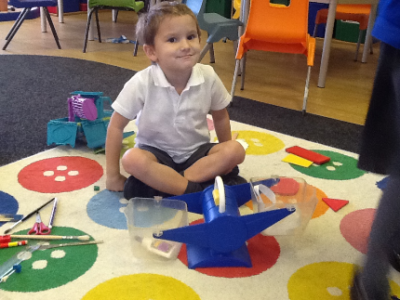 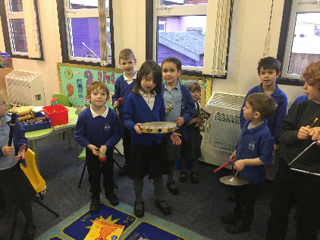 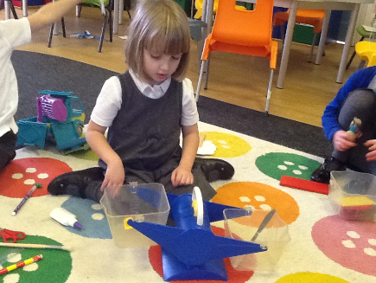

Emerald class enjoyed the KS1 sports event at Navenby, sharing equally in maths and reading using their new books

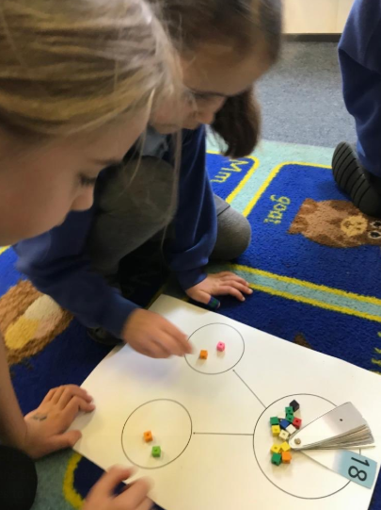 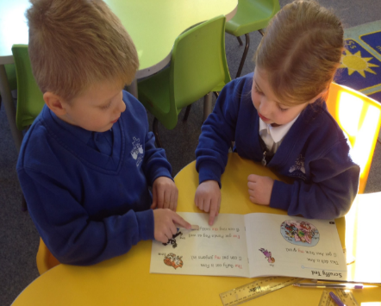 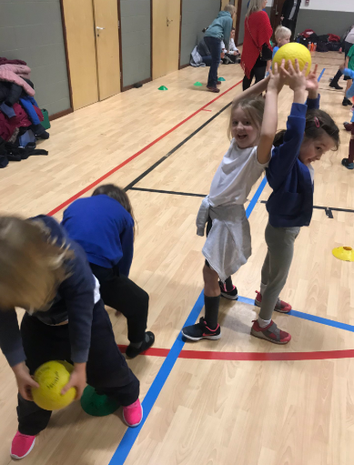

Amethyst Class enjoyed printing in art and some children sang at SWRA

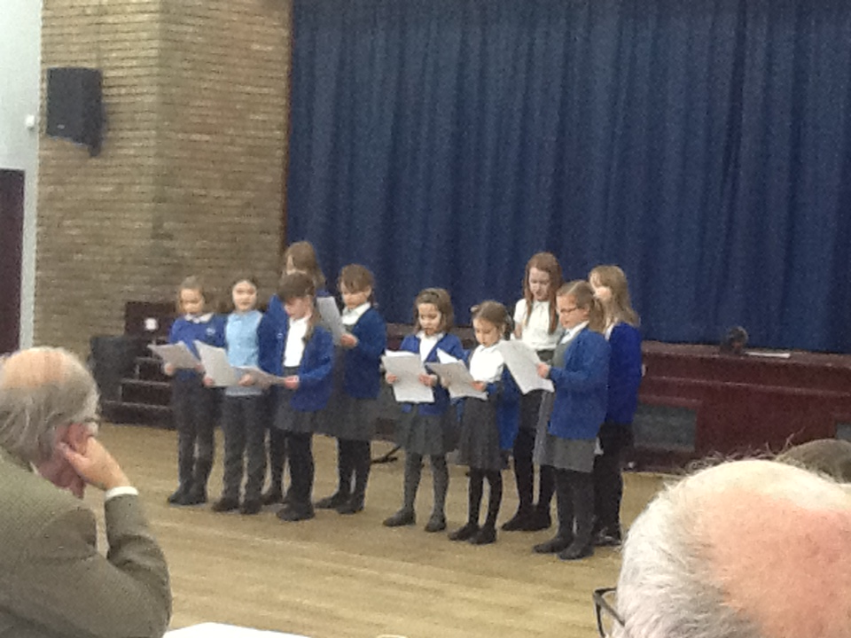 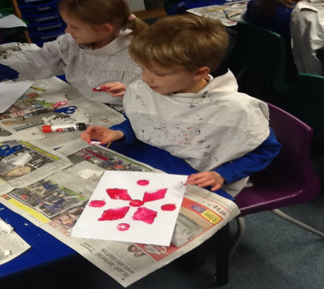 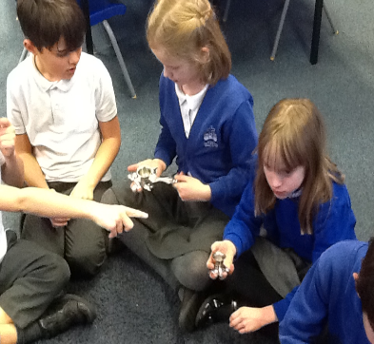

Moontone class enjoyed learning about different forms of communication in Science and family trees in French

