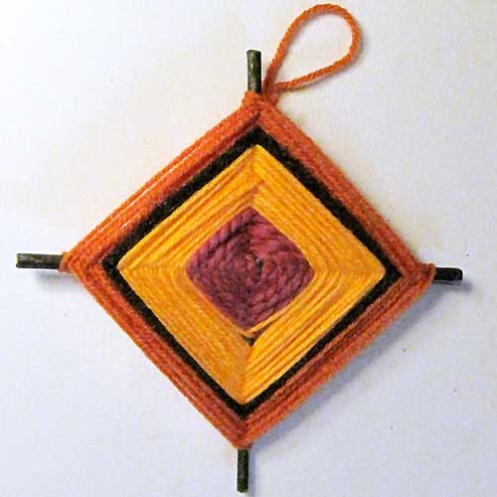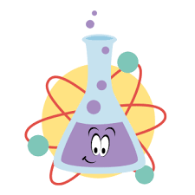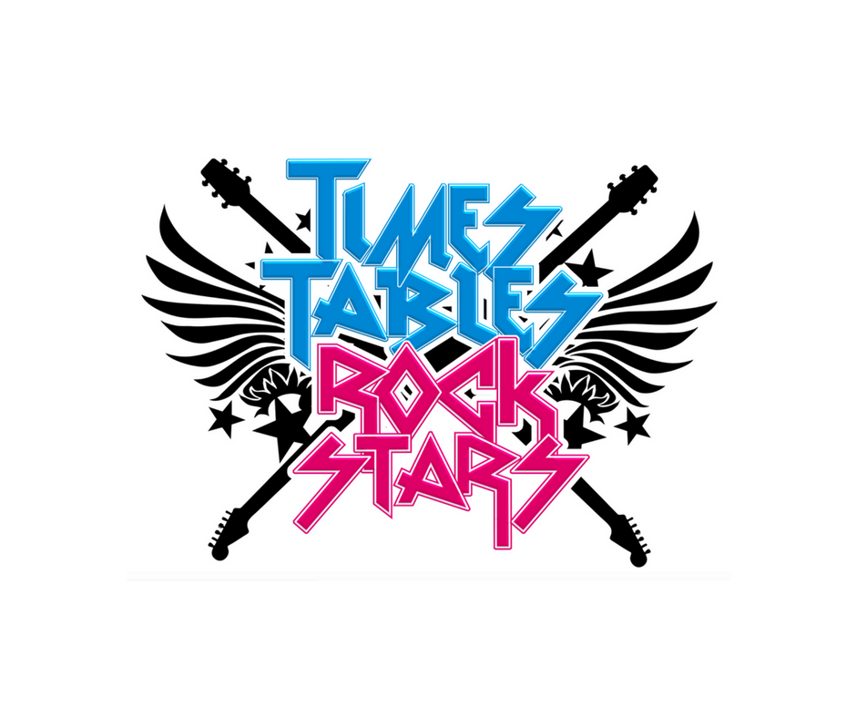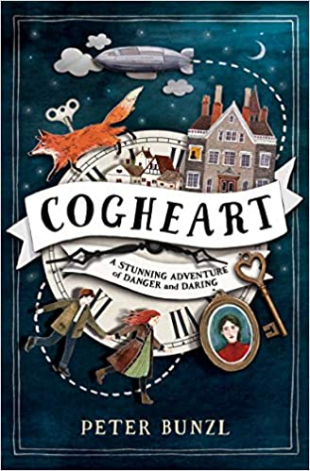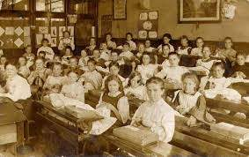

As artists we will: be developing our skills during art week by focusing on weaving skills. We will be creating dream catchers, and also using natural resources during a forest school session. We will

also be designing

a weaving project

to brighten up the

school!

As readers we will:

be reading ‘Gaslight’

in group 1, and

‘Hetty Feather’ in

group 2. We will be

concentrating on pace

and punctuation. We

will be comparing

both books to our

Victorian topic, and

to our class book.

As scientists we will:

be focusing on the topic ‘Properties and changes of materials We

will be exploring thermal

conductors and insulators, irreversible changes, dissolving and separating mixtures!

In PSHE we will: be focusing on how to develop a positive mindset, making friends and what to do when we fall out, and internet safety.

As authors we will: be writing character descriptions based on our class

book ‘Cogheart’. We will also be

looking at diary entries, journalistic

writing and letter writing. We will

then write letters to Mrs Boulter to

apply for jobs within school. We will

be focusing on SPAG through Active English.

As mathematicians we will:

be focusing on number and place value, addition and subtraction, measurement and statistics.

We will also be climbing the leader board on Times Tables Rock Stars!

Dear Parents and Year 4, 5 and 6 children:

Welcome to the new academic year in Amethyst. This term we will be exploring the history topic ‘Would you like to be a Victorian?’

Our learning challenges for this half term are:

LC1: To know what happened during the Industrial Revolution.

LC2: To know who Queen Victoria was.

LC3: To know about Victorian childhood.

LC4: To know what life was like in the workhouse.

LC5: To know about Victorian homes.

LC6: To know about Victorian leisure.

Would you like to be a Victorian?