Long Term Curriculum Overview Year 5/6 2019 - 2020
‘Believe, Excite, Succeed, Together’
Year group
 | Autumn 1 | Autumn 2 | Spring 1 | Spring 2 | Summer 1 |  | Summer 2
Key Question  ( Topic name) | History – World Wars with a focus of WW2 |  | Science – Forces | Geography/History – Scandinavia /Vikings | Mayans | Amazon Basin
Driver | History |  | Science | History / Geography | History | Geography
Key events, experiences, trips | Cranwell Aviation Museum  Bomber Command Centre | Holocaust Centre | Science day | Jorvik Viking Centre  York Chocolate Factory | Mayan Workshop with Past Productions
Parental engagement opportunities | What we have learned about WW2 so far | What we understand about the Holocaust |  | All about the Vikings | Maya Presentations | Creating poison dart frog bean bags
English units and rich texts | Goodnight Mister Tom  Fiction – Author Study / Genre study Biography Argument Texts | Diary of Anne Frank  Fiction – Author Study / Genre study Biography Argument Texts | Fiction: Scientific  Fiction study – write in the style of a genre  Poetry – Power of Imagery | Persuasive writing  Poetry – Power of Imagery | Fiction - Myths and Legends Fiction - Stories with Flashbacks Poetry – Finding a Voice |  | Fiction - Myths and Legends Fiction - Stories with Flashbacks
Maths links and opportunities | Create a weekly menu for rationing for a family of 4 including all costs from the rationing book provided | Code breaking | Mass, Weight and Gravity – Newtons Law | Viking fraction lines  Measuring | The Mayan Number System |  | The Amazon Basin in numbers
Science topic | Light | Electricity | Forces | Animals including humans | Animals Including Humans |  | Animals Including Humans
WS skills opportunities | observing changes over different periods of time,  noticing patterns,  grouping and classifying things,  carrying out comparative and fair tests  and finding things out using a wide range of secondary sources | observing changes over different periods of time,  noticing patterns,  grouping and classifying things,  carrying out comparative and fair tests  and finding things out using a wide range of secondary sources | observing changes over different periods of time,  noticing patterns,  grouping and classifying things,  carrying out comparative and fair tests  finding things out using a wide range of secondary sources. | Create new investigations  Record data and present it in a range of ways  Use scientific instruments  Know what variables to consider when following an enquiry | observing changes over different periods of time,  noticing patterns,  grouping and classifying things,  carrying out comparative and fair tests  and finding things out using a wide range of secondary sources |  | observing changes over different periods of time,  noticing patterns,  grouping and classifying things,  carrying out comparative and fair  tests and finding things out using a wide range of secondary sources.
Geography | Local Study – Welbourn vs London | Looking at the countries that were involved in WW2 | Forces of nature | Region in Europe locating Scandinavia and how the UK has changed over time. | Maya civilisation mapping skills |  | North/South America – Amazon Basin
History | World wars |  | The work of Galileo Galilei and how it relates to forces | Vikings | Non- European – Mayans |  | History of the Amazon Basin/ how it has changed overtime
Art | Every picture tells a story – exploring artists and hidden meaning behind art | - Henry Moore art look up! |  | Sketching fierce warriors | Mayan Murals |  | Rainforest Art using sugar paper
DT | Rationing | Make do and mend – sewing  Sock teddies | Making our centrifugal device | Designing and making longships (Forest School) | Mayan masks |  | Poison Dart Frog Bean Bags
Music | WW2 Music and songs |  | Ukulele | Ukulele | Composing Mayan music |  | Recreating the sounds of the rainforest using different instruments
PE | Athletics  Hockey | Dodgeball  Football | Table Tennis  Badminton | Orienteering  Dance | Gymnastics  Gymnastics |  | Team Building  First Aid
Computing | Routine week : basic skills word  Bletchley Park 1: Secret codes | Bletchley Park 2  WW2 First Computers | Big Data 1 | Big Data 2 | Intro to Python |  | Micro:bit
RE | LAS Compulsory  Being Human - Islam | LAS Compulsory  Being Human - Hinduism | LAS Additional  DO you have to believe in God to be good? | Creation  Creation and science: conflicting or Complementary as conflicting or complementary digging deeper | LAS Compulsary  Life Journey – Hinduism/Islam  Hinduism: How do Hindus show they belong?  Islam: How do Muslims show they belong?  Rites of passage; include other religions. E.g. Bar/Bat Mitzvah in Judaism, confirmation in Christianity; have looked at how we know whether religious claims are true or not – this unit considers whether their truth or otherwise actually matters- what impact
Church school values | Justice | Equality | Love and Compassion | Service and Stewardship | Peace and Forgiveness |  | Generosity and Thankfulness
British values | Democracy | Mutual Respect | Individual Liberty | The Rule of Law | Tolerance |  | The best of being British
Global learning links/ international days | 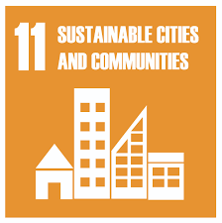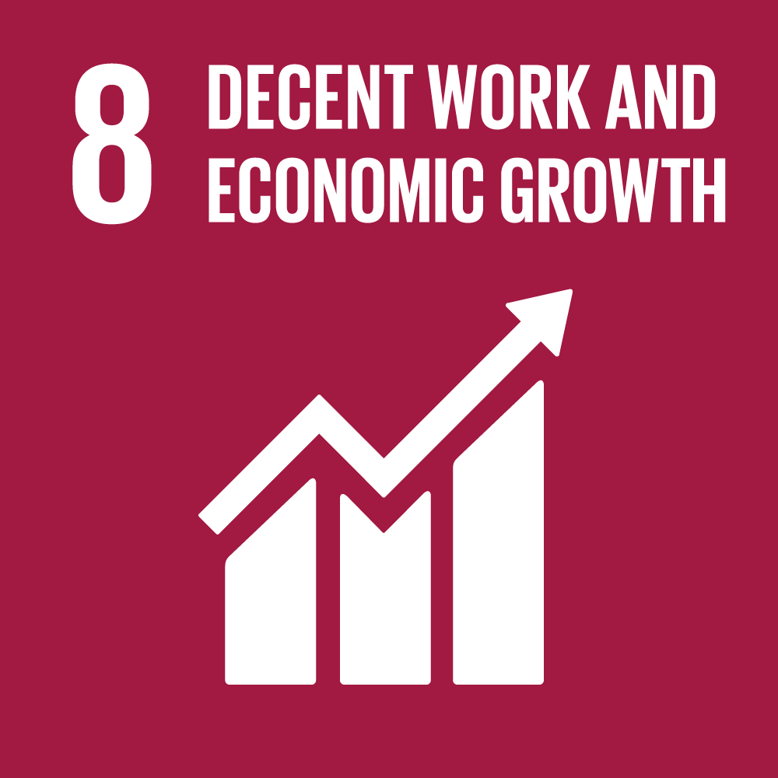 | 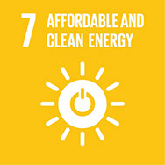 | 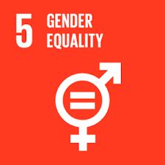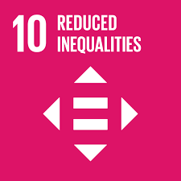 | 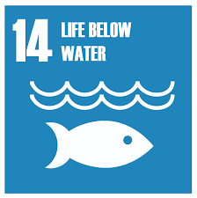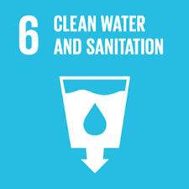 | 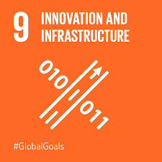
SMSC opportunities | Moral development Understanding the consequences of actions |  | Making appropriate choices about own life and justifying choices |  | Dealing with changes in life. Strategies for challenges and moral dilemmas.
PSHE/ P4C | Living in the wider world – rights and laws | Taking responsibility for our actions | Wellbeing – looking forward, safety and being responsible citizens |  | Changes, emotions and relationships
MFL | French revision of key concepts |  | Life in my home |  | Meet the family , a week in the life
Themed weeks | Democracy Week | Anti-Bullying Week  World Hello Day | Arts Week  E-Safety Day | World Book Day  Chinese New Year | Routine Week |  | Aspirations Week

