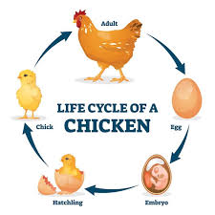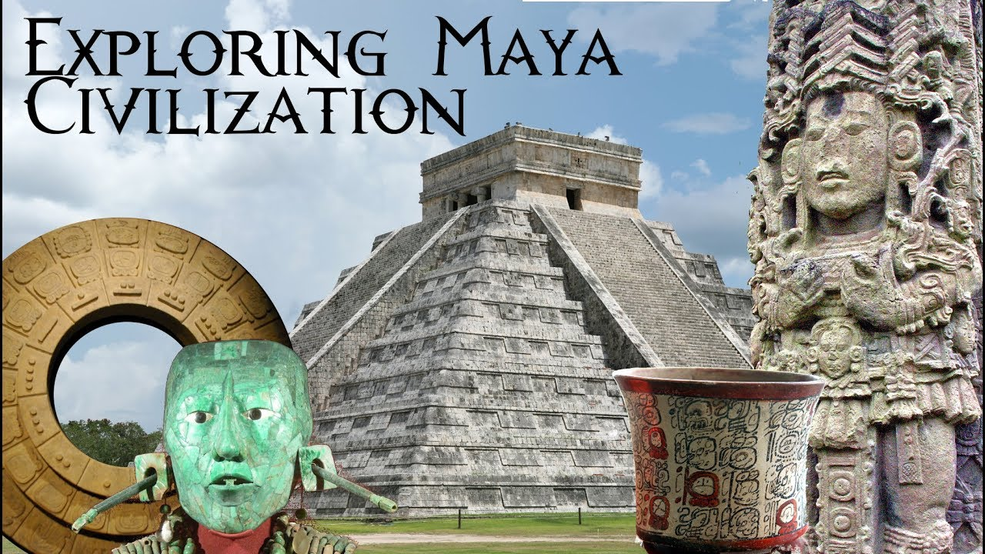

As scientists we will: be continuing to explore the topic ‘Living things and their habitats’. We will be learning about different animals, including life cycles of chicks and other animals.

Dear Parents and Year 5/6

In Moonstone this half term we will be looking at the History topic ‘Who were The Mayans?’

Our challenge questions are:

LC1: To know when and where the Maya lived and their beliefs.

LC2: To know how society has changed over time for the Mayan civilisation.

LC3: To know about the Maya calendar and number system

LC4: To know and research Mayan trade and how their transactions covered a huge geographical area.

LC5: To know and understand significant individuals within Maya rule and the significance of their roles.

LC6: To know and understand hierarchy within a society.

As athletes we will:

Be developing our skills in athletics and volleyball



As performers and musicians we will:

be rehearsing for our end of year play ‘Cinderella Rockerfella’. Please help your child

to learn

their lines

and

practise

the songs!

Who were The Mayans?

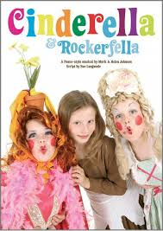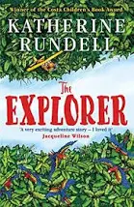

As mathematicians we will:

be learning about fractions, decimals and percentages. We will then be focusing on ratio, algebra and shape.

.

As Readers we will:

be continuing to read the

book ‘The

Explorer’ by

Katherine

Rundell

As writers we will:

be studying fantasy and adventure narrative based on a film clip. We will then be focusing on poetry and figurative language.