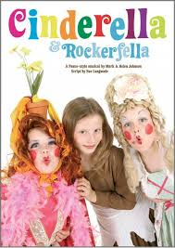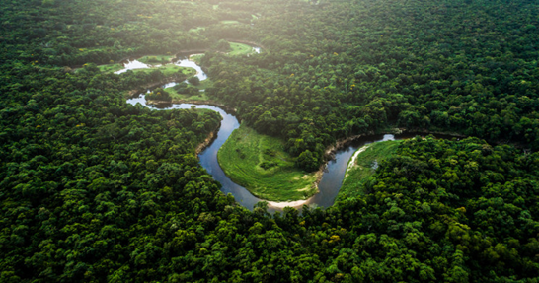

In RE we will: be learning about celebrations in different religions, before comparing them.

As actors, we will be beginning

to focus on our summer play,

‘Cinderella Rockerfella’ We will be

focusing on learning the songs

in music before auditioning for parts.

Dear Parents and Year 5/6

In Amethyst this half term we will be looking at the Geography topic ‘Why is the Amazon rainforest important?’

Our challenge questions are:

LC1: To know the locations of the worlds rainforests, and the conditions that create them.

LC2: To know the names and locations of the countries in the Amazon Basin

LC3: To know and label the layers of a rainforest.

LC4: To know how daily life and climate in the Amazon is different to the UK

LC5: To know the effects of deforestation on the Amazon Rainforest.

LC6: To understand the impact of human geography on the rainforest and environmental issues caused by this.

Wow Days and trips:

We will be creating, rainforests in a jar.

We will be visiting Rand farm Park to launch our science topic ‘living things and their habitats’ We will also be having an incubator in school to observe chicks hatching. A group of baby chicks in a carton

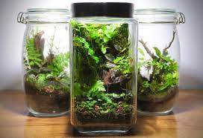

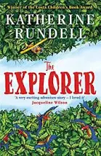

As mathematicians we will:

be focusing on SATs revision, before moving onto area and perimeter.

We will also continue

with Times tables

Rock stars!

As writers we will:

be completing our non-chronological reports on the Vikings, then studying the features of black out poetry, before creating our own.

As Readers we will:

be reading the

book ‘The

Explorer’ by

Katherine

Rundell

Why is the Amazon Rainforest important?